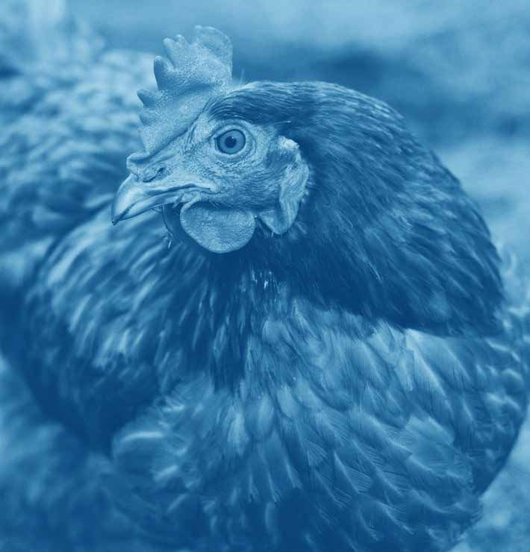


The Business Benchmark on Farm Animal Welfare
2024 Report

Au hors: Dr Na han Rhys Williams, Nicky Amos and Ka herine Bu on

The Business Benchmark on Farm Animal Welfare
The Business Benchmark on Farm Animal Welfare (BBFAW) is he leadin

lobal measure of farm animal welfare mana emen , policy commi men , performance and disclosure in food companies. I enables inves ors, companies, NGOs and o her s akeholders o unders and corpora e prac ice and performance on farm animal welfare, and i drives – direc ly and hrou h
he e­or s of o hers – corpora e improvemen s in he welfare of animals reared for food.

The BBFAW Secre aria main ains he Global Inves or S a emen on Farm Animal Welfare and convenes he Global Inves or Collabora ion on Farm Animal Welfare, a collabora ive en a emen be ween major ins i u ional
inves ors and food companies on he issue of farm animal welfare. In addi ion,
he BBFAW Secre aria mana es ex ensive en a emen pro rammes wi h companies and wi h inves ors and provides prac ical uidance and ools for companies and for inves ors on key animal welfare issues.

The pro ramme is suppor ed by Compassion in World Farmin and FOUR PAWS, who provide echnical exper ise, uidance, fundin and prac ical resources, alon side suppor in he assessed food businesses wi h rainin , pro ramma ic exper ise and consul ancy en a emen .

More informa ion on he pro ramme can be found a www.bbfaw.com

Compassion in World Farmin
Compassion in World Farmin is he leadin in erna ional farm animal welfare or anisa ion dedica ed o endin fac ory farmin and reshapin
he food sys em o benefi he lives of animals, people, and he heal h of he plane . Throu h campai nin , lobbyin for le isla ive chan e, and posi ive en a emen wi h he lobal food indus ry, we seek o influence key decision makers ha shape, make and fund he food sys em.

Throu h our Food Business pro ramme, we work in par nership wi h leadin food companies o drive ransforma ional chan e for farm animal welfare, reduce he reliance on animal sourced foods and encoura e
a shi‹ o re enera ive farmin prac ices. The eam o­ers s ra e ic advice and exper echnical suppor for he developmen , implemen a ion and communica ion of hi her welfare policies and prac ices, and solu ions and frameworks for a fu ure-fi food sys em.

Compassion en a es direc ly wi h many of he companies evalua ed
in he BBFAW o hi hli h and suppor wi h policy developmen , welfare improvemen and ransparen repor in . The Food Business eam uses
he Benchmark alon side Compassion’s o her ools such as i s Awards pro ramme, E Track, ChickenTrack, and i s advisory services o help companies unders and how hey are performin rela ive o heir peers,
o iden ify areas and mechanisms for con inuous improvemen , and o hi hli h sources of risk and oppor uni y.

More informa ion on Compassion in World Farmin can be found a : www.ciwf.or

More informa ion on he work of he Food Business eam a Compassion in World Farmin can be found a :
www.compassioninfoodbusiness.com

FOUR PAWS
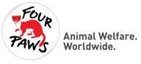
FOUR PAWS is he lobal animal welfare or anisa ion for animals under direc human influence, which reveals su­erin , rescues animals in need and pro ec s hem. Founded in 1988 in Vienna by Heli Dun ler and friends,
he or anisa ion advoca es for a world where humans rea animals wi h respec , empa hy and unders andin .

FOUR PAWS' sus ainable campai ns and projec s focus on farm animals, companion animals and wild animals kep in inappropria e condi ions, as well as animals in disas er and conflic zones. Wi h i s curren campai ns o reform animal welfare le isla ion, a ains live animal ranspor and cruel prac ices such as live lamb cu in (mulesin ) and in favour of animal-friendly fashion, FOUR PAWS is commi ed o improvin he livin condi ions of billions of farm animals. On a business level, he or anisa ion suppor s he BBFAW
o drive chan e in numerous in erna ional food sec ors. FOUR PAWS also works on mul iple o her farm animal opics and raises awareness amon he public hrou h radi ional and social media channels, lobbies poli icians and runs awareness campai ns o hold he food and ex ile indus ries o accoun . One addi ional oal is o develop exper ise on he in ersec ion of farm animal welfare and he clima e crisis and o ransla e his in o e­ec ive campai n narra ives and ac ions.

Wi h oœces in Aus ralia, Aus ria, Bel ium, Bul aria, France, Germany, Kosovo, he Ne herlands, Swi zerland, Sou h Africa, Thailand, Ukraine,
he UK, he USA and Vie nam as well as sanc uaries for rescued animals in eleven coun ries, FOUR PAWS provides rapid help and lon - erm solu ions.
For more informa ion abou FOUR PAWS please visi : www.four-paws.or More abou FOUR PAWS work on farm animals can be found a :
h ps://www.four-paws.or /campai ns- opics/ opics/farm-animals

Contents
Foreword 5
Acknowled emen s 8
- The 2024 Benchmark Headline Findins 9
- Company Tier Rankins and Impac Ra ins 15
Tier Rankin s 16
Impac Ra in s 20
Pillar Analysis 25
- The 2024 Benchmark Resul s in De ail 33
Farm Animal Welfare Policy Commi men s 34
Farm Animal Welfare Governance and Mana emen 44
Farm Animal Welfare Tar e s 46
Farm Animal Welfare Performance Impac 47
Reducin Reliance on Animal Sourced Foods 55
- Accelera in Impac 57
Appendix 61
Company Covera e 62
2024 Benchmark Ques ions and Scorin 63
Credi s 121

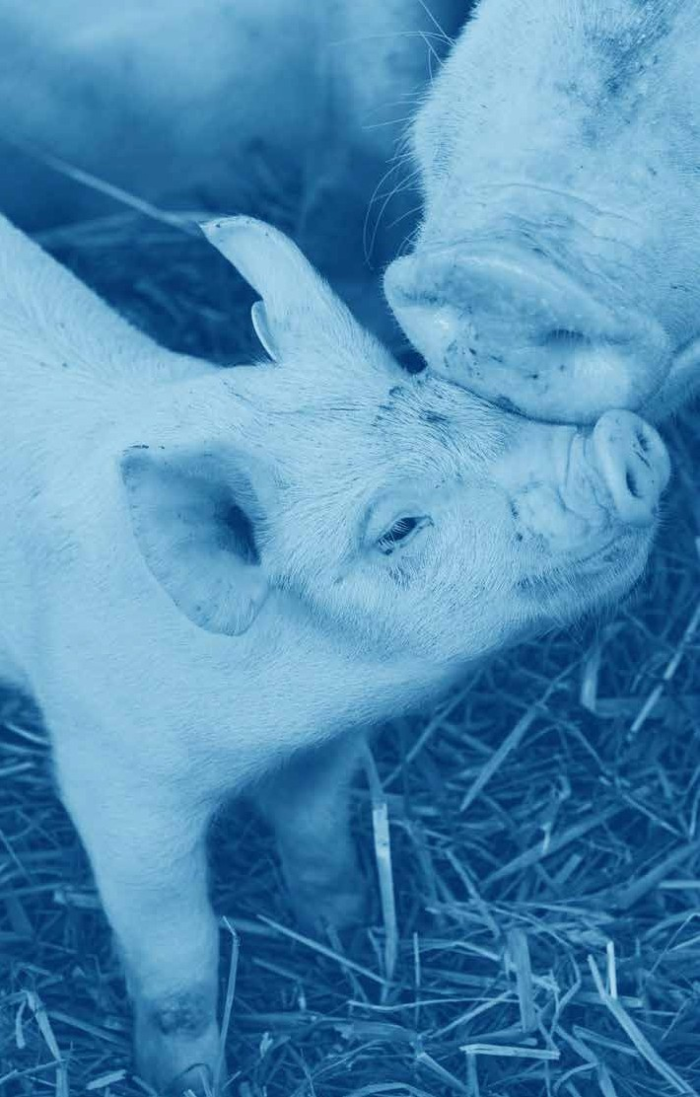

Foreword

Since i s founda ion in 2012, he Business Benchmark on Farm Animal
Welfare (BBFAW) has been a drivin force in advancin animal welfare across
he food indus ry. As he clima e, heal h, and biodiversi y crises in ensify, BBFAW has expanded i s scope o address he ur en need o reduce he reliance on animal-sourced foods – an essen ial s ep oward ransformin our failin food sys ems.

Compassion in World Farming


Philip Lymbery
Global CEO
The Food Sys em Economics Commission repor ed las year ha he economic cos of human su­erin and plane ary harm caused by food
sys ems exceeds 10 rillion USD annually - more han food sys ems con ribu e
o Global GDP. Even more concernin is ha despi e his enormous cos , our lobal food sys em fails o mee he mos basic oal: feedin people. Over 780 million people o hun ry while over half of all food is los or was ed and billions of farmed animals are ca ed, crammed and confined.

Companies can’ solve hese sys emic issues alone, bu hey play a cri ical leadership role. The ur ency for humane and sus ainable food sys ems will only in ensify as he consequences of inac ion row more severe for people, animals and he plane .

Se in a course for a be er omorrow is some hin all companies can do by embeddin clear in en for chan e in o corpora e policy, suppor ed a board level. Bu in en alone is no enou h, real pro ress requires robus roadmaps wi h clear commi men s, ar e s and imelines. These mus include wholesale shi‹s oward hi her welfare produc s, diversifica ion of pro ein por folios
o encompass more plan -based foods, and a ransi ion o na ure-posi ive, re enera ive farmin .

Governmen ac ion is equally cri ical. Le isla ion can and mus suppor businesses ha are leadin he char e. Proposals o ban ca es – he very epi ome of fac ory farmin – across Europe and in he UK exemplify how
overnmen s can drive lar e-scale ransforma ion in food produc ion. Such policies no only level he playin field bu also provide re ula ory cer ain y, enablin businesses o inves in sus ainable solu ions.

Inves ors oo have a pivo al role o play. They have he power o accelera e chan e by holdin businesses accoun able for ransi ionin o hi her welfare, sus ainable food sys ems. And by ur in businesses o mi i a e risk by movin away from indus rial and na ure-des royin forms of food produc ion o ones
ha ruly respec animals as sen ien bein s.

BBFAW provides a ri orous ye fair framework o uide businesses, policymakers, and inves ors oward a more sus ainable food sys em.
As a foundin par ner, Compassion in World Farmin has helped es ablish BBFAW as he respec ed and au hori a ive benchmark i is oday.

The oal remains clear: buildin a be er food sys em requires bold s eps
oward produc ion wi h hi her s andards of animal welfare. The elimina ion of ca es is a crucial firs move in he ransi ion oward re enera ive, na ure-friendly farmin and a si nifican reduc ion in consump ion of animal produc s. BBFAW 2024 shows pro ress, bu he road ahead demands ac ion, collabora ion,
and commi men . The choices we make oday have he power o shape food
sys ems ha are humane, sus ainable, and resilien for enera ions o come.

Despi e findin ourselves in a ime of lobal chan e and uncer ain y caused by
poli ical shi‹s, war, infla ion, pandemics and clima e crises i is more impor an
han ever o no for e abou he animals ha we are responsible for.

FOUR PAWS


Dr Marina Sephany
Senior Pro rammes Direc or
Fac ory farmin is he leadin cause of animal cruel y worldwide. Globally, i is es ima ed ha 92 billion animals are farmed for food each year, mos of hem bein reared in in ensive farms. These animals canno fulfil heir basic needs and in consequence develop behavioural disorders. Throu hou heir shor lives, hey are subjec ed o various cruel prac ices and mus adap o heir housin condi ions for economic reasons. Over he years, his abuse has aken i s oll resul in in pandemic ou breaks, an ibio ic resis ance, clima e chan e and loss of livelihood.

To drive he ransforma ion of he a ricul ural sys em and o improve he life of farmed animals sus ainably, FOUR PAWS promo es he 3Rs principle
– Reduc ion, Replacemen and Refinemen . The aims are o reduce he consump ion of animal-based produc s and herefore unnecessary su­erin ,
o replace hese produc s wi h plan -based al erna ives as well as o refine farmin prac ices and promo e be er livin condi ions. FOUR PAWS calls on every company ha is profi in from animal-based produc s o ac responsibly and o s ar followin his principle, as i is he prerequisi e for a sus ainable food sys em.

I is essen ial companies se quan i a ive ar e s o address animal welfare and reduc ions in he numbers of animals farmed, o ensure he wellbein of animals, humans and he plane . The food indus ry needs o commi he resources required for implemen a ion of ar e s and o repor ransparen ly on pro ress. Ul ima ely, we need o see a race o he op, wi h leadin companies demons ra in wha is possible and inspirin o hers o follow.

FOUR PAWS is deli h ed o be a fundin par ner, o e her wi h CIWF,
for his second i era ion of he BBFAW followin he revisions o s ren hen
he cri eria in 2022. We are confiden he upda ed cri eria provide more comprehensive and accura e insi h s in o he s a e of animal welfare in
he supply chains of he world’s lar es food companies.

Animal welfare is no lon er a nice- o-have, bu a moral obli a ion o mi i a e risk and ensure he wellbein of humans and animals. We look
forward o celebra in all achievemen s for he animals o come and commi
o con inuin suppor in all s akeholders in crea in a food sys em wi hin plane ary boundaries ha is posi ive and heal hy for animals, humans and he plane .

Acknowledgements

This repor has been prepared by he BBFAW Secre aria run by Chronos
Sus ainabili y L d. The lead au hors were Dr Na han Rhys Williams, Nicky Amos and Ka herine Bu on.

We would like o hank he followin for heir suppor of his projec and
heir con ribu ion o he desi n and developmen of he 2024 Benchmark:

- Philip Lymbery, Dr Tracey Jones, Louise Valducci, Amélie Le rand and he Food Business eam a Compassion in World Farmin .

- Dr Mar ina S ephany, Dr Marlene Kirchner, Dr Carolina Cardoso Na ib Nascimen o, Carina Nierobisch and collea ues a FOUR PAWS.

- The many companies who have con inued o en a e wi h he BBFAW pro ramme over he pas year and who provided feedback durin he assessmen process.

- The many inves ors who have con inued o en a e wi h he BBFAW pro ramme and he companies covered by he BBFAW.

- The eam of BBFAW assessors and reviewers.

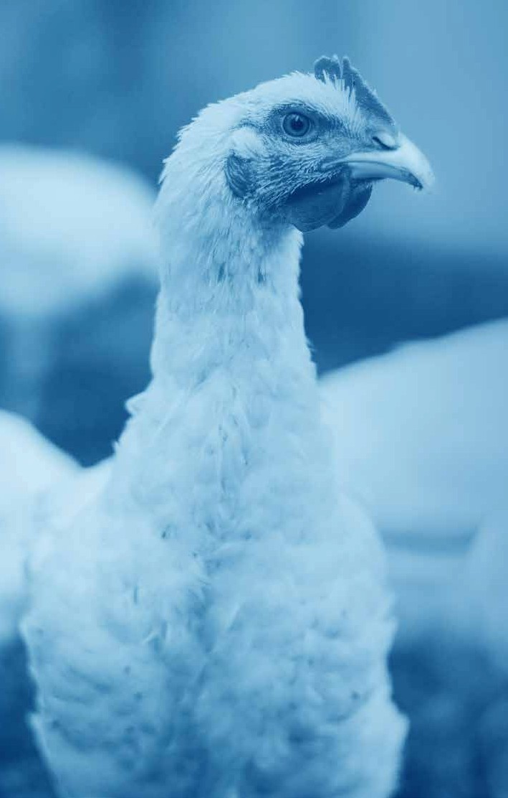
1

2024 Benchmark Headline Findings

Chaper 1

2024 Benchmark Headline Findings

Headline Findings

  - Susained and renewed focus on farm animal welfare by food companies

There has been a radual rise in he overall avera e company score, from 16% in 2022, 17% in 2023, o 18% in 2024,
which su es s ha companies are con inuin
o focus on farm animal welfare mana emen and disclosure and are be innin o
respond o he new expec a ions on farm animal welfare, as in roduced in he BBFAW cri eria in 2022.

This is only he second year of published repor s usin he new Benchmark cri eria, so pro ress is expec ed o be slower ini ially. A similar rend was observed amon he 150 benchmarked companies followin previous adjus men s o he BBFAW cri eria
where meanin ful improvemen s in company performance ypically ook wo o hree years o ma erialise.

94%

of companies acknowled e farm animal welfare as a business issue

No ably, in 2024 more lobal food companies reco nise farm animals as
sen ien bein s, wi h 67 companies (45%) ci in farm animal sen ience as a s ron founda ion for animal welfare policies,
an increase from 54 companies (36%)
in 2023.

Meanwhile, 141 of he 150 lobal food companies (94%) acknowled e farm animal welfare as a business issue and 128 companies (85%) have published a farm animal welfare policy s a emen .

  - The ap widens beween hi her performin companies and companies makin lile o no pro ress on farm animal welfare

I is eviden ha several food companies are accelera in ac ion on farm animal welfare in comparison o heir indus ry peers. For ins ance, 14 companies (9%) have improved heir overall avera e score by five percen a e poin s or more.
The rea es improvemen seen was from Arla Foods L d, which improved heir score by 23% movin from Tier 5 o Tier 4. In o al, 14 of he 150 companies (9%) have moved up a ier rankin in 2024 (see able 1.1).

A ains his pro ress, some major food companies appear o be akin limi ed or no ac ion o address farm animal welfare in heir opera ions and supply chains. Twen y- wo companies (15%) have no published a formal animal welfare policy. Of hese companies, nine (6%) do no appear o reco nise farm animal welfare as a business issue.

Table 1.1

Companies that have risen a Tier Ranking in the 2024 Benchmark

Tier ranking change Companies that moved up a Tier in 2024

3 to 2 | Greggs PLC
4 to 3 | Danish Crown AmbA
 | Fonterra
 | Minerva Foods
5 to 4 | Arla Foods Ltd.
 | Hershey Co
 | JD Wetherspoon PLC
 | Mitchells & Butlers PLC
 | Terrena Group
 | Whitbread PLC
 | Wm Morrison Supermarkets PLC
6 to 5 | Campbell Soup Company
 | Darden Restaurants PLC
 | Wayne-Sanderson Farms
The Business Benchmark on Farm Animal Welfare Repor 2024

The 14 companies whose scores have increased by five per cent or more in the 2024 Benchmark
Arla Foods L d C&S Wholesale

Danish Crown AmbA China Resources Vanuard

Fon erra Cos co Wholesale Corpora ion

Hershey Co Dino Polska SA

Hil on Food Group JAB Holdin Company
(paren company for brands such as
JD We herspoon PLC Pre A Man er and Krispy Kreme)

Marfri Global Foods SA Lianhua Supermarke Holdins Co

Minerva Foods Roark Capi al
(paren company for brands such as
Mi chells & Bu lers PLC Dunkin' and Subway)

SSP Group Yonhui Supers ores Co L d
Terrena Group Zhonpin Inc.

Wayne-Sanderson Farms Whi bread PLC
Wm Morrison Supermarke s PLC

The Business Benchmark on Farm Animal Welfare Repor 2024
The nine companies for which animal welfare does not appear to be a business issue are:

  - Companies are makin si nifican srides in performance impac reporin
The hree companies achievin Impac Rain B in he 2024 BBFAW benchmark are:

Fonerra (E o B)
Marks & Spencer PLC (C o B)
Premier Foods PLC (C o B)
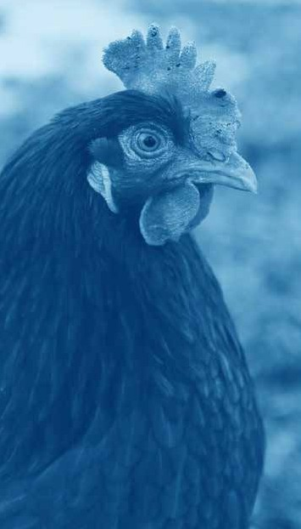

One of he key objec ives for he BBFAW is
o drive posi ive welfare impac s for animals.
I is herefore reassurin ha companies are s ar in o show pro ress in heir performance impac scorin in he 2024
Benchmark. This is an impor an developmen as i si nals ha companies’ e­or s o

build heir farm animal welfare mana emen sys ems are s ar in o deliver welfare improvemen s for animals in heir opera ions and supply chains.

Whils he number of companies – 109 ou of 150 companies (73%) – repor in
performance impac da a remains unchan ed since 2023, we have seen an increase in
he number of companies repor in on all 11 of he new species-specific ques ions
in roduced in 2022. This demons ra es ha companies are respondin o increased expec a ions of repor in on farm animal welfare performance.

Encoura in ly, some companies are repor in si nifican pro ress in heir performance impac da a, wi h hree companies achievin a B Impac Ra in for he firs ime, and one company movin up hree Impac Ra in s, from E o B.

In o al, 14 companies ou of 150 (9%) increased heir Impac Ra in in 2024, which indica es ha hese companies are workin o deliver welfare benefi s o animals in heir opera ions and supply chains.

Table 1.2

Companies whose Impact Rating improved in 2024

Companies whose Impact Rating improved in 2024 Impact Rating
2024
Impact Rating 2023

Fon erra | B | E
Marks and Spencer PLC | B | C
Premier Foods PLC | B | C
Gre s PLC | C | D
Danish Crown AmbA | D | E
Marfri Global Foods SA | D | E
Minerva Foods | D | E
Arla Foods L d | E | F
Coop Group (Swi zerland)/ Coop Genossenscha | E | F
Hil on Food Group | E | F
Maple Leaf Foods | E | F
Terrena Group | E | F
Whi bread PLC | E | F
Wm Morrison Supermarke s PLC | E | F
The Business Benchmark on Farm Animal Welfare Repor 2024

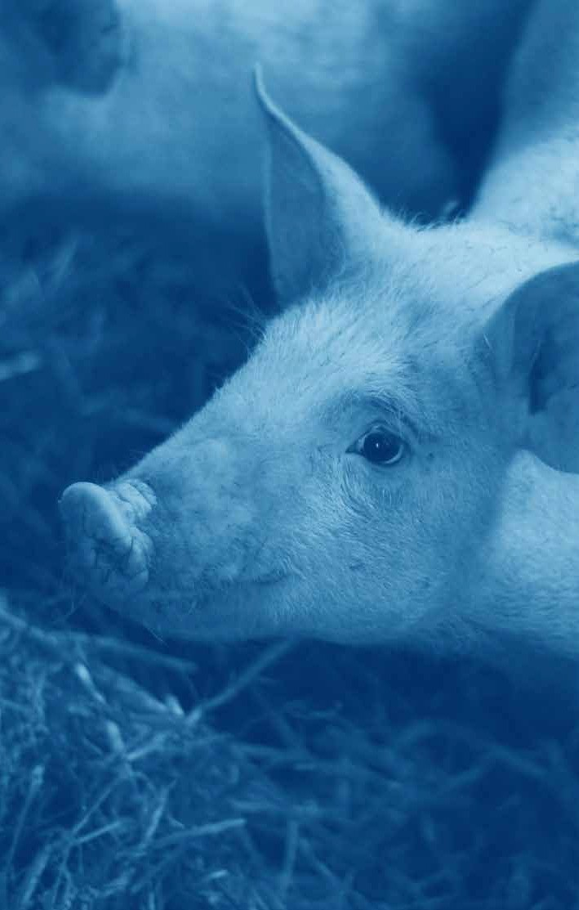
2

Company Tier Rankings and Impact Ratings

Chaper 2 Company Tier Rankings and Impact Ratings

Tier Rankings

The 150 benchmarked companies are
rouped in o one of six iers, based on heir overall percen a e scores, as indica ed in Table 2.1. A composi e pic ure of 2023 and 2024 company scores by Tier rankin and by Impac Ra in (IR) appears in Fi ure 2.1.

Table 2.1

BBFAW Benchmark Tiers

Tier Percena e score

1 | The company has aken a leadership posi ion on farm animal welfare | >80%
2 | The company has made farm animal welfare an in eral par of i s business s ra ey | 62-80%
3 | The company has an es ablished approach o a farm animal welfare bu has more work o do  o ensure i is e“ec ively implemen ed | 44-61%
4 | The company is makin proress on implemen in  i s policies and commi men s on farm animal welfare | 27-43%
5 | The company has iden ified farm animal welfare as a business issue bu provides limi ed evidence  ha i is manain he issue e“ec ively | 11-26%
6 | The company provides limi ed if any evidence  ha i reconises farm animal welfare as a business issue | <11%

16 The Business Benchmark on Farm Animal Welfare Repor 2024

Fi ure 2.1
IR

Company Tier Rankings and Impact Ratings*
Fi ure 2.1 presen s company BBFAW Impac Ra in and Tier Rankin in one able o provide he mos accura e pic ure of company's performance wi hin he benchmark.

Tier 1
Leadership

Tier 2
In eral o business s ra ey

Tier 3
Es ablished bu work o be done

Tier 4
Makin proress on implemen a ion

Tier 5
On he business aenda bu limi ed evidence of implemen a ion

Tier 6
No evidence on he business aenda

0 4 8 20 60 58

Greggs PLC C
Marks & Spencer PLC B
Premier Foods PLC B
Waitrose C

Co-op UK D
Cranswick PLC D
Danish Crown AmbA. D
Fonterra B
Groupe Danone SA C Migros-Genossenschafts-Bund C Minerva Foods D
Noble Foods D

ALDI Süd/ALDI Einkauf
SE & Co. oHG F
Arla Foods Ltd. E
Barilla SpA E
BRF SA E
Compass Group PLC F
Groupe Lactalis E
Hershey Co. E
Hilton Food Group E
J Sainsbury PLC D
JD Wetherspoon PLC. F
LDC Groupe F
Les Mousquetaires E
Marfrig Global Foods SA D
Mitchells & Butlers PLC. F
Terrena Group. E
Tesco PLC E
Unilever NV F
Whitbread PLC. E
Wm Morrison
Supermarkets PLC. E
Woolworths Limited F

(The) Kroger Company F
2 Sisters Food Group (Boparan Holdings Ltd) F
Agro Super F
Ahold Delhaize F
ALDI Einkauf SE & Co. oHG
(ALDI Nord) F
Aramark Corporation F
Bellis Topco Ltd./Asda F
Bimbo F
Campbell Soup Company F
Cargill F
Carrefour SA. F
Casino Guichard-Perrachon SA F Charoen Pokphand Foods F
Chipotle Mexican Grill F
Coles Group F
Colruyt F
ConAgra F
Coop Group (Switzerland)/
Coop Genossenschaft E
Cooperativa Central Aurora Alimentos F
Coopérative U Enseigne F
Cooperl Arc Atlantique F
Cremonini SpA F
Darden Restaurants PLC. F
E.Leclerc F
EDEKA Group F
Elior Group F
Elo Group F
Ferrero Group F
General Mills Inc F
Gruppo Veronesi F
Hormel Foods Corporation F
ICA Gruppen AB F
IKEA (Inter IKEA Group) F
JBS SA F
Jeronimo Martins F
Kraft Heinz Company F
Maple Leaf Foods E
McDonald’s Corporation F
METRO AG F
Metro Inc F
Mowi ASA F
Nestlé SA F
OSI Group F
Papa John’s Pizza F
Perdue Farms F
Plukon Food Group F Restaurant Brands International F REWE Group F
Royal FrieslandCampina. F
Saputo Inc F
Schwarz Gruppe F
Sodexo F
SSP Group F
Sysco Corporation F
The Cheesecake Factory F
Tönnies Group F
Tyson Foods Inc F
Vion Food Group F
Wayne-Sanderson Farms. F
Yum! Brands Inc F

Aeon Group F
Albertsons F
Alimentation Couche-Tard F Amazon/Whole Foods Market F Avolta AG (previously Autogrill) F
Beijing Dabeinong Technology Group Co., Ltd. F
BJ’s Wholesale Club Holdings F Bloomin’ Brands Inc F
C&S Wholesale F
Camst – La Ristorazione
Italiana Soc. Coop. ARL F
Cencosud F
Chick-fil-A F
China Resources Vanguard F
China Yurun Group Limited F
CKE Restaurants F
Conad Consorzio Nazionale F Cooke Seafood Inc F
Coop Italia. F
Costco Wholesale Corporation F Cracker Barrel F
Dairy Farmers of America F
Dico’s/Ting Hsin International
Group F
Dino Polska SA F
Domino’s Pizza Inc F
Empire Company/Sobey’s F
Gategroup Holding AG F
H E Butt Company F
Habib’s F
Industrias Bachoco F
JAB Holding Company F
Kerry Group. F
Lianhua Supermarket
Holdings Co F
Loblaw Companies Limited F
Mars Inc F
Maruha Nichiro F
Meiji Holdings F
Mercadona SA F
Mondelēz International F
Müller UTM F
New Hope Liuhe Co Ltd F
Nippon Ham F
Publix Super Markets Inc F
Roark Capital (Inspire Brands, Subway et al.) F
Seaboard Corp F
Seven & i Holdings F
Spar Holding AG F
Starbucks Corporation F
Target Corporation F
UNFI F
US Foods F
Walmart Inc F
Wendy’s Company (The) F
Wens Foodstuff Group F
WH Group Ltd F
Yili Group F
Yonghui Superstores Co Ltd F
Yum China Holdings F Zhongpin Inc (Huayu Holdings) F

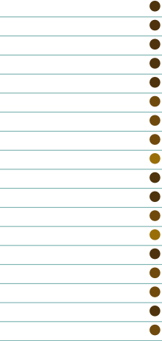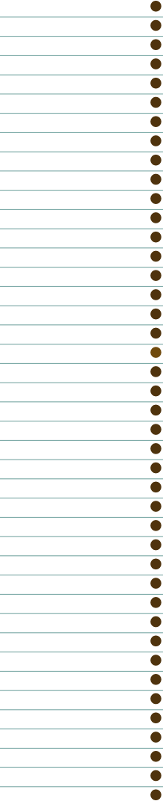
* Impac ra in s are based on companies’ scores for he 20 performance impac ques ions, namely Q30 o Q49. The scores are presen ed in a six- ier ra in , labelled A-F, usin he percen a e boundaries presen ed in Table 2.5. The arrows indica e he chan e in Tier Rankin and Impac Ra in compared o 2023.

Year-on-Year Tier Comparison

Tier No. Companies
2024
No. Companies 2023
No. Companies 2022

1
2 | 4 | 3 | 1
3 | 8 | 7 | 6
4 | 20 | 16 | 14
5 | 60 | 66 | 74
6 | 58 | 58 | 55

Table 2.3

Comparative Tier Movements

Tier Movements 2024

18
The Business Benchmark on Farm Animal Welfare Repor 2024
4
- 1
14
+1

Table 2.4

Company tier ranking changes
Tier ranking changes in 2024 from 2023 | Company
1 Tier rise | Arla Foods Ltd | 5 to 4
 | Campbell Soup Company | 6 to 5
 | Danish Crown AmbA | 4 to 3
 | Darden Restaurants PLC | 6 to 5
 | Fonterra | 4 to 3
 | Greggs PLC | 3 to 2
 | Hershey Co | 5 to 4
 | JD Wetherspoon PLC | 5 to 4
 | Minerva Foods | 4 to 3
 | Mitchells & Butlers PLC | 5 to 4
 | Terrena Group | 5 to 4
 | Wayne-Sanderson Farms | 6 to 5
 | Whitbread PLC | 5 to 4
 | Wm Morrison Supermarkets PLC | 5 to 4
1 Tier fall | Carrefour SA | 4 to 5
 | Coop Italia | 5 to 6
 | Kerry Group | 5 to 6
 | Royal FrieslandCampina | 4 to 5
The Business Benchmark on Farm Animal Welfare Repor 2024

19

Impact Rating

The BBFAW Impac Ra in was in roduced in 2020 o provide a more accura e pic ure of
he welfare benefi o animals in a company’s supply chain. Companies are awarded an Impac Ra in of A-F as shown in Table 2.5. The Impac Ra in s are based on company scorin across 20 Performance Impac
ques ions, namely Q30 o Q49.

Table 2.5

2024 Impact Ratings*

Impact Rating Number of
companies
2024
Number of companies 2023

A
>80%

B
62-80%
These companies are declarin improved
welfare impac s for a reasonable propor ion of farm animals in heir opera ions and/or supply chains.
C
44-61%

D
27-43%
These companies are declarin improved
welfare impac s for a leas some farm animals in heir opera ions and/or supply chains.
E
11-26%

F
<11%
These companies have ye o demons ra e
ha hey are deliverin improved welfare impac s for farm animals in heir opera ions and/or supply chains.

3
4 | 6
7 | 5
14 | 13
122 | 126

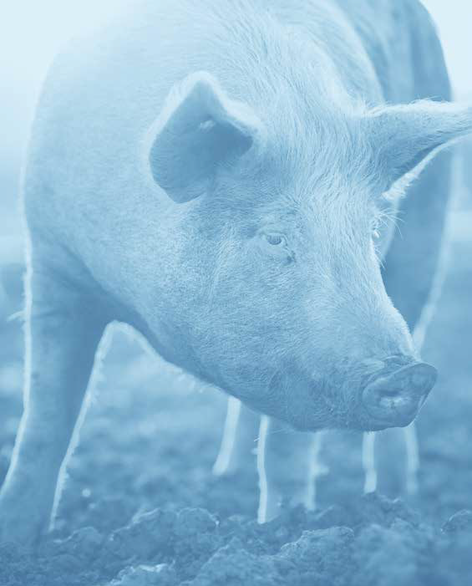

Table 2.6

Company Impact Rating Movements

Impact Rating Movements | 2024
+3 | 1
+ 1 | 13
- 1 | 6

Table 2.7

Company Impact Rating Changes

Impact rating change in 2024 from 2023
Company Rating 2023
to 2024

3 Impact Rating rise
Fon erra E to B

1 Impact Rating rise

1 Impact Rating fall
Arla Foods L d F to E
Coop Group (Swi zerland)/Coop Genossenscha F to E
Danish Crown AmbA E to D
Gre s PLC D to C
Hil on Food Group F to E
Maple Leaf Foods F to E
Marfri Global Foods SA E to D
Marks & Spencer PLC C to B
Minerva Foods E to D
Premier Foods PLC C to B
Terrena Group F to E
Whi bread PLC F to E
Wm Morrison Supermarke s PLC F to E
Coopéra ive U Ensei ne E to F
Cranswick PLC C to D
Royal FrieslandCampina E to F
Tesco PLC D to E
Unilever NV E to F
Woolwor hs Limi ed E to F

22 The Business Benchmark on Farm Animal Welfare Repor 2024

Tier Rankin and Impac
Rain resuls and comparison
The 2024 Benchmark shows an overall posi ive rend wi h companies improvin bo h heir Tier Rankin s and heir Impac Ra in s compared wi h he previous year.
This is encoura in iven he more s rin en cri eria in roduced in 2022 as i shows ha companies are respondin o increased expec a ions of hem on heir animal welfare mana emen and repor in .

Four een companies (9%) have moved
up a ier rankin his year, compared o four companies (3%) ha dropped down a ier. No ably, Gre s PLC has moved up a ier
o join Premier Foods PLC, Marks & Spencer PLC, and Wai rose in Tier 2. This indica es
ha some companies are con inuin o make e­or s o si nifican ly improve heir farm animal welfare mana emen and repor in .

The Impac Ra in movemen s are also
posi ive. Performance impac ques ions have since 2022 accoun ed for 55% of he o al company score in he BBFAW assessmen ;
his requires companies o demons ra e
ac ual improvemen s in he welfare of animals on he round. Measurin and repor in animal welfare performance da a across species, lobal opera ions and supply chains will ake ime which means ha year-on-year pro ress is expec ed o be radual.

Companies in Tier 6 no reco nisin farm animal welfare as a business issue In he hir een years BBFAW has been assessin companies – since 2012 – farm animal welfare has become an es ablished business issue for many companies. Despi e
he si nifican improvemen s seen across
he benchmarked companies, 59 companies (39%) appear in Tier 6 in 2024, indica in
ha hese companies are makin limi ed or no pro ress on farm animal welfare.

Addi ionally, 22 companies (15%) have no published a formal animal welfare policy, and nine (6%) do no appear o reco nise farm animal welfare as a business issue.

The nine companies for which animal welfare does no appear o be a business issue are:
The Business Benchmark on Farm Animal Welfare Repor 2024

- C&S Wholesale

- China Resources Van uard

- Cosco Wholesale Corporaion

- Dino Polska SA

- JAB Holdin Company
(paren company for brands such as Pre A Man er and Krispy Kreme)

- Lianhua Supermarke Holdins Co

- Roark Capi al
(paren company for brands such as Dunkin' and Subway)

- Yonhui Supers ores Co L d

- Zhonpin Inc.

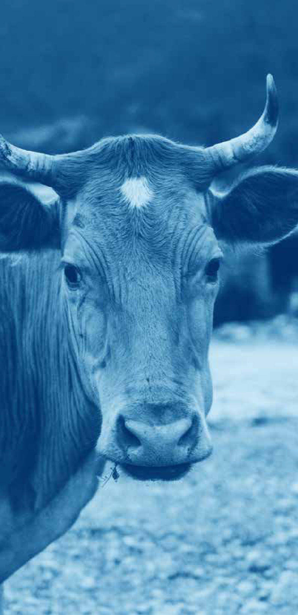
Encoura in ly, 14 companies (9%) have improved heir performance impac score by five percen a e poin s or more. The hi hes score awarded for he performance impac ques ions in 2024 was 66% compared wi h 61% in 2023.

We are s ar in o see a posi ive correla ion be ween he BBFAW Tier Rankin s and
he BBFAW Impac Ra in s. In 2024,
all companies in Tier 2 achieved an Impac Ra in of B or C, and all companies in
Tier 3 achieved an Impac Ra in of B, C or D. The Impac Ra in suppor s he
BBFAW’s overall aim o subs an ially improve
he welfare of farm animals in he lobal food sys em, and i can help inves ors and o her s akeholders o assess whe her companies are deliverin ac ual welfare
improvemen s o animals in heir opera ions and supply chains.

36%
37%
23%
23%
6%
9%
9%
16%
2022
17%
2023
18%
2024
2022
2023
11%
2024
2022
7%
2023
8%
2024
2022
2023
22%
2024
2022
38%
2023
39%
2024
2022
38%
2023
39%
2024

Pillar Analysis

The BBFAW benchmark is divided in o five pillars ha each assess a di­eren aspec of company mana emen and repor in on farm animal welfare.

Fi ure 2.2

Average Score per Pillar

Farm Animal Welfare Policy Commi men s

Farm Animal Welfare Governance & Manaemen

Farm Animal Welfare Tare s

Farm Animal Welfare Performance Impac

Reducin Reliance on Animal Sourced Foods

Overall Avera e Score

The hi hes avera e scores are achieved in he Farm Animal Welfare Policy Commi men s and Farm Animal
Welfare Governance & Mana emen pillars.
This shows ha many companies have pu in place he policy commi men s and
overnance and mana emen sys ems required o e­ec ively mana e animal welfare in heir opera ions and supply chains. Never heless, here remains scope for improvemen across all pillars, includin wi hin he Policy and Commi men s sec ion where many companies score only par ial poin s due o heir s a ed commi men s applyin only o limi ed par s of
heir opera ions and supply chains.

Pro ress is bein made on Farm Animal Welfare Performance Impac . Whils overall performance la s o her sec ions of he benchmark, we are s ar in o see policy commi men s, mana emen prac ices
and ime-bound ar e s deliverin performance impac s on he round
o farm animal welfare.
I is also encoura in o see pro ress
in he Benchmark’s newes area of focus,
he Reducin Reliance on Animal Sourced Foods pillar, where he assessmen has revealed a s ron response from some companies. Whils he avera e score is s ill rela ively low, here are encoura in si ns
ha companies are s ar in o address
his issue in heir opera ions.

In con ras o he o her pillars of he assessmen , he Farm Animal Welfare Tar e s pillar is he only pillar o see a mar inal drop in avera e score, a 22%
in 2024, down from 23% in 2023. I is no possible o say a his s a e whe her he decrease in score represen s a chan e
in companies’ posi ions on ar e s or a drop in repor in , which could be emporary.

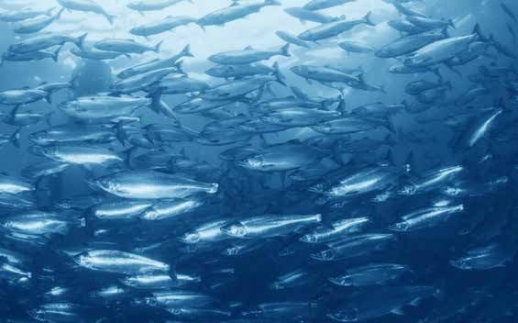
26

Sub-secor Comparison
The BBFAW benchmark companies are divided in o hree indus ry sub-sec ors: Re ailers and Wholesalers; Producers and Manufac urers; and Res auran s and Bars (see also Appendix able A1).

Fi ure 2.3

Sub-sector Comparison
42%
37%
38%
39%

46%
36%
33%
39%

22%
19%
27%
22%

10%
7%
5%
8%

9%
12%
10%
11%

21%
17%
16%
18%
3570: Food Producer
5337: Food Re ailers and Wholesalers
5757: Res auran s and Bars
Overall Averae

Farm Animal Welfare Policy Commi men

Farm Animal Welfare Governance and Manaemen

Farm Animal Welfare Tare s

Farm Animal Welfare Performance Impac

Reducin Reliance on Animal Sourced Foods

Overall Secor Score

27

Table 2.8

Sub-sector Tier Movements

Tier Ranking Movements
Retailers and Wholesalers
Producers and Manufacturers
Restaurants and Bars

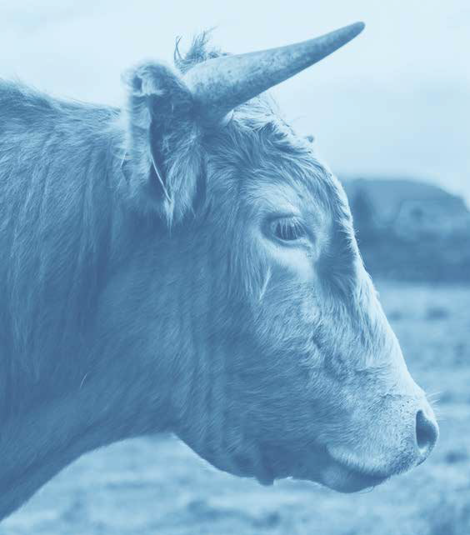+1 1 8 5
-1 2 2 0

- The Business Benchmark on Farm Animal Welfare Repor 2024

Producers and Manufac urers con inue o ou -perform he o her sub-sec ors wi h an overall avera e score of 21%, up from 19%
2023. Indeed, seven ou of he 12 companies (58%) in Tier 2 and Tier 3 are Producers
and Manufac urers. This is likely reflec ive of he closer proximi y many Producers and Manufac urers have o heir supply chains and rea er oppor uni y for moni orin and
repor in on performance. The Re ailers and Wholesalers sec or has four companies in Tier 2 and 3 (33%), and he Res auran and Bars sec or has one Tier 2 company.

21%

The overall avera e score for Producers and Manufacurers

Conversely, he Res auran s and Bars sub- sec or has he lowes overall avera e score a 16% (14% in 2023). No ably, 27 ou of a o al of 32 (84%) Res auran s and Bar companies in he Benchmark appear in Tiers 5 and
6. The Res auran s and Bars sub-sec or is o‹en he mos removed from produc ion and he lower avera e performance in his sec or likely reflec s he diœcul ies his poses in influencin produc ion prac ices and
ob ainin performance da a. However, he sub-sec or is showin some improvemen in scorin , par icularly in he Farm Animal Welfare Policy Commi men s (38% in 2024 compared wi h 35% in 2023) and Governance and Mana emen pillars (33% in 2024 compared wi h 29% in 2023).
This su es s ha Res auran s and Bar companies are focusin e­or in formalisin
heir mana emen commi men s and heir
overnance of farm animal welfare. Indeed, five of he 14 companies ha have increased
heir Tier Rankin in 2024 are Res auran s and Bars companies, includin Gre s,
ha has moved up o Tier 2 and Impac Ra in C in 2024.

- The Business Benchmark on Farm Animal Welfare Repor 2024

Geo raphical Comparison
Five eo raphical re ions are covered by he BBFAW benchmark: Asia Pacific;
Europe, excludin he UK; La in America; Nor h America; and he UK. The compara ive re ional company performance is ou lined
in Fi ure 2.4 (see also Appendix able A2).

Fi ure 2.4

Geographic Comparison
18%
43%
34%
41%
67%

20%
45%
30%
42%
69%

7%
24%
15%
18%
52%

4%
8%
2%
10%
27%

0%
16%
3%
12%
28%

9%
20%
12%
20%
41%
Asia Pacific
Europe (excl. UK)
Nor h America (USA & Canada)
La in America
UK

Farm Animal Welfare Policy Commi men

Farm Animal Welfare Governance and Manaemen

Farm Animal Welfare Tare s

Farm Animal Welfare Performance Impac

Reducin Reliance on Animal Sourced Foods

Overall Secor Score

30

UK – Hi hes performin re ion
UK companies a ain achieved he hi hes overall avera e score of all re ions, a 41%. Indeed, UK companies achieved he hi hes avera e score across all pillars of
he Benchmark.

Lookin a he UK sub-sec or scores, UK Res auran s and Bars achieved he hi hes increase in overall avera e score from 31% in
2023 o 36% in 2024. UK Food Re ailers and Wholesaler companies achieved he hi hes overall avera e score in he Farm Animal Welfare Governance and Mana emen
Pillar (81%), and in he Farm Animal Welfare Performance Impac Pillar (31%). Meanwhile, UK Res auran s and Bar companies achieved
he hi hes avera e score in he Policy Commi men s pillar a 70%, he Farm Animal Welfare Tar e s pillar a 60% and
he Animal Sourced Food pillar a 36%.

UK companies domina e he upper Tier Rankin s of he 2024 Benchmark, wi h all four Tier 2 companies and hree ou of
he ei h Tier 3 companies based in he UK. This means ha seven ou of he 12 companies (58%) in Tiers 2 and 3 are UK domiciled. The o her five companies in Tier 3 are domiciled in Asia Pacific, Europe (excludin he UK), and La in America.

Fur hermore, wo of he hree companies in Impac Ra in B are UK domiciled.
Of he 14 companies in Impac Ra in s B o D, ei h (57%) are based in he UK.

41%

The overall avera e score of UK companies

Lain America and Europe (excl. UK) – Join second-hi hes performin re ions Europe (excludin UK) and La in America are now join -second hi hes -scorin re ions wi h overall avera e scores of 20%. This reflec s
a sli h increase in scorin for La in American companies, from 18% in 2023, and no
chan e in scorin for European companies (excludin UK), from 20% in 2023. European companies (excludin he UK) were he second-hi hes performin re ion a‹er he UK on Impac Ra in , wi h hree companies (21%) achievin ra in s B o D.

Producers and Manufac urers were
he hi hes scorin sub-sec or in Europe (excludin UK) and in La in America, wi h an overall avera e score of 25% and 24% respec ively. No ably, Producers and Manufac urers in La in America saw an increase in overall avera e score from
21% in 2023 o 24% in 2024, he second- lar es increase seen his year, followin
he increase in overall avera e score achieved by Res auran s and Bars in he UK.

31 The Business Benchmark on Farm Animal Welfare Repor 2024

I is no able ha one Asia Pacific company (Fon erra) bucks his overall rend and has risen hree Impac Ra ins, from E o B, and one Tier Rankin, from Tier 4 o
Tier 3, o become one of he hihes performin companies in 2024.

Oher Geo raphical Findin s Companies domiciled in Nor h America and Asia Pacific la hose in o her re ions wi h overall avera e scores of 12% and 9%
respec ively, bo h represen in 1% increases since 2023 (from 11% and 8%). Indeed,
49 of he 50 companies (98%) in Nor h America appear in Tiers 5 and 6, su es in
ha he majori y of Nor h American companies have ye o formalise heir farm animal welfare approaches or provide up
o da e repor in on farm animal welfare.

Similarly, 19 of 21 companies (90%) in Asia Pacific appear in Tiers 5 and 6. Moreover, four ou of he nine companies (44%) ha appear no o reco nise farm animal welfare as a business issue are domiciled in his
re ion. This is perhaps indica ive of a re ion where he issue of farm animal welfare is
no as well es ablished as in o her re ions, and where farm animal welfare le isla ion is less advanced.

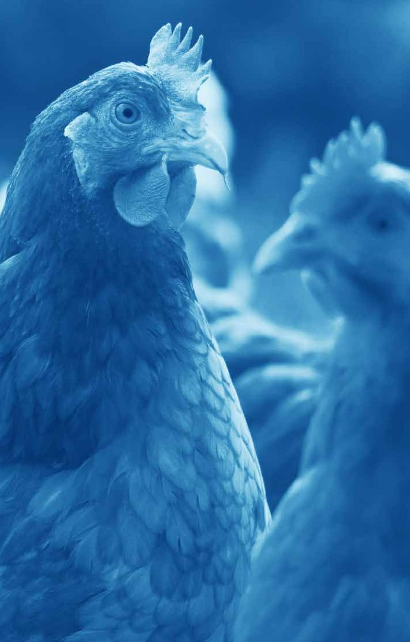
3

The 2024 Benchmark Results in Detail

Chaper 3 The 2024 Benchmark

Results in Detail

Farm Animal Welfare Policy Commitments

The 2024 Benchmark indica es ha a majori y of companies, 141 ou of he 150 companies (94%), acknowled e farm animal welfare as a business issue, and 128 companies (85%) have formal policies on farm animal welfare in place.
However, despi e he hi h propor ion of food companies publishin formal animal welfare policies, i is disappoin in o see
ha 22 companies (15%) are ye o publish formal policies on his cri ical issue. Indeed, whils 85% of companies have published an overarchin animal welfare policy,
only 36 companies (24%) have universal animal welfare policies, coverin all relevan species, all relevan eo raphies and all relevan produc s.

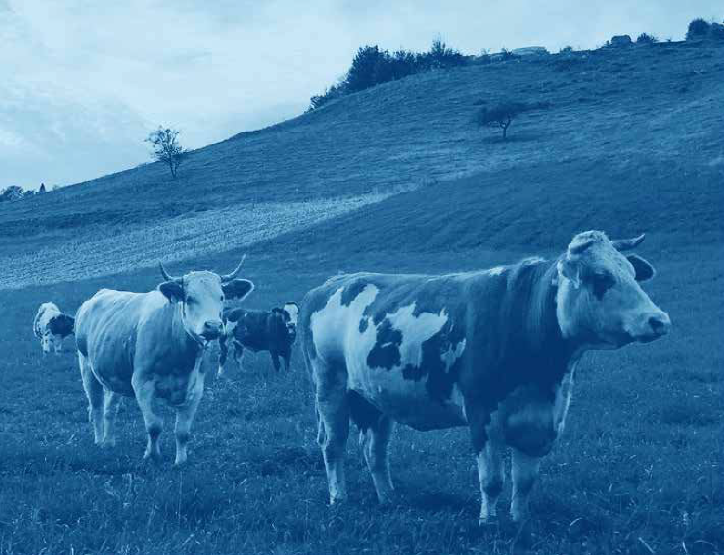
34
The Business Benchmark on Farm Animal Welfare Repor 2024

In 2024 more lobal food companies reco nise farm animals as sen ien bein s,
wi h 67 companies (45%) reco nisin farm animal sen ience as a s ron founda ion for animal welfare policies, an increase from 54 companies (36%) in 2023.

Case sudy examples

We fundamen ally unders and ha animal welfare is no a sinular issue for a sinle species, bu ra her, a se of holis ic and comprehensive principles for all sen ien animals hrouhou heir lifecycles.
Animal welfare is cen ral o our values and in eral o our business, enablin us
o mee our cus omers’ expec a ions for hih quali y, sus ainably reared lives ock and farmed fish. [...] We reconise animal

sen ience; we accep ha animals can

The Cheesecake Fac ory
experience bo h posi ive and nea ive emo ions. We ake in o accoun he Five Domains model which focuses a en ion

on hose fac ors ha ive rise o specific

We believe lives ock are sen ien crea ures and reconize he sinifican social issue of improvin animal welfare in supply chain. We emphasize he dini y of life and humane rea men of lives ock in
he supply chain as much as we respec human rih s and he environmen .
subjec ive experiences which ul ima ely con ribu es o an animals’ men al s a e.
However, we also acknowlede he
limi a ions of he Five Domains model as a welfare assessmen ool. We reconise
ha ood or accep able animal welfare canno be achieved by simply mi ia in

or avoidin nea ive experiences bu ha

Meiji Holdins
pleasurable experiences are needed as well and we will suppor and promo e
hose oppor uni ies for animals wi hin our supply chain.

Hil on Food Group

- The Business Benchmark on Farm Animal Welfare Repor 2024

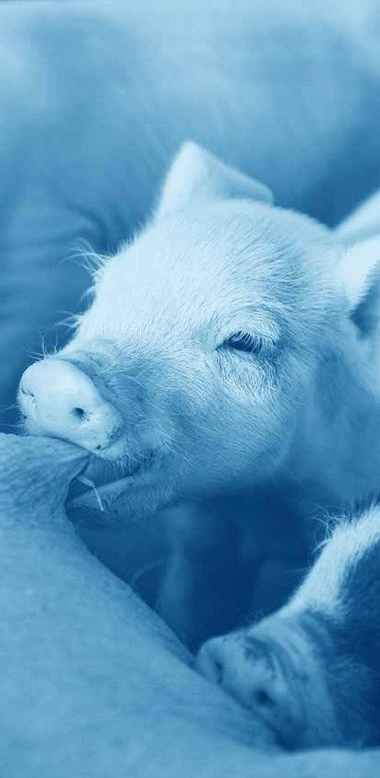
The specific welfare issues mos addressed by companies include endin he use of close confinemen and ensurin he use of humane me hods of pre-slau h er s unnin , wi h
77% (82% in 2023) and 56% (55% in 2023)
of companies respec ively havin par ial or universal policy commi men s in place o address hese issues. This reflec s he rea er level of awareness of he impac of close confinemen produc ion sys ems, such as
ca es for layin hens and es a ion cra es for sows, on he welfare of farm animals. These produc ion sys ems have been he focus of public and corpora e campai ns from animal welfare NGOs for many years.

As in previous years, he 2024 Benchmark resul s show ha over 90% of company commi men s addressin specific welfare issues (wi h he excep ion of commi men s on foie
ras) are limi ed in scope o specified species,
eo raphies and/or produc s. This reflec s di­erences in he drivers and oppor uni ies for addressin species-specific issues, wi h NGO and civil socie y pressure havin lar ely been focused on layin hens and broiler chickens in recen years, and availabili y of al erna ive,
hi her welfare supply chains varyin in di­eren re ions. For example, he barriers o adop in ca e-free supply chains in Germany, where over 95% of e produc ion is now ca e-free and he use of ca es for layin hens will be comple ely prohibi ed in January 2026, are very di­eren o Brazil, where 95% of na ional produc ion is from barren ba ery ca e sys ems.

- The Business Benchmark on Farm Animal Welfare Repor 2024

Fi ure 3.10

Companies with partial or universal policies addressing specific farm animal welfare issues

Close confinemen

Species-specific enrichmen

Rou ine mu ila ions

Prophylac ic and
rou ine me aphylac ic an ibio ic use

Lon-dis ance live
ranspor

Pre-slauh er s unnin

Foie Gras

O her inhumane prac ices
2024

2023

2024

2023

2024

2023

2024

2023

2024

2023

2024

2023

2024

2023

2024

2023
77%
82%

50%
49%

50%
48%

42%
40%

32%
33%

56%
55%

14%
6%

24%
20%

N.B. The ques ion on foie ras only applies o he 83 companies wi h ducks or eese in heir supply chain.

- The Business Benchmark on Farm Animal Welfare Repor 2024

In 2022, BBFAW s ar ed assessin companies’ posi ions on addi ional key welfare issues no covered by he
lon -s andin cross-species ques ions. The addi ional issues assessed are
rouped under he headin of ‘o her inhumane prac ices’ (Ques ion 12) and are:

  - The cullin of day-old male chicks in e supply chains;

  - Cow-calf separa ion in dairy and beef supply chains;

  - Fully sla ed floorin for pis, dairy and beef ca le, and ducks;

  - Live pluckin or live harves in for eese.
In 2024, here is encoura in pro ress o be seen on hese issues. In o al, 36 companies (24%) have made commi men s o endin one or more of hese prac ices, a rise from 30 companies (20%) in 2023. No ably, 23 companies (15%) have commi ed o endin
he cullin of day-old male chicks, compared
o 18 companies (12%) in 2023. Male chick cullin is performed because he male chicks from layin hen breeds are no needed wi hin e -layin supply chains and do no row suœcien ly fas for eœcien mea produc ion.

Company commi men s on his issue
have been driven bo h by he in roduc ion of na ional bans on he cullin of day-old male chicks in several EU Member S a es such as Germany (2022) and France (2023), and also
echnolo ical advancemen . For ins ance, in-ovo sexin echniques are now in use
a ha cheries in Europe and Nor h America, makin i possible o iden ify male chicks early in incuba ion and o remove hem before ha chin .

- ¹ www. c-animalwelfare.or /wp-con en /uploads/2024/02/GCAW-Knowled e-Share-Ca e-Free-E s-Global- Landscape-Review-Execu ive-Summary.pdf.

The 2024 Benchmark resul s indica e ha mos companies publishin mana emen commi men s on specific welfare issues con inue o score only par ial poin s due
o heir policies bein limi ed o specified species, eo raphies or produc s.


Fi ure 3.2
Q4 Commitment to avoid close confinement
23% No addressed.
75% produc s or eo raphies.
Limi ed o cer ain species,
3%
Universal across all relevan species, produc s and eo raphies.
Fi ure 3.3
Q5 Commitment to environmental enrichment
50% No addressed.
47% produc s or eo raphies.
Limi ed o cer ain species,
3%
Universal across all relevan species, produc s and eo raphies.
Fi ure 3.4
Q6 Commitment to ending the use of routine mutilations
50% No addressed.
49% produc s or eo raphies.
Limi ed o cer ain species,
1%
Universal across all relevan species, produc s and eo raphies.


Fi ure 3.5
Q7 Commitment to ending the prophylactic and routine metaphylactic use of antibiotics
58% No addressed.
33% produc s or eo raphies.
Limi ed o cer ain species,
9%
Universal across all relevan species, produc s and eo raphies.

Fi ure 3.6
Q8 Commitment to ending long distance live transport
68% No addressed.
29% produc s or eo raphies.
Limi ed o cer ain species,
3%
Universal across all relevan species, produc s and eo raphies.
Fi ure 3.7
Q9 Commitment to humane forms of pre-slaughter stunning
44% No addressed.
54% produc s or eo raphies.
Limi ed o cer ain species,
2%
Universal across all relevan species, produc s and eo raphies.


Fi ure 3.8
Q11 Commitment to not produce or sell foie gras or meat from birds reared for foie gras
86% No addressed.
14% produc s or eo raphies.
Limi ed o cer ain species,
0%
Universal across all relevan species, produc s and eo raphies.

Fi ure 3.9
Q12 Commitment to ending the use of other inhumane practices
76% No addressed.
23% produc s or eo raphies.
Limi ed o cer ain species,
1%
Universal across all relevan species, produc s and eo raphies.

Q10 Commitment to ending the use of breeds with low welfare potential

74%

No addressed.

Limi ed o cer ain species, produc s or eo raphies.
26%

Universal across all relevan species, produc s and eo raphies.
0%

In he 2024 Benchmark, we assessed companies on heir commi men s o endin
he use of breeds wi h low welfare po en ial for he firs ime, coverin broiler chickens,
improved welfare ou comes or a slower
row h po en ial, defined as <40 /d avera ed over he row h cycle accordin
o he breedin company specifica ion.

pi s and beef ca le ( his ques ion was

applicable o 139 companies wi h hese species in heir supply chains). The welfare of farmed animals is no only influenced
Pi s
End he use of sows wi h an avera e
>16 pi le s liveborn per li er.

by mana emen prac ices and he inpu s

provided o hem, bu also by ene ic
selec ion. For example, some breeds selec ed for hi h row h ra e and lean mea deposi ion can su­er a ran e of physiolo ical and
me abolic heal h issues, as well as poor immuni y and le har y and poor behavioural expression. The choice of breed or s rain
of animals used in lives ock produc ion can herefore have a si nifican impac on
animal welfare. Given his is a new ques ion, poin s from his ques ion have no been included in overall scores for 2024 bu will be incorpora ed in scores in fu ure assessmen s.

The specific requiremens by species are as follows:
Beef cale
End he use of double-muscled breeds (e. . Bel ian Blue and Piedmon ese).

The 2024 baseline da a show ha 36 ou of 130 (28%) companies wi h beef, chicken and pork in heir supply chains have made commi men s o end he use of breeds
wi h lower welfare po en ial. The majori y of
hese commi men s focus on broiler chickens, wi h 32 companies (21%) havin made
commi men s ha apply o a leas par of
heir chicken supply chains, predomina ely driven by his bein one of he requiremen s of he Be er Chicken Commi men /European Chicken Commi men . Five companies (3%)

have made commi men s o end he use of

Broiler chickens
End he use of breeds ha do no mee
he Be er Chicken Commi men /European Chicken Commi men requiremen s for
double-muscled breeds in beef supply chains bu only one company (1%) has made a commi men o end he use of sows wi h
an avera e >16 pi le s liveborn per li er.

Case sudy examples

Q10 Does the company have a clear commitment to ending the use of breeds with low welfare potential?

The followin welfare s a emen s include
he minimum s andards required for lives ock reared o produce mea and poul ry produc s supplied o Mi chells &
Bu lers [...] Welfare s a emen s rela in o
he produc ion of beef ca le: Mi chells & Bu lers prohibi he use of double- muscled breeds (e.. Belian Blue
and Piedmon ese) in pure-bred and cross-bred form.
By 2026, we will require our suppliers o mee he followin requiremen s for 100% of our fresh, frozen and inredien chicken mea , includin ambien , in our supply chain [...] Comply wi h all EU animal welfare laws and reula ions, reardless
of he coun ry of produc ion; Adop breeds ha demons ra e hiher welfare ou comes: Hubbard JA757, 787, 957 or 987, Rambler Raner, Raner Classic,

Raner Gold, Redbro or o hers ha mee

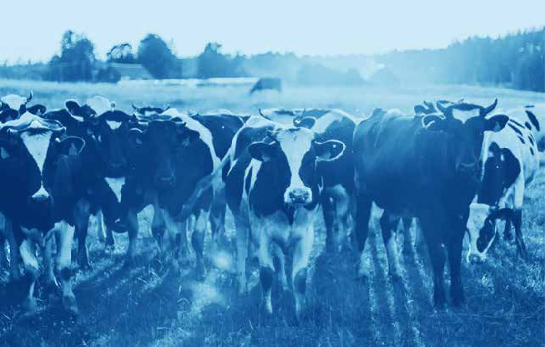Mi chell & Bu lers PLC
he cri eria of he RSPCA broiler breed assessmen pro ocol.

Wai rose

Farm Animal Welfare Governance and Management

Farm Animal Welfare Governance and
44
Mana emen , alon side Policy Commi men s, con inues o be he hi hes scorin pillar
in he 2024 Benchmark. The avera e score has shown a s eady upward rend, increasin from 37% in 2022, o 38% in 2023 and 39% in 2024. This reflec s a rowin propor ion
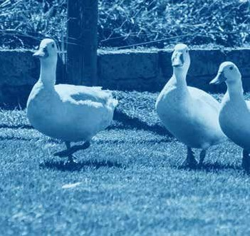of companies wi h es ablished mana emen sys ems and processes in place for mana in farm animal welfare.

Whils inpu measures are criical, such as he avoidance of ca ed producions sysems and he provision of environmenal enrichmen, i is also imporan o have in place moniorin of welfare oucomes o ensure he desired posiive impacs on welfare benefis and improvemens are
bein seen.
Improvemen can be seen in he number
of companies assi nin day- o-day and board or senior mana emen responsibili y for farm animal welfare, which is an essen ial elemen for e­ec ive implemen a ion of policies.
In he 2024 benchmark, 88 companies (59%) repor board or senior mana emen oversi h of farm animal welfare compared
o 81 companies (54%) in 2023. Meanwhile,
83 companies (55%) repor ed assi nin day- o-day mana emen responsibili y for farm animal welfare, which is a sli h
decrease on he 56% of companies in 2023. The propor ion of companies repor in on bo h senior mana emen oversi h and opera ional responsibili y rose mar inally
in 2024, wi h 70 companies (47%) scorin maximum poin s for bo h ques ion par s (compared o 45% in 2023).

Sli h ly more companies provide informa ion on how hey use welfare ou come measures
o inform con inuous improvemen in heir supply chains, or repor on welfare ou come measure da a from heir supply chain.
In he 2024 benchmark, 45 companies (30%) describe heir use of welfare ou come measures and 42 companies (28%) repor da a on indica ors such as mor ali y ra es, lameness, e­ec iveness of pre-slau h er
s unnin , and he expression of posi ive behaviours such as dus -ba hin .

The number of companies audi in heir produc s o ei her basic or hi her farm assurance s andards has also increased. In 2024, 88 companies (59%) repor ed
ha a subs an ial propor ion of produc s conform o basic or hi her welfare assurance schemes across cer ain species and eo raphies, compared
wi h 85 companies (57%) in 2023.
Meanwhile, year-on-year findin s for o her
overnance and mana emen cri eria are rela ively unchan ed or showin mar inal declines. For example, on companies
repor in on employee rainin and supplier mana emen . Here, 77 companies (51%, compared wi h 52% in 2023) describe heir provision of employee rainin on animal welfare in 2024, and 77 companies (51%, compared wi h 53% in 2023) describe he ac ions aken in he even of non-compliance wi h heir farm animal welfare policies.
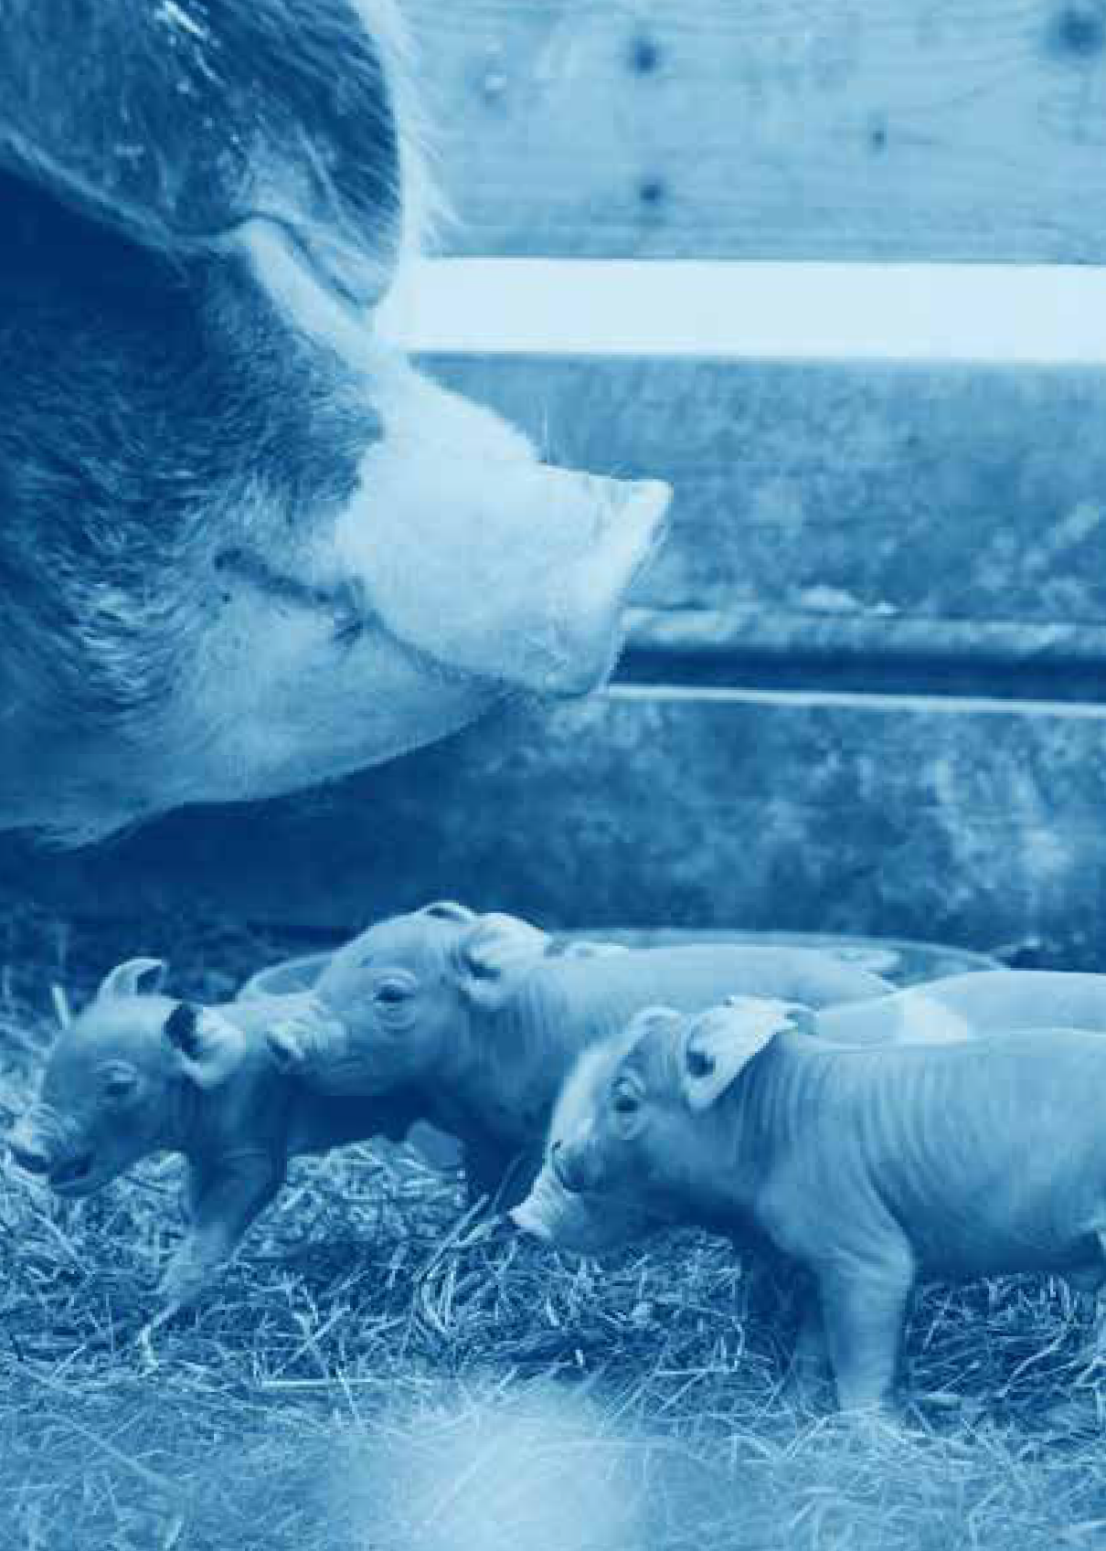
Fur her, 77 companies (51%, compared wi h 53% in 2023) describe how hey provide educa ion and suppor o suppliers and
86 companies (57%, compared wi h 59% in 2023) include farm animal welfare in supplier con rac s, wi h around half of hese
companies only doin so for specific species,
eo raphies or produc s (40 companies, or 47% of hose ha include farm animal welfare in supplier con rac s).

Farm Animal Welfare Targets

Over he pas decade, we have seen
Lookin a he species-specific
ar es in more deail:

Layin hen welfare
99 of he 140 companies wi h e s in
heir supply chains (70% compared wi h 73% in 2023) publish a ime-bound
ar e or provide evidence of havin achieved 100% of e s from ca e- free sources.

Broiler chicken welfare
40 of he 134 companies ha have broiler chickens in heir supply chain (30% compared wi h 31% in 2023) have se a ime-bound ar e o achieve
he requiremen s for he Be er Chicken Commi men /European Chicken Commi men .

Dairy cow welfare
31 of he 142 companies (22% compared wi h 18% in 2023) ha have dairy cows in heir supply chain in have published
ime-bound ar e s o elimina e he use of e herin or have provided
evidence ha hey have achieved 100% zero e herin .

Pi welfare
Only 13 of he 137 companies wi h pi s in heir supply chains (9%, compared wi h 10% in 2023) have published
ime-bound ar e s o end he use of es a ion/sow s alls and farrowin cra es for sows.
si nifican indus ry movemen s of hundreds of companies commi in o ime-bound ar e s for specific animal welfare improvemen s.
In con ras o he s eady pro ress seen in
he o her pillars, he avera e score for he Farm Animal Welfare Tar e s pillar is broadly unchan ed in 2024, a 22% compared
wi h 23% in 2023. I is no possible o say a his s a e whe her he decrease in score
represen s a chan e in companies’ posi ions on ar e s or a drop in repor in , which could be emporary. None heless, companies will likely come under increased scru iny on animal welfare ar e s from NGOs and civil socie y his year, as 2025 is he deadline se by many companies for achievin ca e-free e commi men s.

Farm Animal Welfare Performance Impact

There are early si ns of companies respondin o he new Farm Animal Welfare Performance Impac cri eria in roduced
in 2022. Encoura in ly, all 11 of he new species-specific cri eria in roduced in 2022 have seen an increase in company scorin
his year. This indica es ha more companies are in roducin he required moni orin
and repor in processes o enable disclosure on hese prac ices across a leas some
of heir supply chains and opera ions (see Fi ure 3.10).

Fi ure 3.10

Proportion of companies reporting on species-specific performance measures introduced in 2022

Species New Species-specific performance measures 2024 2023

Layin Hens Broiler Chickens Pis

Dairy Ca le
Day-old male chicks no killed
Humane s unnin
Sows free from farrowin cra es Provided wi h pas ure access Free from disbuddin/dehornin
Free from confinemen in CAFOs or feedlo s Group housed as calves, hrouhou rearin Free from disbuddin/dehornin
Reared a lower s ockin densi ies
Free from fas in las in loner han 72 hours E“ec ively s unned and killed
9%*
30%
16%
16%
8%
16%
10%
11%
13%
11%
23%
9%
28%
14%
15%
6%
13%
9%
7%
11%
5%
18%
*Al hou h he percen a e remains he same, one addi ional company repor ed on he propor ion of day-old male chicks in i s supply chain ha are no killed in 2024, compared o 2023.
The Business Benchmark on Farm Animal Welfare Repor 2024

Beef Ca le

Salmon

47

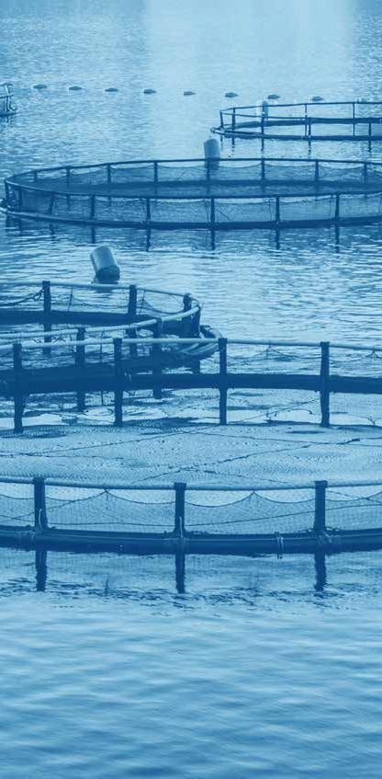
In o al, 109 companies (73% in 2024 and 2023) provide some performance repor in da a across heir lobal supply chain in 2024, and he avera e score has increased o 8% from 7% in 2023 and 6% in 2022.

This pillar is he mos challen in for businesses as i requires repor in species- specific welfare impac da a across lobal supply chains. I is herefore encoura in
o see a radual increase in repor in from companies. None heless, he rela ively low avera e score for his pillar of he assessmen indica es ha more needs o be done by many companies o moni or and repor on key welfare risks in heir supply chains.

48 The Business Benchmark on Farm Animal Welfare Repor 2024

Fi ure 3.11

Proportion of companies reporting on species-specific performance measures

Cae-free

Free from beak rimmin/ ippin
Layin Hens

Day-old male chicks are no killed

Reared a lower s ockin densi ies

Slow rowin breeds
Broiler Chickens

Humane s unnin

Sows free from es a ion/sow s alls

Sows free from farrowin cra es
Pis

Free from ail dockin

No e hered

Provided wi h pas ure access
Dairy Cows

Free from disbuddin/dehornin

Free from confinemen in CAFOs or feedlo s

Group housed as calves,
Beef Ca le
hrouhou rearin

Free from disbuddin/dehornin

Reared a lower s ockin densi ies
Farmed Salmon

Free from fas in las in loner
han 72 hours

E“ec ively s unned and killed

Pre-slauh er s unnin
All Species

Transpor ed wi hin specified maximum journey imes
2024
2023

2024
2023

2024
2023

2024
2023

2024
2023

2024
2023

2024
2023

2024
2023

2024
2023

2024
2023

2024
2023

2024
2023

2024
2023

2024
2023

2024
2023

2024
2023

2024
2023

2024
2023

2024
2023

2024
2023
67%
67%
12%
12%
9%
9%
31%
28%
19%
20%
30%
28%
12%
9%
16%
14%
15%
16%
25%
22%
16%
15%
8%
6%
16%
13%
10%
9%
11%
7%
13%
11%
11%
5%
23%
18%
32%
33%
23%
27%

The impac measure mos repor ed on by companies remains he propor ion of layin hens ha is ca e-free. Here, 94 of he 140 companies (67% in 2024 and in 2023) wi h layin hens in heir supply chains publish impac da a (67%).

89% 63%

of companies awarded poins for
havin a ime-bound ar e, or evidence of achievemen, for endin he use
of ca es for layin hens are reporin on pro ress.
wih a ime-bound ar e o achieve
he requiremens for he Beer Chicken Commimen/European Chicken Commimen have repored on
pro ress on lower sockin densiies.

The nex mos repor ed on species-specific measures rela e o broiler chickens:

- 41 of he 134 companies (31% compared wi h 28% in 2023) repor on he propor ion of broiler chickens reared a lower s ockin densi ies
- 40 of he 134 companies (30% compared wi h 28% in 2023) repor on
he propor ion of broiler chickens subjec
o con rolled a mosphere s unnin or elec rical s unnin wi hou live inversion

Repor in on performance impac da a for o her species is less well pro ressed. For ins ance, only 16 of he 137 companies wi h pi s in heir supply chain (12%) repor
51
on he propor ion of sows free from es a ion cra es/sow s alls, and only 12 of he 142 companies wi h dairy cows in heir supply chain (8%) repor on he propor ion of
dairy ca le ha is free from disbuddin or dehornin .
I is encoura in ha more companies are repor in hey have made si nifican pro ress on priori y issues. In par icular, he number
of companies repor in more han 60% pro ress on specific issues has increased on he issues of:

- Cae-free layin hens (33 companies in 2024, up from 28 in 2023)

- Layin hens free from beak rimmin or ippin (five companies in 2024, up from zero in 2023)

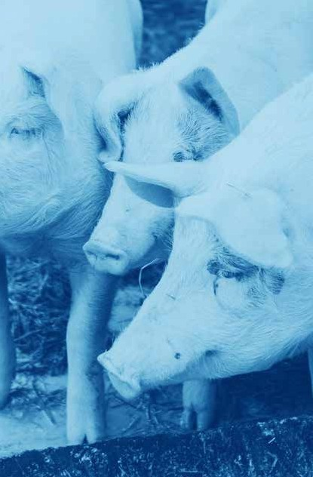
- Use of broiler chicken breeds wi h improved welfare ou comes or wi h a slower row h po en ial (6 companies in 2024, up from zero in 2023)

- Beef ca le roup housed as calves,
hrouhou rearin (11 companies in 2024, up from 5 in 2023)

Fi ure 3.12

BBFAW 2024 Impact Ratings

Impac Rain Company

A  >80% | These companies are declarin improved welfare impac s for a reasonable propor ion of farm animals
B  62-80% | in heir opera ions and/or supply chains. | Fon erra ↑↑↑ . Marks & Spencer PLC ↑ . Premier Foods PLC ↑
C These companies are declarin improved welfare  44-61% impac s for a leas some  farm animals in heir opera ions |  | Gres PLC ↑ . Groupe Danone SA . Miros-Genossenscha°s-Bund . Wai rose
D  27-43% | and/or supply chains. | Co-op UK . Cranswick PLC ↓ . Danish Crown AmbA ↑ . J Sainsbury PLC . Marfri Global Foods SA ↑ . Minerva Foods ↑ . Noble Foods
E  11-26% | These companies have ye o demons ra e ha  hey are deliverin improved welfare impac s for farm  animals in heir opera ions | Arla Foods L d ↑ . Barilla SpA . BRF SA . Coop Group (Swi zerland)/Coop Genossenscha° ↑ . Groupe Lac alis . Hershey Co . Hil on Food Group ↑ Les Mousque aires . Maple Leaf Foods ↑ . Terrena Group ↑ . Tesco PLC ↓ .  The Cheesecake Fac ory . Whi bread PLC ↑ . Wm Morrison Supermarke s PLC ↑
F  <11% | and/or supply chains. | (The) Kroer Company . 2 Sis ers Food Group (Boparan Holdins L d) . Aeon Group  . Aro Super . Ahold Delhaize . Alber sons . ALDI Einkauf SE & Co. oHG (ALDI Nord)  . ALDI SOUTH Group . Alimen a ion Couche-Tard . Amazon/Whole Foods Marke . Aramark Corpora ion . Avol a AG (previously Au orill) . Beijin Dabeinon Technoloy Group Co., L d. . Bellis Topco L d./Asda . Bimbo . BJ’s Wholesale Club Holdins  . Bloomin’ Brands Inc . C&S Wholesale . Campbell Soup Company . Cams – La Ris orazione I aliana Soc. Coop. ARL . Carill . Carrefour SA . Casino Guichard-  Perrachon SA . Cencosud . Charoen Pokphand Foods . Chick-fil-A . China Resources Vanuard . China Yurun Group Limi ed . Chipo le Mexican Grill . CKE Res auran s  . Coles Group . Colruy . Compass Group PLC . Conad Consorzio Nazionale . ConAra . Cooke Seafood Inc . Coop I alia . Coopera iva Cen ral Aurora Alimen os . Coopéra ive U Enseine ↓ . Cooperl Arc A lan ique . Cos co Wholesale Corpora ion  . Cracker Barrel . Cremonini SpA . Dairy Farmers of America . Darden Res auran s PLC . Dico’s/Tin Hsin In erna ional Group . Dino Polska SA . Domino’s Pizza Inc  . E.Leclerc . EDEKA Group . Elior Group . Elo Group . Empire Company/Sobey’s . Ferrero Group . Ga eroup Holdin AG . General Mills Inc . Gruppo Veronesi . H E Bu Company . Habib’s . Hormel Foods Corpora ion . ICA Gruppen AB . IKEA (In er  IKEA Group) . Indus rias Bachoco . JAB Holdin Company . JBS SA . JD We herspoon PLC . Jeronimo Mar ins . Kerry Group . Kra° Heinz Company . LDC Groupe . Lianhua Supermarke Holdins Co . Loblaw Companies Limi ed . Mars Inc . Maruha Nichiro . McDonald’s Corpora ion . Meiji Holdins . Mercadona SA . METRO AG . Me ro Inc .  Mi chells & Bu lers PLC . Mondelēz In erna ional . Mowi ASA . Müller UTM . Nes lé SA . New Hope Liuhe Co L d . Nippon Ham . OSI Group . Papa John’s Pizza . Perdue Farms  . Plukon Food Group . Publix Super Marke s Inc . Res auran Brands In erna ional . REWE Group . Roark Capi al (Inspire Brands, Subway e al.) . Royal FrieslandCampina  ↓ . Sapu o Inc . Schwarz Gruppe . Seaboard Corp . Seven & i Holdins . Sodexo . Spar Holdin AG . SSP Group . S arbucks Corpora ion . Sysco Corpora ion . Tare Corpora ion . Tönnies Group . Tyson Foods Inc . UNFI . Unilever NV ↓ . US Foods  . Vion Food Group . Walmar Inc . Wayne-Sanderson Farms . Wendy’s Company (The) . Wens Foods u“ Group . WH Group L d . Woolwor hs Limi ed ↓ . Yili Group . Yonhui Supers ores Co L d . Yum China Holdins . Yum! Brands Inc . Zhonpin Inc (Huayu Holdins)

Case sudy examples

Q36 What proportion of sows (for fresh/ frozen pork products and ingredients) in the company’s global supply chain is free from gestation crates /sow stalls?

In 2023 over 96% of he o al pork processed from our lobal supply chain was sourced from farms where sows are no confined a all durin he es a ion period. This is a 6% increase from 2020 which hihlih s he work we are doin o promo e non-confinemen [...]
Cranswick closely work wi h all our lobal suppliers and we are commi ed o endin confinemen hrouh all species across all
eoraphies. 100% of our suppliers ha do no use es a ion cra es only confine
he sow for a maximum of 4 hours durin
he insemina ion period.
Q41 What proportion of dairy cows
(for fresh/frozen milk and milk products and ingredients) in the company’s global supply chain is free from disbudding/dehorning?

A leas 32.6% of all dairy ca le are free from rou ine surical in erven ions
(disbuddin and dehornin). For he dairy ca le providin milk, cream, and dairy produc s his is 33.6%.

Gres PLC

Q43 What proportion of beef cattle (for fresh/frozen beef products and ingredients) in the company’s global supply chain is group housed as calves,

throughout rearing?
Cranswick

Mos beef produc s ha we purchase are in he form of beef fa and beef
s ock. All our beef produc s are sourced from he UK & EU. Beef ela ine is now purchased 100% from he EU. 19% of beef is from he UK and 81% from he EU. 82% of beef ca le are roup housed
hrouhou rearin. Premier Foods PLC

- The Business Benchmark on Farm Animal Welfare Repor 2024

Q47 What proportion of farmed salmon (for fresh/frozen salmon products
and ingredients) in the company’s global supply chain is stun-killed using percussion or electrocution or is pre- slaughter stunned using e ective percussion or electrocution followed up by a kill method before recovery
of consciousness?

De ailed commi men s and proress on species... Farmed fish (Salmon, seabass, seabream and Trou ) [in] 2023: 91%
of farmed fishes were pre-s unned elec rically (excluded rou ).
Q48 What proportion of animals (excluding fin fish) in the company’s global supply chain is transported within specified maximum journey times? (Less than 4 hours for poultry and rabbits, and less than 8 hours
for other species.)

In 2023, i was found ha a leas 88% of he animals involved in our value chain were ranspor ed wi hin he specified
maximum ravel imes: 4 hours for poul ry and 8 hours for o her species. I should

be s ressed ha Marfri does no carry

Groupe Danone
ou mari ime ranspor , all our opera ions bein performed by land rou es.

Marfri Global Foods SA

- The Business Benchmark on Farm Animal Welfare Repor 2024

Reducing Reliance on Animal Sourced Foods

Socie y’s dependence on in ensive animal
a ricul ure is no only de rimen al for animal welfare, bu is a major driver of he lobal clima e, na ure and heal h crises. A ransi ion
o hi her welfare produc ion for all animals used for food requires a reduc ion in he numbers of lives ock produced if animals are o be farmed sus ainably and wi hin plane ary boundaries.
The hi hes score achieved in his pillar in 2024 is 85% and 11 companies scored
more han 50% (comprisin four Re ailers and Wholesalers, four Producers and Manufac urers, and hree Res auran s and Bars). Of hese, five companies were
domiciled in he UK, four were domiciled in Europe (excludin he UK), and one company each was domiciled in La in America and Nor h America. Indeed, UK companies

lead he way on his pillar wi h an avera e
score of 28%, whereas he Asia Pacific

85%
The hi hes scores achieved by wo companies - Hilon Food Group and Wairose - on he Reducin Reliance on Animal Sourced Foods pillar.

re ion scored he lowes (0.4%). This rend con inues in he sub-sec or analysis, wi h UK res auran s and bars scorin hi hes in he sec ion wi h an avera e score of 36%.

This shows ha some companies reco nise
he need o address and repor on his issue. Moreover, he hi h scores from some companies in his pillar indica e ha he

cri eria are achievable across all sub-sec ors.

The Animal Sourced Foods pillar enables inves ors and o her s akeholders o be er assess whe her and how companies are approachin his issue.

The avera e score across he Reducin Reliance on Animal Sourced Foods pillar is 11%, reflec in he imma uri y of his issue in company repor in . However,
i is encoura in he avera e score has increased from 9% in 2023.

Policy Commimens
Ou of he 150 companies in he Benchmark, 43 companies (29%, compared wi h 25%
in 2023) acknowled e he need o reduce reliance on animal sourced foods as a business issue. However, only 16 companies (11%, compared wi h 13% in 2023) have published formal policies on he need o reduce reliance on animal sourced foods, ei her as par of heir broader sus ainabili y policies or heir animal welfare policies.

Governance and Mana emen
The 2024 benchmark indica es ha many companies are ye o formalise heir in ernal
overnance and mana emen processes around heir commi men s o reducin reliance on animal-sourced foods. Jus 11 companies (7%, vs. 6% in 2023) repor ed on heir day- o-day mana emen and 12 companies (8%, vs. 6% in 2023) repor ed
on senior mana emen oversi h of company commi men s o reducin reliance on animal- sourced foods. Twen y-five companies (17% in 2024 and 2023) ave a leas one example of communica in o cus omers on reducin reliance on animal-sourced foods hrou h educa ion and/or awareness-raisin ac ivi ies. Six een companies (11%) repor ed mul iple examples of communica in o cus omers
(19 companies and 13% in 2023). Mos of hese communica ions are focused on
communica in o consumers on al erna ive pro eins and plan -based produc s.
Tar es
Approxima ely half of he companies ha have reco nised reducin reliance on animal sourced foods as a relevan business issue have se ar e s o address his issue. Twen y-
wo companies ou of 150 (15% compared
o 14% in 2023) have se ar e s o reduce reliance on animal-sourced foods in 2023. Two of hese companies have published universal ar e s o reduce reliance on animal-sourced foods across all eo raphies and business divisions. Here here is a
s ron re ional di­erence wi h 13 (59%) of
hese companies bein domiciled in Europe (excludin UK) and seven (32%) domiciled in he UK. However, wo companies – one
domiciled in La in America and one in Nor h America – have also published ime-bound
ar e s for reducin reliance on animal sourced foods.

Performance reporin
Whils here are rela ively few companies se in ar e s for reducin reliance on
animal-sourced foods, i is encoura in ha a majori y of companies wi h ar e s are also repor in on pro ress a ains hem. Six een companies of he 22 companies wi h ar e s (73% of he companies wi h ar e s) repor pro ress owards heir ar e s for reducin reliance on animal-sourced foods, no ably, all pro ress repor in a ains ar e s is
par ial in scope, bein limi ed by eo raphy, produc s or species.

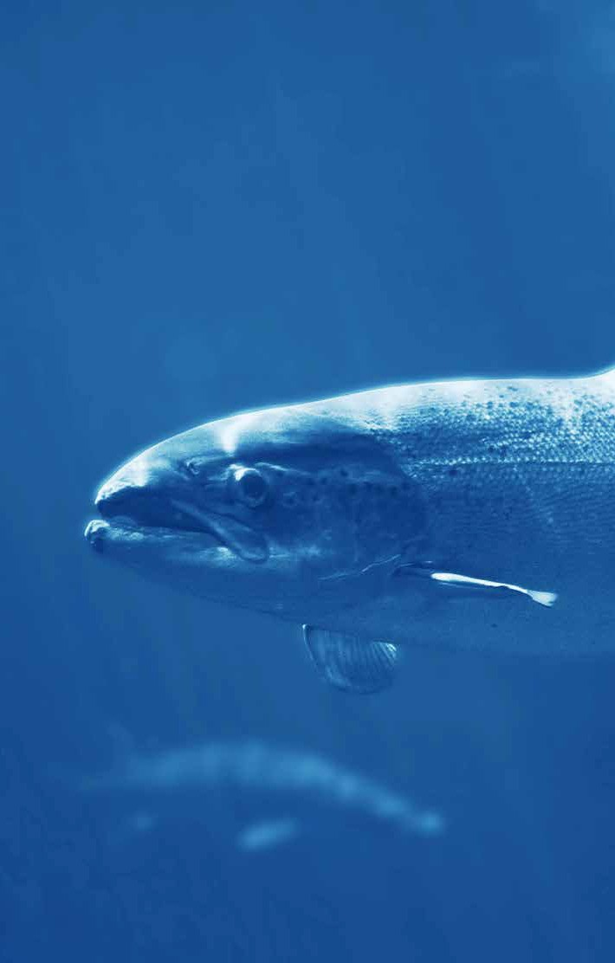
4

Accelerating Impact

Chaper 4 Accelerating Impact

In 2022, the BBFAW underwent substantial revisions to align with rising stakeholder expectations of food companies and the urgent need to accelerate the delivery of welfare benefits for farm animals across global operations and supply chains. While improving animal welfare requires focused management attention, strong governance, and collaboration between companies and their suppliers, customers and consumers, companies must also balance managing these commitments alongside other sustainability priorities, such as transitioning to a low carbon economy, conserving natural resources, and addressing biodiversity loss.
Consequently, advancements in animal rearing, transportation, and slaughter practices must be considered alongside broader issues a ecting human and planetary health.

The 2024 BBFAW assessmen reinforces
ha animal welfare remains a key business priori y for a majori y of food companies.
I also hi hli h s pro ress by companies in formalisin heir mana emen and repor in of animal welfare. Encoura in ly, indica ors su es ha companies remain en a ed
wi h he benchmark and are commi ed o incremen ally improvin heir performance over ime. For ins ance, 62 companies (41%) reviewed heir 2024 preliminary assessmen s, compared o 48 companies (32%) in 2023. Fur her, many companies con inue o reques mee in s wi h he BBFAW secre aria and
wi h he Food Business Team a Compassion in World Farmin o unders and how hey
mi h improve he welfare of farm animal in
heir opera ions and supply, and subsequen ly
heir scorin in he benchmark. The 2024 benchmark hi hli h s hree principal challen es for companies.

The firs , and mos s rai h forward o address, is ensurin accura e repor in of
heir farm animal welfare commi men s and performance and ensure annual upda es.

The second challen e is he ime required for companies o unders and and respond
o he revised cri eria. I ypically akes wo or hree benchmark cycles for companies o familiarise hemselves wi h he requiremen s and adjus heir mana emen processes and public repor in accordin ly.

The hird challen e involves demons ra in
he an ible impac of heir farm animal welfare policies and commi men s. While
he baseline s udy shows ha wo- hirds of companies repor a leas some performance da a, fur her improvemen s are needed.
Companies are encoura ed o expand he scope of heir repor in o cover a broader ran e of species, eo raphies, and produc s.

The revised BBFAW framework provides companies wi h clear uidance on s ruc urin
heir mana emen processes and repor in .
I also helps hem ali n wi h he expec a ions of key s akeholders, includin inves ors,
cus omers and consumers.

Company en a emen wih he BBFAW
The 2024 company assessmen repor s o­er
ailored recommenda ions o help companies s ren hen heir mana emen approaches and impac repor in . Addi ionally, he annual BBFAW repor provides valuable insi h s
in o how companies perform rela ive o heir indus ry peers, helpin senior mana emen assess overall pro ress and build a s ron er in ernal case for inves men and ac ion.

Beyond he annual company assessmen s and repor s, companies are encoura ed
o en a e wi h he pro ramme for deeper insi h on heir performance. The Food Business Team a Compassion in World Farmin o­ers suppor and advice o companies lookin o enhance heir
farm animal welfare performance and benchmark rankin s. Fur her, he BBFAW Secre aria works wi h food businesses o improve heir unders andin and ali nmen wi h he BBFAW me hodolo y and assessmen cri eria.

Given he subs an ial chan es o he BBFAW cri eria and scorin , i is par icularly impor an for companies o unders and he nuances of he benchmark and how heir
publicly available informa ion will be assessed a ains he revised s andards.

Invesor en a emen in he BBFAW Havin es ablished he firs ever Global Inves or S a emen on Farm Animal Welfare
and he BBFAW Global Inves or Collabora ion on Farm Animal Welfare in 2015, hese
pro rammes are now suppor ed by 31
ins i u ional inves ors wi h over £1.9 rillion in asse s under mana emen . In July 2024,
inves ors in he BBFAW Inves or Collabora ion wro e ailored le ers o he CEOs of all 150 companies covered by he BBFAW o si nal
heir suppor of he revised BBFAW and
o encoura e companies o upda e heir repor in ahead of he 2024 Benchmark assessmen s in Oc ober and November
he same year.

41%
of companies (62 companies) reviewed
heir 2024 preliminary assessmens

The resul s of our on oin en a emen s wi h inves ors su es ha hey re ard
he issue of farm animal welfare as bein po en ially ma erial o lon - erm inves men value crea ion in he food sec or and is a relevan considera ion when formin views on he s ra e ic posi ionin of companies in he food sec or. Inves ors herefore seek assurances ha he companies in which
hey are inves ed have fully considered
he risks and oppor uni ies associa ed wi h farm animal welfare, and ha companies have e­ec ive policies and processes for dealin wi h he challen es. Inves ors also unders and ha food companies have an impor an role o play in raisin farm animal welfare s andards wi hin heir own opera ions and in heir supply chains. Consequen ly, inves ors are increasin ly likely o en a e
wi h companies o encoura e hem o be er mana e he issue of farm animal welfare.

Inves or en a emen is widely ci ed by companies – par icularly in heir responses
o he annual le ers sen by inves ors o CEOs – as a key driver for hem o ake ac ion on farm animal welfare.

The 2024 Benchmark hi hli hs four key acions for invesors:

1
Review companies’ ier rankins o assess how companies are manain he risks and oppor uni ies associa ed wi h farm animal welfare and how hey perform in he benchmark rela ive o heir indus ry or sub-sec or peers. Alonside companies’ ier rankins, inves ors should also consider companies’ impac ra ins o unders and
he ex en o which companies are repor in anible welfare benefi s for animals in heir opera ions and supply chains.
The BBFAW secre aria can suppor inves ors wi h heir company enaemen s
hrouh providin confiden ial access o company summary repor s which provide
a year-on-year analysis of a company’s performance in he BBFAW, ou line i s s ren hs and weaknesses aains he benchmark cri eria, and provide key recommenda ions
o s ren hen a company’s performance in he benchmark.
Par icipa e in he annual inves or le ers o companies o encourae companies o use he BBFAW as a prac ical ool o help hem manae heir farm animal welfare issues and as a framework o uide heir repor in.
Inves ors who have no ye sined he BBFAW Global Inves or S a emen or who have no ye joined he BBFAW Inves or Collabora ion, can con ac he secre aria for more informa ion. Membership of he Collabora ion is free-of-chare and provides inves ors wi h echnical briefins, webinars and a mon hly newsle er o keep hem informed
on welfare-specific opics in he food sec or. The Collabora ion can also provide suppor o inves ors wi h heir company enaemen s.

The Business Benchmark on Farm Animal Welfare Repor 2024

2

3
4

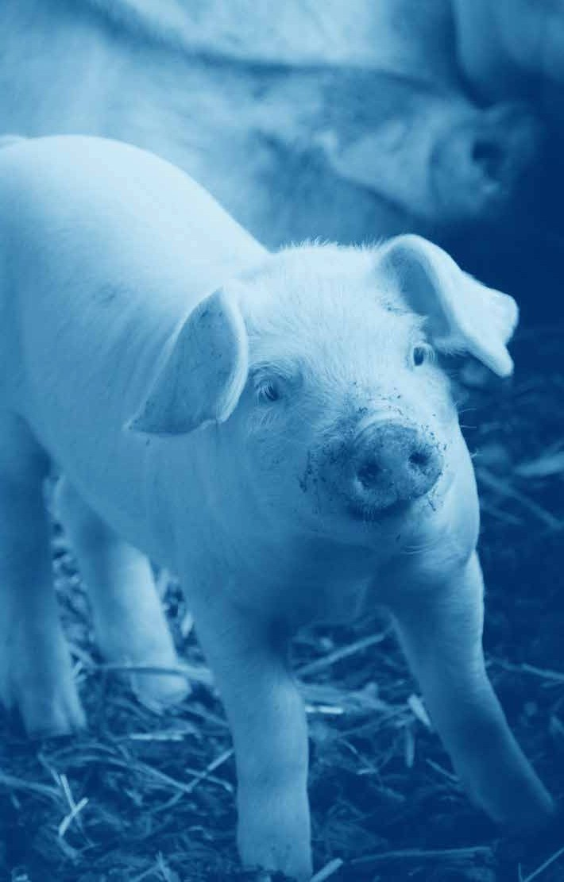

Appendix

Appendix Company Coverage

The Benchmark scope
In o al, 150 of he world’s lar es food companies were included in he 2024 Benchmark. These companies were broadly spread across he hree food indus ry sub-sec ors. The universe of companies is lobal al hou h i con inues o be wei h ed owards Nor h American and European companies.

Table A1

Companies by sub-sector

Sub-secor (ICB Classificaion) | Number of Companies
Food Re ailers & Wholesalers (5337) | 55
Food Producers (3570) | 63
Res auran s & Bars (5757) | 32
Toal | 150

Table A2

Companies by country of listing or incorporation

Counry of Lisin or Incorporaion | Number of Companies
USA | 44
UK | 18
France | 13
China | 12
Germany | 8
Canada | 7
I aly | 7
Brazil | 6
Ne herlands | 6
Japan | 5
Swi zerland | 5
Sweden | 3
Aus ralia | 2
Chile | 2
Denmark | 2
Mexico | 2
Norway | 1
Belium | 1
Ireland | 1
New Zealand | 1
Por ual | 1
Spain | 1
Thailand | 1
Luxembour | 1

Appendix 2024 Benchmark

Questions and Scoring

Farm Animal Welfare Policy Commimen
Quesion 1. | Does he company acknowled e farm animal welfare as a business issue?
Ra ionale | Acknowledin farm animal welfare as a relevan business issue is an impor an firs s ep owards implemen in a comprehensive approach o farm animal welfare manaemen . I is ood prac ice for food companies o iden ify whe her and why farm animal welfare is a relevan issue for he business. Reconisin animals as sen ien beins provides a s ron founda ion for animal welfare policies.
Scorin | No evidence ha farm animal welfare is rearded as a relevan business issue. | 0
 | The company iden ifies farm animal welfare as a relevan business issue. | 2.5
 | The company iden ifies farm animal welfare as a relevan business issue and reconises farm animals as sen ien beins. | 5
 | (Max Score 5)
Explana ory No es | - This ques ion is lookin for an acknowledemen by he paren company  ha farm animal welfare is a relevan business issue and ha farm animals are sen ien beins.  - Companies ha publish policies ha address farm animal welfare, even if  hey do no explain why his is relevan o he business, are awarded poin s.  - Companies ha acknowlede farm animal welfare as a relevan business  issue and/or se ou he reasons why i mih be a business issue (e.. because of public or cus omer concerns, securi y and sus ainabili y of supply, cos , e c.) are awarded poin s.  - Maximum poin s are awarded o companies ha also reconise farm animals as sen ien beins. This may be hrouh reconi ion of he ‘Five Freedoms of Animal Welfare’ in combina ion wi h reconi ion of he need o promo e posi ive welfare s a es, reconi ion of he ‘Five Domains of Animal Welfare’, or explici reconi ion of animal sen ience.  - The score does no ake accoun of he impor ance assined by companies o farm animal welfare (e.. rela ive o o her corpora e responsibili y issues).

Farm Animal Welfare Policy Commimens
Quesion 2. | Does he company publish an overarchin farm animal welfare policy (or equivalen)?
Ra ionale | I is ood prac ice for companies o formalise heir approach o animal welfare in a policy (or equivalen documen such as a s a emen of uidin principles, a code of prac ice or a sourcin char er). While he exis ence of a policy may no provide a  uaran ee of implemen a ion, he absence of a policy is a clear sin ha farm animal welfare is no firmly on he business aenda.
Scorin | No evidence of a formal policy s a emen (or equivalen ) on farm animal welfare. | 0
 | The company has a broad commi men o farm animal welfare wi hin a policy s a emen (or equivalen ). | 2.5
 | The company has a broad commi men o farm animal welfare wi hin a policy s a emen (or equivalen ) and a descrip ion of he processes in place o ensure  ha he policy is e“ec ively implemen ed. | 5
 | (Max Score 5)
Explana ory No es | - The assessmen does no di“eren ia e be ween companies ha publish s and-alone farm animal welfare policies and companies ha incorpora e farm animal welfare  in o wider responsible sourcin or sus ainabili y policies or codes of prac ice.  - Companies ha publish a clear s a emen of commi men o farm animal welfare  ha provides a s ar in poin for he company’s accoun abili y o i s s akeholders are awarded a score of 2.5 poin s.  - Policies issued by company subsidiaries are no considered as overarchin policies, and companies wi h such policies bu no overarchin (i.e. a he paren company level) policy are herefore no awarded poin s for his ques ion. These policies are considered when decidin whe her o award poin s for Ques ions 1, 4-12, 24-  28 and 30-50.  - Policies focused on specific farm animal welfare issues (e.. an ibio ics where farm animal welfare is men ioned in passin) are no considered as overarchin policies. Companies wi h such policies bu no overarchin policy on farm animal welfare are  herefore no awarded poin s for his ques ion. These policies are considered when decidin whe her o award poin s for Ques ions 1, 4-12, 24-28 and 30-50.  - Companies ha supplemen hese commi men s or principles wi h de ails of how hese are o be implemen ed are awarded a score of 5 poin s. To score maximum poin s, company farm animal welfare policies need o include mos /all of he followin:  - A clear s a emen of he reasons why farm animal welfare is impor an o he business (includin bo h he business case and he e hical case for ac ion)  - A clear posi ion re ardin expec ed s andards of farm animal welfare  - A descrip ion of he processes in place o ensure ha he policy is e­ec ively implemen ed (e. . senior mana emen oversi h , commi men s o con inuous improvemen , performance moni orin , correc ive ac ion if he policy is no bein e­ec ively implemen ed)  - A commi men o con inuous improvemen and public repor in on performance.

Farm Animal Welfare Policy Commimens
Quesion 3. | Does he farm animal welfare policy provide a clear explanaion of scope?
Ra ionale | Unders andin he scope of a policy is impor an o unders and he bread h of a company’s commi men o ac ion on farm animal welfare.
Scorin | 3a. Georaphic scope
 | Georaphic scope is no specified. | 0
 | Scope is limi ed o cer ain specified eoraphies. | 1.5
 | Scope is universal across all eoraphies. | 3
 | 3b. Species scope
 | Species scope is no specified. | 0
 | Scope is limi ed o cer ain specified species. | 1.5
 | Scope is universal across all relevan species. | 3
 | 3c. Produc scope
 | Produc scope is no specified. | 0
 | Scope is limi ed o cer ain specified produc s (such as own-brand produc s). | 1.5
 | Scope is universal across own brand and o her brand produc s. | 3
 | (Max Score 9)

Explana ory No es
  - This ques ion is only scored if poin s have been awarded for Ques ion 2, i.e. when he company has a published farm animal welfare policy.
  - The sub-ques ions on eoraphy, species and produc s are scored separa ely (i.e. companies could score up o 3 poin s in each of he hree sub-ques ions, and he scores for each sub-ques ion do no influence he scores awarded for
he o her sub-ques ions).
  - The ques ion acknowledes ha policies can vary from marke o marke , across species and across produc ranes. Companies are iven credi if hey clearly specify he limi s o he applica ion of heir farm animal welfare policies.
  - To qualify for par ial poin s on produc scope, policies need o apply o a sinifican propor ion of a company’s supply chain, such as a subs an ial business division (e.. a res auran brand or manufac urin division) or own-brand produc s (in he case of re ailers and wholesalers). Policies which apply o limi ed produc ranes are no awarded poin s.
  - In some cases, companies use erms such as ‘all animals’ or ‘all produc s’. For he purposes of his assessmen , we ake his o mean ha he policy has universal applica ion (wi h respec o animals and produc s respec ively) and companies receive 3 poin s for hese sub-ques ions. When unclear, we ask companies o clarify he scope in order o keep receivin hese poin s in
fu ure Benchmarks.
  - For companies involved in or usin he produc s from finfish aquacul ure, we do no assume ha he corpora e farm animal welfare policy also applies o finfish (i.e. he policy has universal applica ion) unless he company s a es o herwise, or has a separa e policy ha applies o finfish. If i is unclear whe her finfish are included, only par ial poin s are awarded for he species-par of he ques ion.
  - We define finfish aquacul ure as he breedin, rearin and harves in of aqua ic ver ebra es (i.e. cold blooded animals wi h a bony or car ilainous skele on and a semen ed spinal column) in all ypes of wa er environmen enclosures, includin ponds, rivers, lakes and he ocean.
  - We do no consider policies for finfish ha focus on conserva ion or sus ainable fishin, unless here is an explici reference o animal welfare wi hin hese.

Farm Animal Welfare Policy Commimens
Quesion 4. | Does he company have a clear commimen o endin he use of close confinemen for all species?
Ra ionale | Many of he mos sinifican farm animal welfare concerns resul from close confinemen prac ices (e.. caes (ba ery, enriched/colony and combina ion/limi ed access sys ems) for layin hens; caes for rabbi s and o her poul ry; es a ion/sow  s alls and farrowin cra es for sows; concen ra ed animal feedin opera ions (CAFOs or feedlo s) for beef ca le; permanen housin for dairy cows and beef ca le; sinle pennin, e herin, veal cra es for youn ruminan s; and, for finfish, recircula in aquacul ure sys ems and close confinemen of soli ary finfish species, e.. urbo )  or from hih s ockin densi ies. I is ood prac ice for companies o commi o no close confinemen of farm animals and o avoid hih s ockin densi ies.
Scorin | No addressed. | 0
 | Limi ed o cer ain species, produc s or eoraphies. | 2.5
 | Universal across all relevan species, produc s and eoraphies. | 5
 | (Max Score 5)
Explana ory No es | - This ques ion may be scored even if poin s have no been awarded for Ques ion 2. Poin s may be awarded for policies issued by company subsidiaries.  - Companies ha simply men ion hey avoid close confinemen bu do no s a e  he specific confinemen o be avoided receive zero poin s.  - Simply s a in compliance wi h leisla ion is no rea ed as a proxy for havin a clear posi ion on he issues in ques ion. The reasons are (a) leisla ion, even in  he EU, does no cover all relevan issues, (b) a commi men o compliance wi h leisla ion does no provide uaran ees on performance in coun ries where such leisla ion is absen . Companies ha s a e ha hey comply wi h leisla ion bu do no have a formal policy are, herefore, awarded zero poin s.  - Similarly, simply s a in compliance wi h a farm assurance s andard ha specifies any of hese issues is no rea ed as a proxy for havin a clearly s a ed posi ion, unless he commi men o he issue in ques ion is made explici (e.. compliance wi h he s andard is presen ed as a way of deliverin on i s commi men ).  - The ques ion acknowledes ha policies can vary from marke o marke and across produc ranes. Companies are iven credi if hey clearly specify he limi s o he applica ion of heir policies.  - To qualify for par ial poin s on produc scope, policies need o apply o a sinifican propor ion of a company’s supply chain, such as a subs an ial business division (e.. a res auran brand or manufac urin division) or own-brand produc s (in he case of re ailers and wholesalers). Policies which apply o limi ed produc ranes are no awarded poin s.  - In some cases, companies use erms such as ‘all animals’ or ‘all produc s’. For he purposes of his assessmen , we ake his o mean ha he policy has universal applica ion (wi h respec o animals and produc s respec ively) and companies receive 5 poin s. When unclear, we ask companies o clarify he scope in order o keep receivin hese poin s in fu ure Benchmarks.

Explana ory No es Con inued
  - Reardin es a ion/sow s alls, his ques ion is lookin for commi men s ha do no allow any ime in s alls, excep for a maximum of 4 hours for manaemen purposes. Companies are expec ed o s a e he maximum ime permi ed wi hin heir policies and repor in.
  - Reardin CAFOs and feedlo s, hese are defined as sys ems in which beef ca le are kep a hih s ockin densi ies, indoors on fully sla ed or solid floors, or ou doors, and here is no oppor uni y for razin, ins ead, feed is brouh o he animals.
  - For companies involved in or usin he produc s from finfish aquacul ure, we do no assume ha he corpora e farm animal welfare policy also applies o finfish (i.e.
he policy has universal applica ion) unless he company s a es o herwise, or has a separa e policy ha applies o finfish. If i is unclear whe her finfish are included, only par ial poin s are awarded.

Farm Animal Welfare Policy Commimens
Quesion 5. | Does he company have a clear commimen o he provision of e¤ecive, species- specific enrichmen for all species?
Ra ionale | Companies are expec ed o provide animals wi h s imula in and complex environmen s ha enable species-specific behaviours. E“ec ive environmen al modifica ions allow for he performance of s ronly mo iva ed species-specific behaviours and lead o he expression of a more complex behavioural reper oire. Examples include (bu are no limi ed o) brushes for ca le; manipulable ma erials such as s raw for pis; peckin and dus ba hin subs ra es, and perches for chickens; ba hin wa er for ducks; ou door rane enhancemen , such as ar ificial or na ural shel er; for fish, physical enrichmen such as (ar ificial) plan s, floor subs ra es and  s ruc ures, as well as sensory enrichmen , such as cover or lih in, or occupa ional enrichmen such as curren s or wa er flow o induce swimmin exercise.  Animals wi h ou door access should no be excluded from enrichmen (provided ou doors or indoors). The BBFAW does no score ou door access per se as enrichmen . See he BBFAW briefin paper on environmen al enrichmen for  fur her uidance on sui able forms of enrichmen per species.
Scorin | No addressed. | 0
 | Limi ed o cer ain species, produc s or eoraphies. | 2.5
 | Universal across all relevan species, produc s and eoraphies. | 5
 | (Max Score 5)
Explana ory No es | - This ques ion may be scored even if poin s have no been awarded for Ques ion 2. Poin s may be awarded for policies issued by company subsidiaries.  - Companies ha simply men ion hey provide environmen al enrichmen bu do no s a e he specific environmen al enrichmen o be provided, receive zero poin s.  - ‘Enriched’ caes are no awarded poin s.  - Simply s a in compliance wi h leisla ion is no rea ed as a proxy for havin a clear posi ion on he issues in ques ion. The reasons are (a) leisla ion, even in he EU, does no cover all relevan issues, (b) a commi men o compliance wi h leisla ion does no provide uaran ees on performance in coun ries where such leisla ion is absen . Companies ha s a e ha hey comply wi h leisla ion bu do no have a formal policy are, herefore, awarded zero poin s.  - Similarly, simply s a in compliance wi h a farm assurance s andard ha specifies any of hese issues is no rea ed as a proxy for havin a clearly s a ed posi ion, unless he commi men o he issue in ques ion is made explici (e.. compliance wi h he s andard is presen ed as a way of deliverin on i s commi men ).  - The ques ion acknowledes ha policies can vary from marke o marke and across produc ranes. Companies are iven credi if hey clearly specify he limi s o he applica ion of heir policies.  - To qualify for par ial poin s on produc scope, policies need o apply o a sinifican propor ion of a company’s supply chain, such as a subs an ial business division (e.. a res auran brand or manufac urin division) or own-brand produc s (in he case  of re ailers and wholesalers). Policies which apply o limi ed produc ranes are no awarded poin s.  - In some cases, companies use erms such as ‘all animals’ or ‘all produc s’. For he purposes of his assessmen , we ake his o mean ha he policy has universal applica ion (wi h respec o animals and produc s respec ively) and companies receive 5 poin s. When unclear, we ask companies o clarify he scope in order o keep receivin hese poin s in fu ure Benchmarks.  - For companies involved in or usin he produc s from finfish aquacul ure, we do no assume ha he corpora e farm animal welfare policy also applies o finfish (i.e.  he policy has universal applica ion) unless he company s a es o herwise, or has a separa e policy ha applies o finfish. If i is unclear whe her finfish are included, only par ial poin s are awarded.

Farm Animal Welfare Policy Commimens
Quesion 6. | Does he company have a clear commimen o endin he use of rouine muilaions for all species?
Ra ionale | Many farm animals are subjec ed o procedures ha al er heir bodies, o°en  wi h no anaes hesia, causin pain and dis ress. Examples include beak rimmin/  ippin and any ype of flih res rain in poul ry, brandin wi h ho irons, as well as disbuddin/dehornin of ruminan s and ail dockin and cas ra ion in ruminan s and pis (surical, rubber rins or clampin), oo h resec ion in pis, and fin clippin in finfish aquacul ure.
Scorin | No addressed. | 0
 | Limi ed o cer ain species, produc s or eoraphies. | 2.5
 | Universal across all relevan species, produc s and eoraphies. | 5
 | (Max Score 5)
Explana ory No es | - This ques ion may be scored even if poin s have no been awarded for Ques ion 2. Poin s may be awarded for policies issued by company subsidiaries.  - Companies ha simply men ion hey have a commi men o endin rou ine mu ila ions bu do no s a e he specific mu ila ions hey are lookin o end he use of receive zero poin s.  - Simply s a in compliance wi h leisla ion is no rea ed as a proxy for havin a clear posi ion on he issues in ques ion. The reasons are (a) leisla ion, even in he EU, does no cover all relevan issues, (b) mu ila ions are s ill commonly performed  under deroa ions (c) a commi men o compliance wi h leisla ion does no provide  uaran ees on performance in coun ries where such leisla ion is absen . Companies  ha s a e ha hey comply wi h leisla ion bu do no have a formal policy are,  herefore, awarded zero poin s.  - Similarly, simply s a in compliance wi h a farm assurance s andard ha specifies any of hese issues is no rea ed as a proxy for havin a clearly s a ed posi ion, unless he commi men o he issue in ques ion is made explici (e.. compliance wi h he s andard is presen ed as a way of deliverin on i s commi men ).  - The ques ion acknowledes ha policies can vary from marke o marke and across produc ranes. Companies are iven credi if hey clearly specify he limi s o he applica ion of heir policies.  - To qualify for par ial poin s on produc scope, policies need o apply o a sinifican propor ion of a company’s supply chain, such as a subs an ial business division (e.. a res auran brand or manufac urin division) or own-brand produc s (in he case  of re ailers and wholesalers). Policies which apply o limi ed produc ranes are no awarded poin s.  - In some cases, companies use erms such as ‘all animals’ or ‘all produc s’. For he purposes of his assessmen , we ake his o mean ha he policy has universal applica ion (wi h respec o animals and produc s respec ively) and companies receive 5 poin s. When unclear, we ask companies o clarify he scope in order o keep receivin hese poin s in fu ure Benchmarks.  - For companies involved in or usin he produc s from finfish aquacul ure, we do no assume ha he corpora e farm animal welfare policy also applies o finfish (i.e.  he policy has universal applica ion) unless he company s a es o herwise, or has a separa e policy ha applies o finfish. If i is unclear whe her finfish are included, only par ial poin s are awarded.

Farm Animal Welfare Policy Commimens
Quesion 7. | Does he company have a clear commimen o endin he prophylacic and rouine meaphylacic use of anibioics for all species?
Ra ionale | Prophylaxis is he rea men of animals wi hou clinical sin of disease. Me aphylaxis is  he rea men of a roup of animals when some wi hin he roup are showin clinical sins of disease.  The over-use of an ibio ics in humans and in animals is direc ly linked o he increase in an ibio ic resis ance. The use of an ibio ics on-farm ( ypically hrouh feed or wa er) is frequen ly prophylac ic or me aphylac ic; e“ec ively ‘proppin up’  in ensive farmin sys ems where animals are kep in confined and s ressful condi ions and where heir immune sys ems are compromised and disease ou breaks can spread rapidly. Companies are expec ed o commi o reducin he levels of an ibio ics hey adminis er rou inely and o develop animal produc ion sys ems ha are no relian  on he rou ine use of an ibio ics for disease preven ion. Poin s are no awarded for supply chains marke ed as an ibio ic-free due o he incen ive his crea es o wi hhold an ibio ics from animals in need of rea men .  For farmed fish, his ques ion is lookin for a clear commi men o endin he prophylac ic use of an ibio ics only.
Scorin | No addressed. | 0
 | Limi ed o cer ain species, produc s or eoraphies. | 2.5
 | Universal across all relevan species, produc s and eoraphies. | 5
 | (Max Score 5)
Explana ory No es | - This ques ion may be scored even if poin s have no been awarded for Ques ion 2. Poin s may be awarded for policies issued by company subsidiaries.  - Simply s a in compliance wi h leisla ion is no rea ed as a proxy for havin a clear posi ion on he issues in ques ion. The reasons are (a) leisla ion, even in he EU, does no cover all relevan issues, (b) a commi men o compliance wi h leisla ion does no provide uaran ees on performance in coun ries where such leisla ion is absen . Companies ha s a e ha hey comply wi h leisla ion bu do no have a formal policy are, herefore, awarded zero poin s.  - Similarly, simply s a in compliance wi h a farm assurance s andard ha specifies any of hese issues is no rea ed as a proxy for havin a clearly s a ed posi ion, unless he commi men o he issue in ques ion is made explici (e.. compliance wi h he s andard is presen ed as a way of deliverin on i s commi men ).  - The ques ion acknowledes ha policies can vary from marke o marke and across produc ranes. Companies are iven credi if hey clearly specify he limi s o he applica ion of heir policies.  - To qualify for par ial poin s on produc scope, policies need o apply o a sinifican propor ion of a company’s supply chain, such as a subs an ial business division (e.. a res auran brand or manufac urin division) or own-brand produc s (in he case  of re ailers and wholesalers). Policies which apply o limi ed produc ranes are no awarded poin s.  - Par ial poin s may be awarded for commi men s focused on prophylac ic use in he absence of a commi men on rou ine me aphylac ic use.  - In some cases, companies use erms such as ‘all animals’ or ‘all produc s’. For he purposes of his assessmen , we ake his o mean ha he policy has universal applica ion (wi h respec o animals and produc s respec ively) and companies receive 5 poin s. When unclear, we ask companies o clarify he scope in order o keep receivin hese poin s in fu ure Benchmarks.  - For companies involved in or usin he produc s from finfish aquacul ure, we do no assume ha he corpora e farm animal welfare policy also applies o finfish (i.e. he policy has universal applica ion) unless he company s a es o herwise, or has a separa e policy ha applies o finfish. If i is unclear whe her finfish are included, only par ial poin s are awarded.

Farm Animal Welfare Policy Commimens
Quesion 8. | Does he company have a clear commimen o endin lon -disance live ranspor for all species?
Ra ionale | When bein ranspor ed, animals can experience huner, hirs , discomfor , pain, frus ra ion, fear and dis ress, as well as physical welfare problems includin injury, disease, and, in he wors cases, dea h. For hese reasons, ranspor of live animals should be minimised wherever possible and journeys should be kep as shor as possible; less han 4 hours for poul ry and rabbi s, and less han 8 hours for o her species. Unweaned animals, heavily prenan animals and animals unfi for ranspor should no be ranspor ed. Transpor of animals exceedin hese limi s, includin loadin and unloadin, has been shown o decrease welfare sinifican ly. In he case of farmed fish, handlin prac ices and wa er quali y condi ions, par icularly  oxyena ion, can have a sinifican impac on welfare.
Scorin | No addressed. | 0
 | Limi ed o cer ain species, produc s or eoraphies. | 2.5
 | Universal across all relevan species, produc s and eoraphies. | 5
 | (Max Score 5)
Explana ory No es | - This ques ion may be scored even if poin s have no been awarded for Ques ion 2. Poin s may be awarded for policies issued by company subsidiaries.  - The ques ion covers animals ranspor ed on land and by sea, and companies are expec ed o include sea ranspor in heir policies and repor in on ranspor imes. We encourae companies o clearly s a e whe her sea ranspor is included in heir policies, or clearly s a e ha hey do no ranspor animals by sea.  - Simply s a in compliance wi h leisla ion is no rea ed as a proxy for havin a clear posi ion on he issues in ques ion. The reasons are (a) leisla ion, even in he EU, does no cover all relevan issues, (b) a commi men o compliance wi h leisla ion does no provide uaran ees on performance in coun ries where such leisla ion is absen . Companies ha s a e ha hey comply wi h leisla ion bu do no have a formal policy are, herefore, awarded zero poin s.  - Similarly, simply s a in compliance wi h a farm assurance s andard ha specifies any of hese issues is no rea ed as a proxy for havin a clearly s a ed posi ion, unless he commi men o he issue in ques ion is made explici (e.. compliance wi h he s andard is presen ed as a way of deliverin on i s commi men ).  - The ques ion acknowledes ha policies can vary from marke o marke and across produc ranes. Companies are iven credi if hey clearly specify he limi s o he applica ion of heir policies.  - To qualify for par ial poin s on produc scope, policies need o apply o a sinifican propor ion of a company’s supply chain, such as a subs an ial business division (e.. a res auran brand or manufac urin division) or own-brand produc s (in he case  of re ailers and wholesalers). Policies which apply o limi ed produc ranes are no awarded poin s.  - In some cases, companies use erms such as ‘all animals’ or ‘all produc s’. For he purposes of his assessmen , we ake his o mean ha he policy has universal applica ion (wi h respec o animals and produc s respec ively) and companies receive 5 poin s. When unclear, we ask companies o clarify he scope in order  o keep receivin hese poin s in fu ure Benchmarks.  - For companies involved in or usin he produc s from finfish aquacul ure, we do no assume ha he corpora e farm animal welfare policy also applies o finfish (i.e.  he policy has universal applica ion) unless he company s a es o herwise, or has a separa e policy ha applies o finfish. If i is unclear whe her finfish are included, only par ial poin s are awarded.

Farm Animal Welfare Policy Commimens
Quesion 9. | Does he company have a clear commimen o he use of humane mehods of pre-slau her sunnin for all species?
Ra ionale | I is essen ial o render an animal unconscious before i is slauh ered in order for i o be insensible o pain, discomfor and s ress, un il dea h occurs. For poul ry,  con rolled a mospheric s unnin usin iner as or mul i-phase sys ems, or e“ec ive elec rical s unnin wi hou live inversion, should be used. For pis, his ques ion is lookin for commi men s o end he use of hih concen ra ion CO2 as sys ems.  For salmon and rou , his ques ion is lookin for commi men s o use percussion  or elec rical me hods. For o her fish his ques ion is lookin for commi men s o end he use of ice slurry.
Scorin | No addressed. | 0
 | Limi ed o cer ain species, produc s or eoraphies. | 2.5
 | Universal across all relevan species, produc s and eoraphies. | 5
 | (Max Score 5)
Explana ory No es | - This ques ion may be scored even if poin s have no been awarded for Ques ion 2. Poin s may be awarded for policies issued by company subsidiaries.  - Simply s a in compliance wi h leisla ion is no rea ed as a proxy for havin  a clear posi ion on he issues in ques ion. The reasons are (a) leisla ion, even in  he EU, does no cover all relevan issues, (b) a commi men o compliance wi h leisla ion does no provide uaran ees on performance in coun ries where such leisla ion is absen . Companies ha s a e ha hey comply wi h leisla ion bu do no have a formal policy are, herefore, awarded zero poin s.  - Similarly, simply s a in compliance wi h a farm assurance s andard ha specifies any of hese issues is no rea ed as a proxy for havin a clearly s a ed posi ion, unless he commi men o he issue in ques ion is made explici (e.. compliance wi h he s andard is presen ed as a way of deliverin on i s commi men ).  - The ques ion acknowledes ha policies can vary from marke o marke and across produc ranes. Companies are iven credi if hey clearly specify he limi s o he applica ion of heir policies.  - To qualify for par ial poin s on produc scope, policies need o apply o a sinifican propor ion of a company’s supply chain, such as a subs an ial business division (e.. a res auran brand or manufac urin division) or own-brand produc s (in he case  of re ailers and wholesalers). Policies which apply o limi ed produc ranes are no awarded poin s.  - In some cases, companies use erms such as ‘all animals’ or ‘all produc s’. For he purposes of his assessmen , we ake his o mean ha he policy has universal applica ion (wi h respec o animals and produc s respec ively) and companies receive 5 poin s. When unclear, we ask companies o clarify he scope in order  o keep receivin hese poin s in fu ure Benchmarks.  - For companies involved in or usin he produc s from finfish aquacul ure, we do no assume ha he corpora e farm animal welfare policy also applies o finfish (i.e. he policy has universal applica ion) unless he company s a es o herwise, or has a separa e policy ha applies o finfish. If i is unclear whe her finfish are included, only par ial poin s are awarded

Farm Animal Welfare Policy Commimens
Layin Hens, Pi s and Beef Cale
Quesion 10. | Does he company have a clear commimen o endin he use of breeds wih low welfare poenial?
Ra ionale | The welfare of farmed animals is no only influenced by manaemen prac ices and he inpu s provided o hem, bu also by heir ene ics. For example, some breeds selec ed for hih row h ra e and lean mea deposi ion can su“er a rane of physioloical and me abolic heal h issues, as well as poor immuni y and le hary and poor behavioural expression. Double-muscled breeds of beef ca le are associa ed wi h hiher ra es of dys ocia (di»cul y calvin). The choice of breed or s rain of animals used in lives ock produc ion can herefore have a sinifican impac on animal welfare.  Specific requiremen s for he species covered by his ques ion are as follows:  - broiler chickens: end use of breeds ha do no mee he Be er Chicken Commi men /European Chicken Commi men requiremen s for improved welfare ou comes;  - or end use of breeds wi hou a slower row h po en ial, defined as <40/d averaed over he row h cycle accordin o he breedin company specifica ion  - pis: end use of sows wi h an averae >16 pile s liveborn per li er  - beef ca le: end use of double-muscled breeds (e.. Belian Blue and Piedmon ese) in pure-bred and cross-bred form.
Scorin | No addressed. | 0
 | Limi ed o cer ain species, produc s or eoraphies. | 2.5
 | Universal across all relevan species, produc s and eoraphies. | 5
 | (Max Score 5)

Farm Animal Welfare Policy Commimens
Ducks or Geese
Quesion 11. | Does he company have a clear commimen no o produce or sell foie ras or mea from birds reared for foie ras?
Ra ionale | Welfare issues associa ed wi h he produc ion of foie ras include over-feedin, force-feedin (avae) and he close confinemen of ducks and eese wi hin caes.
Scorin | No addressed. | 0
 | Universal across all relevan species, produc s and eoraphies. | 5
 | (Max Score 5)
Explana ory No es | - This ques ion may be scored even if poin s have no been awarded for Ques ion 2. Poin s may be awarded for policies issued by company subsidiaries.  - This ques ion is only assessed for hose companies ha have ducks or eese in  heir supply chains.  - Companies ha only men ion hey do no produce or sell foie ras produc s do no qualify for poin s. Companies are required o also include mea from birds reared for foie ras wi hin heir commi men s.  - Simply s a in compliance wi h leisla ion is no rea ed as a proxy for havin  a clear posi ion on he issues in ques ion. The reasons are (a) leisla ion, even in  he EU, does no cover all relevan issues, (b) a commi men o compliance wi h leisla ion does no provide uaran ees on performance in coun ries where such leisla ion is absen . Companies ha s a e ha hey comply wi h leisla ion bu do no have a formal policy are, herefore, awarded zero poin s.  - Similarly, simply s a in compliance wi h a farm assurance s andard ha specifies any of hese issues is no rea ed as a proxy for havin a clearly s a ed posi ion, unless he commi men o he issue in ques ion is made explici (e.. compliance wi h he s andard is presen ed as a way of deliverin on i s commi men ).  - Par ial policies, which are limi ed o cer ain species, produc s or eoraphies, are no awarded poin s.  - In some cases, companies use erms such as ‘all animals’ or ‘all produc s’. For he purposes of his assessmen , we ake his o mean ha he policy has universal applica ion (wi h respec o animals and produc s respec ively) and companies receive 5 poin s. When unclear, we ask companies o clarify he scope in order  o keep receivin hese poin s in fu ure Benchmarks.

Farm Animal Welfare Policy Commimens
Layin Hens, Pi s, Dairy Cale, Beef Cale, Ducks or Geese
Quesion 12. | Does he company have a clear commimen o endin he use of oher inhumane pracices?
Ra ionale | Prac ices covered by his ques ion include he cullin of day-old male chicks in e supply chains; cow-calf separa ion in dairy and beef supply chains; fully sla ed floorin for pis, dairy and beef ca le, ducks; and live pluckin or live harves in for eese.
Scorin | No addressed. | 0
 | Limi ed o cer ain species, produc s or eoraphies. | 2.5
 | Universal across all relevan species, produc s and eoraphies. | 5
 | (Max Score 5)
Explana ory No es | - This ques ion may be scored even if poin s have no been awarded for Ques ion 2. Poin s may be awarded for policies issued by company subsidiaries.  - This ques ion is only assessed for hose companies ha have layin hens, pis, dairy ca le, beef ca le, ducks or eese in heir supply chains.  - Accep able al erna ive prac ices o he cullin of day-old male chicks include  he use of in-ovo sexin me hods and he use of dual-purpose breeds.  - Simply s a in compliance wi h leisla ion is no rea ed as a proxy for havin  a clear posi ion on he issues in ques ion. The reasons are (a) leisla ion, even in  he EU, does no cover all relevan issues, (b) a commi men o compliance wi h leisla ion does no provide uaran ees on performance in coun ries where such leisla ion is absen . Companies ha s a e ha hey comply wi h leisla ion bu do no have a formal policy are, herefore, awarded zero poin s.  - Similarly, simply s a in compliance wi h a farm assurance s andard ha specifies any of hese issues is no rea ed as a proxy for havin a clearly s a ed posi ion, unless he commi men o he issue in ques ion is made explici (e.. compliance wi h he s andard is presen ed as a way of deliverin on i s commi men ).  - The ques ion acknowledes ha policies can vary from marke o marke and across produc ranes. Companies are iven credi if hey clearly specify he limi s o he applica ion of heir policies.  - To qualify for par ial poin s on produc scope, policies need o apply o a sinifican propor ion of a company’s supply chain, such as a subs an ial business division (e.. a res auran brand or manufac urin division) or own-brand produc s (in he case  of re ailers and wholesalers). Policies which apply o limi ed produc ranes are no awarded poin s.  - In some cases, companies use erms such as ‘all animals’ or ‘all produc s’. For he purposes of his assessmen , we ake his o mean ha he policy has universal applica ion (wi h respec o animals and produc s respec ively) and companies receive 5 poin s. When unclear, we ask companies o clarify he scope in order  o keep receivin hese poin s in fu ure Benchmarks.

Animal-Sourced Foods Policy Commimens
Quesion 13. | Does he company acknowled e he need o reduce reliance on animal-sourced foods as a business issue?
Ra ionale | Reducin reliance on animal-sourced foods, is key o ensurin ha all animals farmed for food are able o be produced in hih welfare sys ems capable of deliverin a ood quali y of life, and ha he food sys em con ribu es o plane ary and human heal h.  I is ood prac ice for food companies o iden ify whe her and why his is a relevan issue for he business.
Scorin | No evidence ha reducin reliance on animal-sourced foods is rearded as a relevan business issue. | 0
 | The company iden ifies reducin reliance on animal-sourced foods as a relevan business issue. | 5
 | (Max Score 5)
Explana ory No es | - This ques ion is lookin for an acknowledemen by he paren company  ha reducin reliance on animal-sourced foods is a relevan business issue.  - Companies ha publish policies ha address reducin reliance on animal-sourced foods, even if hey do no explain why his is relevan o he business,  are awarded poin s.  - Companies ha acknowlede reducin reliance on animal-sourced foods as a relevan business issue and/or se ou he reasons why i may be a business issue (e.. because of public or cus omer concerns, securi y and sus ainabili y of supply, cos , e c.) are awarded poin s.  - Companies ha only provide evidence rela ed o pro ein diversifica ion, wi hou any acknowledemen of he need o reduce reliance on animal-sourced foods, are no awarded poin s.  - The score does no ake accoun of he impor ance assined by companies  o reducin reliance on animal-sourced foods (e.. rela ive o o her corpora e responsibili y issues).

Animal-Sourced Foods Policy Commimens
Quesion 14. | Does he company publish an overarchin policy (or equivalen) on reducin reliance on animal-sourced foods?
Ra ionale | I is ood prac ice for companies o formalise heir approach o reducin reliance on animal-sourced foods in a policy (or equivalen documen such as a s a emen of uidin principles, a code of prac ice or a sourcin char er). Reducin reliance on animal-sourced foods may be achieved in mul iple ways, includin direc ac ion on reduc ion (e.., was e reduc ion, be er u ilisa ion, chanes o business focus) or hrouh pro ein diversifica ion (e.., new produc developmen , reformula ion). While he exis ence of a policy may no provide a uaran ee of implemen a ion,  he absence of a policy is a clear sin ha reducin reliance on animal-sourced foods is no firmly on he business aenda.
Scorin | No evidence of a formal policy s a emen (or equivalen ) on reducin reliance on animal-sourced foods. | 0
 | The company has a broad commi men o reducin reliance on animal-sourced foods wi hin a policy s a emen (or equivalen ). | 5
 | The company has a broad commi men o reducin reliance on animal-sourced foods wi hin a policy s a emen (or equivalen ) and a descrip ion of he processes in place o ensure ha he policy is e“ec ively implemen ed. | 10
 | (Max Score 10)
Explana ory No es | - This ques ion is only scored if poin s have been awarded for Ques ion 12, i.e., if he paren company reconises ha reducin reliance on animal-sourced foods is a relevan business issue.  - The assessmen does no di“eren ia e be ween companies ha publish s and- alone policies on reducin reliance on animal-sourced foods and companies ha incorpora e reducin reliance on animal-sourced foods in o wider responsible sourcin or sus ainabili y policies or codes of prac ice.  - Companies ha publish a clear s a emen of commi men o reducin reliance on animal-sourced foods ha provides a s ar in poin for he company’s accoun abili y  o i s s akeholders are awarded poin s.  - Policies issued by company subsidiaries are no considered as overarchin policies, and companies wi h such policies bu no overarchin (i.e. a he paren company level) policy are herefore no awarded poin s for his ques ion. These policies are considered when decidin whe her o award poin s for Ques ions 22 and 28.  - Companies ha supplemen hese commi men s or principles wi h de ails of how  hese are o be implemen ed are awarded a score of 10 poin s. To score maximum poin s, company policies need o include mos /all of he followin:  - A clear s a emen of he reasons why reducin reliance on animal-sourced foods is impor an o he business (includin bo h he business case and he e hical case for ac ion).  - A descrip ion of how reducin reliance on animal-sourced foods is o be achieved, such as hrou h pro ein diversifica ion, produc reformula ion or communica ion  o consumers  - A descrip ion of he processes in place o ensure ha he policy is eŸec ively implemen ed (e. . senior mana emen oversi h , commi men s o con inuous improvemen , performance moni orin , correc ive ac ion if he policy is no bein eŸec ively implemen ed)  - A commi men o con inuous improvemen and public repor in on performance.

Animal-Sourced Foods Policy Commimens
Quesion 15. | Does he policy on reducin reliance on animal-sourced foods provide a clear explanaion of scope?
Ra ionale | Unders andin he scope of a policy is impor an o unders and he bread h of a company’s commi men o ac ion on reducin reliance on animal-sourced foods.
Scorin | 15a. Georaphic scope
 | Georaphic scope is no specified. | 0
 | Scope is limi ed o cer ain specified eoraphies. | 2.5
 | Scope is universal across all eoraphies. | 5
 | 15b. Business division scope
 | Business division scope is no specified. | 0
 | Scope is limi ed o cer ain specified business divisions. | 2.5
 | Scope is universal across all business divisions. | 5
 | (Max Score 10)
Explana ory No es | - This ques ion is only scored if poin s have been awarded for Ques ion 13, i.e. when  he company has a published policy on reducin reliance on animal-sourced foods.  - The sub-ques ions on eoraphy and produc s are scored separa ely (i.e. companies could score up o 5 poin s in each of he wo sub-ques ions, and he scores for each sub-ques ion do no influence he scores awarded for he o her sub-ques ion).  - The ques ion acknowledes ha policies can vary from marke o marke and across business divisions. Companies are iven credi if hey clearly specify he limi s o he applica ion of heir policies.

Farm Animal Welfare Governance and Mana emen
Quesion 16. | Has he company assi ned day-o-day and board or senior mana emen responsibiliy for farm animal welfare?
Ra ionale | When lookin a he manaemen of farm animal welfare, bo h oversih and implemen a ion responsibili ies are impor an . Oversih is necessary o ensure ha senior manaemen is aware of he business implica ions of farm animal welfare and is prepared o in ervene when needed (e.., if here are ensions be ween he oranisa ion’s farm animal welfare policy and o her business objec ives). However,  i is o°en he case ha hose chared wi h oversih know rela ively li le abou he specific de ails of how o e“ec ively manae farm animal welfare. I is, herefore, impor an ha here are individual(s) responsible for ensurin ha he farm animal welfare policy is implemen ed and e“ec ively manaed.
Scorin | 16a. Manaemen responsibili y
 | No clearly defined manaemen responsibili y. | 0
 | The company has published de ails of he manaemen posi ion wi h responsibili y for farm animal welfare on a day- o-day basis. | 5
 | 16b. Board or senior manaemen responsibili y
 | No clearly defined board or senior manaemen responsibili y. | 0
 | The company has published de ails of how he board or senior manaemen oversees he implemen a ion of he company’s farm animal welfare policy. | 5
 | (Max Score 10)
Explana ory No es | - The wo sub-ques ions are scored separa ely (i.e. companies could score 5 poin s for publishin de ails of who is responsible for farm animal welfare on a day- o-day basis and 5 poin s for publishin de ails of senior manaemen responsibili y for overseein he farm animal welfare policy).  - For he purposes of scorin on day- o-day responsibili y, he ques ion is no lookin for named individuals, bu evidence of roles wi h responsibili y for farm  animal welfare (e.. a s a emen ha his is he responsibili y of a dedica ed echnical or sourcin manaer, or a s a emen ha responsibili y is divided amon a number of func ions, wi h informa ion on he various roles and responsibili ies).  - For he manaemen oversih sub-ques ion, we reconise ha companies may assin responsibili y o a named senior person or ha farm animal welfare may form par of he remi of a wider sus ainabili y, CSR or sourcin commi ee. Therefore,  5 poin s are awarded if he company provides a clear accoun of board or senior manaemen oversih .  - For he purposes of scorin, he emphasis is on he manaemen of farm animal welfare. General informa ion on he manaemen or oversih of CSR or sus ainabili y is only credi ed if i is clear ha his includes farm animal welfare.

Farm Animal Welfare Governance and Mana emen
Quesion 17. | Does he company describe is inernal processes for ensurin ha is farm animal welfare policies are e¤ecively implemened?
Ra ionale | The e“ec ive implemen a ion of a policy relies on employees who are compe en  o oversee he implemen a ion of he policy, and on con rols ha allow he company  o respond quickly and e“ec ively in he even of non-compliance wi h he policy.
Scorin | 17a. Employee rainin
 | No informa ion provided on employee rainin in farm animal welfare. | 0
 | The company provides specific rainin o employees in farm animal welfare. | 5
 | 17b. Ac ions aken in he even of non-compliance
 | The company provides no informa ion on he ac ions o be aken in he even of non-compliance wi h he farm animal welfare policy. | 0
 | The company describes he ac ions i akes in he even of non-compliance wi h i s farm animal welfare policy. | 5
 | (Max Score 10)
Explana ory No es | - The sub-ques ions (on rainin and on in ernal con rols) are scored independen ly (i.e. he scores for each sub-ques ion do no influence he scores for he o her sub-ques ion).  - On rainin, companies are only awarded 5 poin s if he rainin provided is aimed a employees and if i explici ly addressed farm animal welfare-rela ed issues.  - The rainin ques ion does no address he quali y of he rainin provided, he manner in which skills or compe encies are assessed, he number of employees receivin rainin or he number of hours of rainin provided.  - On in ernal con rols, companies are only awarded 5 poin s if hey explici ly discussed he ac ions ha hey ake in rela ion o employee and/or supplier non-compliance wi h heir farm animal welfare policy, e.. when audi failures are iden ified. Descrip ions of in ernal con rols in rela ion o CSR or produc quali y-rela ed policies are scored zero for his sub-ques ion unless i is clear  ha hese policies and processes also cover farm animal welfare.

Farm Animal Welfare Governance and Mana emen
Quesion 18. | Does he company describe how i implemens is farm animal welfare policy (or equivalen) hrou h is supply chain?
Ra ionale | Many of he business risks and oppor uni ies associa ed wi h farm animal welfare rela e o companies’ supply chains. Companies have he abili y o influence heir suppliers’ performance bo h formally (e.. hrouh con rac s, audi in processes) and informally (e.. hrouh capaci y buildin and educa ion).
Scorin | No descrip ion of processes for implemen in farm animal welfare policy  hrouh supply chain. | 0
 | 18a. Does he company describe how i implemen s i s farm animal welfare policy (or equivalen ) hrouh i s supply chain via supplier con rac s?
 | No informa ion on how farm animal welfare is included in supplier con rac s. | 0
 | The company incorpora es farm animal welfare in o con rac ual oblia ions for suppliers, bu his is limi ed by eoraphy and/or cer ain produc s or species. | 1.5
 | The company incorpora es farm animal welfare in o con rac ual oblia ions for suppliers across all species, produc s and eoraphies. | 3
 | 18b. Does he company describe how i implemen s i s farm animal welfare policy (or equivalen ) hrouh i s supply chain via moni orin and audi in?
 | No informa ion provided on how supplier compliance wi h con rac condi ions is moni ored. | 0
 | The company specifies farm animal welfare as par of supplier audi in proramme. | 3
 | 18c. Does he company describe how i implemen s i s farm animal welfare policy (or equivalen ) hrouh i s supply chain via educa ion and suppor ?
 | No informa ion provided on he specific suppor and/or educa ion provided  o suppliers. | 0
 | The company provides specific suppor and/or educa ion provided o suppliers on farm animal welfare policy/issues. | 3
 | (Max Score 9)
Explana ory No es | - The sub-ques ions (on con rac s, audi in and supplier educa ion) are scored independen ly (i.e. he scores for each sub-ques ion do no influence he scores for he o her sub-ques ions).  - On con rac s, companies are awarded par ial poin s if hey indica ed ha hey included farm animal welfare in con rac s bu do no indica e whe her his applied  o all relevan con rac s or if hey indica ed ha farm animal welfare is no included in all con rac s.  - On audi in, companies are only awarded 3 poin s if i is clear ha heir audi in processes explici ly covered farm animal welfare. Many of he companies reviewed repor ed ha hey audi ed heir suppliers aains safe y and/or quali y s andards bu , unless i is clear ha hese audi processes covered farm animal welfare, companies scored zero for his sub-ques ion.  - On supplier suppor and/or educa ion, 3 poin s are awarded o companies ha publish case s udies or examples and/or provide a more comprehensive descrip ion of heir approach. The award of 3 poin s is no dependen on he number or propor ion of suppliers receivin his suppor and/or educa ion. A number of companies described heir suppor o suppliers on a rane of supply chain issues. However, unless i is clear ha his suppor also covered farm animal welfare, companies scored zero for his sub-ques ion.

Farm Animal Welfare Governance and Mana emen
Quesion 19. | Does he company describe and repor on is use of welfare oucome measures  (i.e. measures linked o he physical, emoional and/or behavioural wellbein of animals)?
Ra ionale | In addi ion o havin clear policy commi men s and manaemen prac ices, companies are expec ed o main ain s ric measuremen cri eria for animals in  heir supply chain. This ques ion is lookin specifically a welfare ou come measures (WOMs) rela in o he physical, emo ional and/or behavioural wellbein of animals. WOMs may be quan i a ive, or quali a ive. They should focus on he mos impor an species-specific measures, of physical wellbein, men al wellbein and behaviour. There is an increasin focus on posi ive ou come measures (e.. ac ive and play behaviour), as well as quali ive Behavioural Assessmen (such as animals bein  con en , happy, or fearful, ai a ed). For re ailers and wholesalers and res auran s and bars, his ques ion applies o all own-brand produc s.  WOMs mih include for example:  - For all species: mor ali y and cull ra es, disease incidence.  - For layin hens: end of lay fea her coverae, fea her cleanliness, keel bone frac ures, bone breakaes a slauh er.  - For dairy cows: lameness, mas i is, body condi ion, involun ary cullin ra e, lonevi y, ease of calvin, lesions, swellins, cleanliness, s omach ulcers, acidosis.  - For sows: Lonevi y, lameness, body condi ion, shoulder and vulva lesions, ear and flank bi in.  - For pis: lameness, cleanliness, ail bi es, fih marks, bursi is and o her lesions.  - For broiler chickens: ai score, le culls, foo pad derma i is, hock burn, breas blis ers, fea her cleanliness, muscle myopa hies.  - For beef: body condi ion, lameness, lesions, swellins, cleanliness, s omach ulcers, acidosis.  - For rabbi s: foo lesions, fur coverae, eye condi ion.  - For fish: fin and body damae, sea lice and o her ec oparasi e infes a ions, skele al deformi ies, condi ion fac or, mor ali y and behaviour.  - For men al wellbein: reac ion o humans or novel y, fear, comfor ; quali a ive behavioural analysis.  - For behaviour: ime spen lyin/res in, rumina in or bein ac ive – forain, perchin, dus ba hin, ba hin (ducks), socialisin, swimmin (fish).  - For ranspor a ion: injuries, slips and falls, fa iue, road ra»c inciden s, mor ali y (dead-on-arrival/DOA).  - For slauh er: e“ec iveness of s unnin.

 | 19a. Does he company describe how i uses welfare ou come measures o inform con inuous improvemen in i s opera ions or supply chain?
 | No informa ion provided on how he company uses welfare ou come measures  o inform con inuous improvemen in i s opera ions or supply chain. | 0
 | The company describes how welfare ou come measures are used o inform con inuous improvemen in i s opera ions or supply chain. | 2
 | 19b. Does he company repor on welfare ou come measures (i.e. measures linked o he physical, emo ional and/or behavioural wellbein of animals)?
 | No repor in on welfare ou come measures. | 0
 | The company par ially repor s on welfare ou come measures bu his repor in is limi ed o cer ain eoraphies, species or produc s. | 1
 | The company repor s fully on one welfare ou come measure for each relevan species, coverin all eoraphies and produc s. | 3
 | The company fully repor s on mul iple welfare ou come measure for each relevan species, coverin all eoraphies and produc s. | 5
 | (Max Score 7)
Explana ory No es | - For he sub-ques ion on how welfare ou come measures are used o inform con inuous improvemen in a company’s opera ions or supply chain, poin s are  awarded o companies ha provide a clear descrip ion of heir approach o usin welfare ou come measures. This may include descrip ion of how welfare ou come measure da a are used o help drive con inuous improvemen , or as indica ors  for correc ive ac ion.  - The sub-ques ion on repor in is lookin for explici , quan i a ive repor in on welfare ou come measures such as:  - Mor ali y ra es (as an indica or of po en ial pain, suŸerin and subop imal performance), for fish: mor ali y or survival ra es.  - Bone breaka es (as an indica or of pain, suŸerin , subop imal performance, and poor house desi n).  - Lameness (as an indica or of po en ial pain, behavioural res ric ion and subop imal environmen al and housin condi ions).  - Body marks/injuries (as an indica or of a ressive fi h dama e, especially durin mixin or compe i ion a feedin , or from sexual behaviours).  - Body condi ion (as an indica or of ood feed mana emen , or compe i ion a feedin ).  - Cleanliness (as an indica or of ood environmen al con rol, hermal comfor ).  - Posi ive flock or herd behaviour (as an indica or of a varied s imula in environmen ,  ood mana emen and sui able breed for produc ion sys em).  - Ne a ive flock or herd behaviour, such as injurious fea her peckin in poul ry or  ail bi in in pi s (as a si npos of a barren non-s imula in environmen , poor environmen al con rol, low space allowance, feed and heal h problems).

Explana ory No es Con inued
  - Scores are no awarded for repor in on inpu -based measures (i.e. measures rela in o he ype of produc ion sys em, e.. caed, barn, free-rane, as well as o he prac ices for ranspor and slauh er).
  - Scores are awarded for some heal h indica ors (e.. soma ic cell coun and mas i is for dairy cows), as hese are o°en rela ed o hih levels of produc ion hereby
a“ec in welfare. Poin s are no awarded for produc ion measures (e.. e ou pu ).
  - Similarly, scores are no awarded for companies ha repor on he propor ion of animals manaed accordin o par icular farm animal welfare s andards bu do no repor on he welfare ou comes resul in from he implemen a ion of
hese s andards.
  - Poin s are only awarded if he company is explici abou he propor ion of animals a“ec ed. Companies ha repor on he o al number of animals a“ec ed bu do no pu his number in o con ex of he o al number of animals used or processed are no awarded poin s.

Farm Animal Welfare Governance and Mana emen
Quesion 20. | Does he company assure is welfare scheme o a prescribed sandard?
Ra ionale | Farm assurance schemes provide frameworks and audi in for manain farm animals, includin heir heal h and welfare, provenance and he leal compliance of he sys ems used. They can also play an impor an role in promo in hiher  welfare s andards. Where species-specific leisla ion exis s, schemes should ensure  ha minimum leisla ive s andards are me and preferably schemes should li°  he s andards above he minimum. Where here is no species-specific leisla ion, assurance s andards are increasinly impor an for pro ec in welfare. For re ailers and wholesalers and res auran s and bars, his ques ion applies o all own-  brand produc s.
Scorin | No assurance s andard specified. | 0
 | A subs an ial propor ion of produc s audi ed o ei her basic or hiher farm assurance (or equivalen company) s andard. | 1
 | All produc s audi ed o basic farm assurance (or equivalen company) s andard across all species, produc s and eoraphies. | 2
 | All produc s audi ed o a combina ion of a basic farm assurance (or equivalen company) s andard and a hiher welfare assurance (or company equivalen  s andard), across all species, produc s and eoraphies. | 4
 | All produc s audi ed o hiher welfare (or company equivalen ) assurance s andard, across all species, produc s and eoraphies. | 10
 | (Max Score 10)
Explana ory No es | - For he purposes of his ques ion, we assess farm assurance schemes as ei her providin a basic or hiher s andard of animal welfare. Hiher welfare schemes include indoor and ou door (free rane, oranic) produc ion sys ems.  - Basic farm assurance s andards ypically do no o beyond leisla ive requiremen s for welfare and so con ribu e rela ively li le o enhanced welfare. In eneral,  hese involve yearly inspec ions by an independen body. Examples of s andards which provide basic farm assurance ( ypically wi hin a wider quali y con ex ) include: Assured Bri ish Mea Scheme; Aquacul ure S andards Council (ASC); Bes Aquacul ure Prac ice (BAP); Cer ifica ion de Conformi é de Produi s; Global S andards; FMI Animal Welfare S andards; GLOBALG.A.P.; Nor h American  Mea Ins i u e; Red Trac or Farm Assurance Scheme (s andard produc ion), VPF (Viande de Porc Française).  - Farmin sys ems ha provide for behavioural freedom wi hou compromisin heal h can be described as havin hiher welfare po en ial. Whils i is essen ial o  se hih s andards hrouh inpu requiremen s, i is also impor an o moni or welfare ou comes (such as mor ali y, disease, lameness, injuries and he occurrence of normal and abnormal behaviours) o assess he overall performance of he sys em. Examples of hiher welfare schemes include: Animal Welfare Approved; AEBEA levels A, B, C (France), Be er Animal Welfare (Denmark); Be er Leven; Cer ified Humane; European Oranic Cer ifica ion; Global Animal Par nership (GAP 5-S ep); KRAV; Neuland; Soil Associa ion Oranic; RSPCA Assured; Red Trac or Enhanced Welfare and Free-rane; Label Roue (for poul ry, bu no pis).  - Companies may have developed heir own hiher welfare s andards ha hey audi  heir suppliers aains . Where his is he case, we need a clear descrip ion of how  he company s andard compares o he relevan basic or hiher welfare assurance s andards ou lined above in order for poin s o be awarded.  - If companies audi aains o her volun ary schemes ha claim o incorpora e animal welfare componen s bu wi hou specifyin hem, hey will ypically no receive any poin , unless hey provide a clear descrip ion of he farm animal welfare requiremen s of such s andards.

Farm Animal Welfare Governance and Mana emen
Quesion 21. | Does he company communicae o cusomers on hi her farm animal welfare  hrou h educaion and/or awareness-raisin aciviies?
Ra ionale | Companies have an impor an role o play in raisin awareness of farm animal welfare amon heir cus omers and clien s. This, in urn, should con ribu e o increases in demand for hiher welfare produc s.
Scorin | No evidence of communica in o cus omers on hiher farm animal welfare. | 0
 | A leas one example of communica in o cus omers on hiher farm animal welfare. | 5
 | Mul iple examples of communica in o cus omers on hiher farm animal welfare. | 10
 | (Max Score 10)
Explana ory No es | - The ac ivi ies ha could be considered in his ques ion are defined broadly. Examples included:  - The provision of farm animal welfare informa ion on he company’s websi e. No e: This is no jus abou providin informa ion in he corpora e responsibili y sec ion of he websi e bu makin hese issues an in e ral par of cus omer communica ions and en a emen .  - On-pack or on-shelf labellin – provided his is evidenced on he company’s websi e, in i s published repor s or on social media pla forms.  - Informa ion leafle s or informa ion packs.  - Media promo ions.  - Suppor in hird par y campai ns or pro rammes e. . he RSPCA Farm Animal Week.  - Cus omer farm visi s, seminars or round ables.  - Social media campai ns.  - Ini ia ives aimed a showin how produc s are sourced or produced bu wi hou an explici focus on he welfare of farm animals are no scored in he assessmen .  - Companies ha produce mul iple consumer-facin videos on farm animal welfare are awarded five poin s, unless i is clear ha hese are linked o separa e consumer enaemen prorammes or hemes.  - Companies are only awarded maximum poin s where here is clear evidence of mul iple pla forms or channels used o communica e o consumers.  - Social media channels are no separa ely reviewed, so companies have  o link o hese channels from heir webpaes in order o receive poin s (e.. for YouTube videos).

Animal-Sourced Foods Policy Commimens
Quesion 22. | Has he company assi ned day-o-day and board or senior mana emen responsibiliy for reducin reliance on animal-sourced foods?
Ra ionale | When lookin a he manaemen of reducin reliance on animal-sourced  foods, which may be achieved hrouh pro ein diversifica ion, bo h oversih and implemen a ion responsibili ies are impor an . Oversih is necessary o ensure ha senior manaemen is aware of he business implica ions of reducin reliance on animal-sourced foods and is prepared o in ervene when needed (e.. if here are  ensions be ween he oranisa ion’s policy on reducin reliance on animal-sourced foods and o her business objec ives). However, i is o°en he case ha hose chared wi h oversih know rela ively li le abou he specific de ails of how o e“ec ively manae reducin reliance on animal-sourced foods. I is, herefore, impor an ha  here are individual(s) responsible for ensurin ha he policy on reducin reliance on animal-sourced foods is implemen ed and e“ec ively manaed.
Scorin | 22a. Day- o-day manaemen responsibili y
 | No clearly defined day- o-day manaemen responsibili y. | 0
 | The company has published de ails of he manaemen posi ion wi h responsibili y for reducin reliance on animal-sourced foods on a day- o-day basis. | 5
 | 22b. Board or senior manaemen responsibili y
 | No clearly defined board or senior manaemen responsibili y | 0
 | The company has published de ails of how he board or senior manaemen oversees he implemen a ion of he company’s policy on reducin reliance on animal-sourced foods. | 5
 | (Max Score 10)
Explana ory No es | - This ques ion is only scored if poin s have been awarded for Ques ion 12, i.e., if he paren company reconises ha reducin reliance on animal-sourced foods is a relevan business issue.  - This ques ion reconises reducin reliance on animal-sourced foods may be achieved in mul iple ways, includin direc ac ion on reduc ion (e.., was e reduc ion, be er u ilisa ion, chanes o business focus) or hrouh pro ein diversifica ion  (e.., new produc developmen , reformula ion).  - The wo sub-ques ions are scored separa ely (i.e. companies could score 5  poin s for publishin de ails of who is responsible for reducin reliance on animal- sourced foods on a day- o-day basis and 5 poin s for publishin de ails of senior manaemen responsibili y for overseein he policy on reducin reliance on animal-sourced foods).  - For he purposes of scorin on day- o-day responsibili y, he ques ion is no lookin for named individuals, bu evidence of roles wi h responsibili y for reducin reliance on animal-sourced foods (e.. a s a emen ha his is he responsibili y  of a dedica ed echnical or sourcin manaer, or a s a emen ha responsibili y is divided amon a number of func ions, wi h informa ion on he various roles and responsibili ies).  - For he manaemen oversih sub-ques ion, we reconise ha companies may assin responsibili y o a named senior person or ha reducin reliance on animal- sourced foods may form par of he remi of a wider sus ainabili y, CSR or sourcin commi ee. Therefore, 5 poin s are awarded if he company provides a clear accoun of board or senior manaemen oversih .  - For he purposes of scorin, he emphasis is on he manaemen of reducin reliance on animal-sourced foods. General informa ion on he manaemen or oversih of CSR or sus ainabili y is only credi ed if i is clear ha his includes reducin reliance on animal-sourced foods.

Animal-Sourced Foods Governance and Mana emen
Quesion 23. | Does he company communicae o cusomers on reducin reliance on animal-sourced foods hrou h educaion and/or awareness-raisin aciviies?
Ra ionale | Companies have an impor an role o play in raisin awareness of reducin reliance on animal-sourced foods amon heir cus omers and clien s. This, in urn, should con ribu e o shi°s in die ary consump ion away from animal-sourced foods.
Scorin | No evidence of communica in o cus omers on reducin reliance on animal-sourced foods. | 0
 | A leas one example of communica in o cus omers on reducin reliance on animal-sourced foods. | 5
 | Mul iple examples of communica in o cus omers on reducin reliance on animal-sourced foods. | 10
 | (Max Score 10)
Explana ory No es | - This ques ion is only scored if poin s have been awarded for Ques ion 12, i.e.,  if he paren company reconises ha reducin reliance on animal-sourced foods is a relevan business issue.  - This ques ion reconises reducin reliance on animal-sourced foods may be achieved in mul iple ways, includin direc ac ion on reduc ion (e.., was e reduc ion, be er u ilisa ion, chanes o business focus) or hrouh pro ein diversifica ion  (e.., new produc developmen , reformula ion).  - The ac ivi ies ha could be considered in his ques ion are defined broadly. Examples included:  - The provision of informa ion on reducin reliance on animal-sourced foods  or pro ein diversifica ion on he company’s websi e. No e: This is no jus abou providin informa ion in he corpora e responsibili y sec ion of he websi e bu makin hese issues an in e ral par of cus omer communica ions and en a emen .  - On-pack or on-shelf labellin – provided his is evidenced on he company’s websi e, in i s published repor s or on social media pla forms.  - Informa ion leafle s or informa ion packs.  - Media promo ions.  - Suppor in hird par y campai ns or pro rammes.  - Cus omer farm visi s, seminars or round ables.  - Social media campai ns.  - Companies ha produce mul iple consumer-facin videos on reducin reliance on animal-sourced foods are awarded five poin s, unless i is clear ha hese are linked o separa e consumer enaemen prorammes or hemes.  - Companies are only awarded maximum poin s where here is clear evidence of mul iple pla forms or channels used o communica e o consumers.  - Social media channels are no separa ely reviewed, so companies have o link o hese channels from heir webpaes in order o receive poin s (e.. for YouTube videos).

Farm Animal Welfare Tar es
Layin Hens
Quesion 24. | Does he company publish a clear ar e for endin he use of ca es (baery and enriched/colony) for layin hens, or provide evidence  ha his has already been achieved?
Ra ionale | Tare s are he poin where policy commi men s are ransla ed in o subs an ive ac ion, and where resources and responsibili ies are alloca ed for he delivery of he are s.
Scorin | No s a ed posi ion. | 0
 | The company has published a par ial ime-bound are , or evidence of achievemen , and he scope (in erms of eoraphy or produc s) is clearly defined. | 5
 | The company has published a universal ime-bound are , or evidence of achievemen , across all relevan own-brand and o her brand produc s and eoraphies. | 10
 | (Max Score 10)
Explana ory No es | - This ques ion is only assessed for hose companies ha produce, use or sell es or e-based produc s.  - This ques ion is lookin for a clear are for endin he use of caes (ba ery and enriched/colony) for layin hens wi hin a reasonable imeframe, or evidence ha his has already been achieved. I is an icipa ed ha his ques ion will expand in scope  o also cover combina ion and limi ed access sys ems in fu ure assessmen s.  - Simply s a in compliance wi h leisla ion is no rea ed as a proxy for havin a clear posi ion on he avoidance of caes. The reasons are (a) leisla ion, even in he  EU, does no cover all close confinemen prac ices, (b) a commi men o compliance wi h leisla ion does no provide uaran ees on performance in coun ries where such leisla ion is absen . Companies ha s a e ha hey comply wi h leisla ion bu do no have a formal policy on caes are, herefore, awarded zero poin s.  - Similarly, simply s a in compliance wi h a farm assurance s andard ha prohibi s caes is no rea ed as a proxy for havin a clearly s a ed posi ion, unless he commi men o avoidance is made explici (e.. compliance wi h he s andard is presen ed as a way of deliverin on i s commi men o he avoidance of caes).  - To qualify for par ial poin s on produc scope, policies need o apply o a sinifican propor ion of a company’s supply chain, such as a subs an ial business division (e.. a res auran brand or manufac urin division) or own-brand produc s (in he case of re ailers and wholesalers). Policies which apply o limi ed produc ranes are no awarded poin s.

Farm Animal Welfare Tar es
Broiler Chickens
Quesion 25. | Does he company publish a clear ar e for achievin he requiremens of he Beer Chicken Commimen/European Chicken Commimen for broiler chickens as a minimum, or provide evidence ha his has already been achieved?
Ra ionale | Tare s are he poin where policy commi men s are ransla ed in o subs an ive ac ion, and where resources and responsibili ies are alloca ed for he delivery of he are s.
Scorin | No s a ed posi ion. | 0
 | The company has published a par ial ime-bound are , or evidence of achievemen , and he scope (in erms of eoraphy or produc s) is clearly defined. | 5
 | The company has published a universal ime-bound are , or evidence of achievemen , across all relevan own-brand and o her brand produc s and eoraphies. | 10
 | (Max Score 10)
Explana ory No es | - This ques ion is only assessed for hose companies ha produce, use or sell chicken or chicken-based produc s.  - This ques ion is lookin for a clear are for achievin he requiremen s of he Be er Chicken Commi men or European Chicken Commi men for broiler chickens or evidence ha his has already been achieved (see www.  be erchickencommi men .com/policy/ and www.welfarecommi men s.com/ europele er/).  - To qualify for poin s, companies need o explici ly s a e heir commi men  o he Be er Chicken Commi men or he European Chicken Commi men .  - Simply s a in compliance wi h leisla ion is no rea ed as a proxy for havin a clear posi ion on he requiremen s of he Be er Chicken Commi men /European  Chicken Commi men . The reasons are (a) leisla ion, even in he EU, does no cover all relevan prac ices, (b) a commi men o compliance wi h leisla ion does no provide uaran ees on performance in coun ries where such leisla ion is absen .  Companies ha s a e ha hey comply wi h leisla ion bu do no have a formal policy on he relevan prac ices are, herefore, awarded zero poin s.  - Similarly, simply s a in compliance wi h a farm assurance s andard is no rea ed as a proxy for havin a clearly s a ed posi ion, unless he commi men o he requiremen s of he Be er Chicken Commi men /European Chicken Commi men is made explici (e.. compliance wi h he s andard is presen ed as a way of deliverin on i s commi men o he relevan prac ices).  - To qualify for par ial poin s on produc scope, policies need o apply o a sinifican propor ion of a company’s supply chain, such as a subs an ial business division (e.. a res auran brand or manufac urin division) or own-brand produc s (in he case of re ailers and wholesalers). Policies which apply o limi ed produc ranes are no awarded poin s.

Farm Animal Welfare Tar es
Pi s
Quesion 26. | Does he company publish a clear ar e for endin he use of esaion/sow salls for sows, hrou hou pre nancy and durin he observaion period, or provide evidence ha his has already been achieved?
Ra ionale | Tare s are he poin where policy commi men s are ransla ed in o subs an ive ac ion, and where resources and responsibili ies are alloca ed for he delivery of he are s.
Scorin | No s a ed posi ion. | 0
 | The company has published a par ial ime-bound are , or evidence of achievemen , and he scope (in erms of eoraphy or produc s) is clearly defined. | 2.5
 | The company has published a universal ime-bound are , or evidence of achievemen , across all relevan own-brand and o her brand produc s and eoraphies. | 5
 | (Max Score 5)
Explana ory No es | - This ques ion is only assessed for hose companies ha produce, use or sell pork or pork-based produc s.  - This ques ion is lookin for a clear are for endin he use of es a ion/sow s alls for sows, hrouhou prenancy and durin he observa ion period ( he period be ween weanin and prenancy confirma ion), wi hin a reasonable imeframe, or evidence  ha his has already been achieved.  - This ques ion is lookin for are s ha do no allow any ime in s alls, excep for a maximum of 4 hours for manaemen purposes. Companies are expec ed o s a e  he maximum ime permi ed wi hin heir policies and repor in.  - Simply s a in compliance wi h leisla ion is no rea ed as a proxy for havin a  clear posi ion on he avoidance of es a ion/sow s alls. The reasons are (a) leisla ion, even in he EU, does no cover all close confinemen prac ices, (b) a commi men  o compliance wi h leisla ion does no provide uaran ees on performance in coun ries where such leisla ion is absen . Companies ha s a e ha hey comply  wi h leisla ion bu do no have a formal policy on es a ion/sow s alls are, herefore, awarded zero poin s.  - Similarly, simply s a in compliance wi h a farm assurance s andard ha prohibi s  es a ion/sow s alls is no rea ed as a proxy for havin a clearly s a ed posi ion, unless he commi men o avoidance is made explici (e.. compliance wi h he  s andard is presen ed as a way of deliverin on i s commi men o he avoidance of es a ion/sow s alls).  - To qualify for par ial poin s on produc scope, policies need o apply o a sinifican propor ion of a company’s supply chain, such as a subs an ial business division (e.. a res auran brand or manufac urin division) or own-brand produc s (in he case  of re ailers and wholesalers). Policies which apply o limi ed produc ranes are no awarded poin s.

Farm Animal Welfare Tar es
Pi s
Quesion 27. | Does he company publish a clear ar e for endin he use of farrowin craes for sows, or provide evidence his has already been achieved?
Ra ionale | Tare s are he poin where policy commi men s are ransla ed in o subs an ive ac ion, and where resources and responsibili ies are alloca ed for he delivery of he are s.
Scorin | No s a ed posi ion. | 0
 | The company has published a par ial ime-bound are , or evidence of achievemen , and he scope (in erms of eoraphy or produc s) is clearly defined. | 2.5
 | The company has published a universal ime-bound are , or evidence of achievemen , across all relevan own-brand and o her brand produc s and eoraphies. | 5
 | (Max Score 5)
Explana ory No es | - This ques ion is only assessed for hose companies ha produce, use or sell pork or pork-based produc s.  - This ques ion is lookin for a clear are for endin he use of farrowin cra es for sows wi hin a reasonable imeframe, or evidence ha his has already been achieved.  - Simply s a in compliance wi h leisla ion is no rea ed as a proxy for havin a clear posi ion on he avoidance of farrowin cra es. The reasons are (a) leisla ion, even in he EU, does no cover all close confinemen prac ices, (b) a commi men  o compliance wi h leisla ion does no provide uaran ees on performance in coun ries where such leisla ion is absen . Companies ha s a e ha hey comply wi h leisla ion bu do no have a formal policy on farrowin cra es are, herefore, awarded zero poin s.  - Similarly, simply s a in compliance wi h a farm assurance s andard ha prohibi s farrowin cra es is no rea ed as a proxy for havin a clearly s a ed posi ion, unless  he commi men o avoidance is made explici (e.. compliance wi h he s andard is presen ed as a way of deliverin on i s commi men o he avoidance  of farrowin cra es).  - To qualify for par ial poin s on produc scope, policies need o apply o a sinifican propor ion of a company’s supply chain, such as a subs an ial business division (e.. a res auran brand or manufac urin division) or own-brand produc s (in he case  of re ailers and wholesalers). Policies which apply o limi ed produc ranes are no awarded poin s.

Farm Animal Welfare Tar es
Dairy Cows
Quesion 28. | Does he company publish a clear ar e for endin he use of eherin for dairy cows, or provide evidence his has already been achieved?
Ra ionale | Tare s are he poin where policy commi men s are ransla ed in o subs an ive ac ion, and where resources and responsibili ies are alloca ed for he delivery of he are s.
Scorin | No s a ed posi ion. | 0
 | The company has published a par ial ime-bound are , or evidence of achievemen , and he scope (in erms of eoraphy or produc s) is clearly defined. | 5
 | The company has published a universal ime-bound are , or evidence of achievemen , across all relevan own-brand and o her brand produc s and eoraphies. | 10
 | (Max Score 10)
Explana ory No es | - This ques ion is only assessed for hose companies ha produce, use or sell dairy or dairy-based produc s.  - This ques ion is lookin for a clear are for endin he use of e herin for dairy cows wi hin a reasonable imeframe, or evidence ha his has already been achieved.  - Simply s a in compliance wi h leisla ion is no rea ed as a proxy for havin a clear posi ion on he avoidance of e herin. The reasons are (a) leisla ion, even in he EU, does no cover all close confinemen prac ices, (b) a commi men o compliance  wi h leisla ion does no provide uaran ees on performance in coun ries where such leisla ion is absen . Companies ha s a e ha hey comply wi h leisla ion bu do no have a formal policy on e herin are, herefore, awarded zero poin s.  - Similarly, simply s a in compliance wi h a farm assurance s andard ha prohibi s  e herin is no rea ed as a proxy for havin a clearly s a ed posi ion, unless he commi men o avoidance is made explici (e.. compliance wi h he s andard is presen ed as a way of deliverin on i s commi men o he avoidance of e herin).  - To qualify for par ial poin s on produc scope, policies need o apply o a sinifican propor ion of a company’s supply chain, such as a subs an ial business division (e.. a res auran brand or manufac urin division) or own-brand produc s (in he case  of re ailers and wholesalers). Policies which apply o limi ed produc ranes are no awarded poin s.

Animal-Sourced Foods Tar es
Quesion 29. | Has he company se ime-bound ar es for reducin reliance on animal-sourced foods?
Ra ionale | Tare s are he poin where policy commi men s are ransla ed in o subs an ive ac ion, and where resources and responsibili ies are alloca ed for he delivery of he are s.
Scorin | No published ime-bound are s. | 0
 | The company has published a par ial ime-bound are and he scope (in erms of eoraphy or business division) is clearly defined. | 5
 | The company has published a universal ime-bound are , across all  eoraphies and business divisions. | 10
 | (Max Score 10)
Explana ory No es | - This ques ion is only scored if poin s have been awarded for Ques ion 12, i.e.,  if he paren company reconises ha reducin reliance on animal-sourced foods is a relevan business issue.  - This ques ion is lookin for evidence of explici , ime-bound are s for reducin reliance on animal-sourced foods wi hin a reasonable imeframe.  - This ques ion reconises reducin reliance on animal-sourced foods may be achieved in mul iple ways, includin direc ac ion on reduc ion (e.., was e reduc ion, be er u ilisa ion, chanes o business focus) or hrouh pro ein diversifica ion (e.., new produc developmen , reformula ion).  - Tare s explici ly focused on e“or s o decrease volumes or propor ions of animal sourced foods will be eliible for maximum poin s (10 poin s), whereas are s which imply reduc ions in animal sourced foods (e.. focused on increasin he propor ion of al erna ive pro eins menu i ems) will be eliible for par ial poin s (5 poin s).

Farm Animal Welfare Performance Impac
Layin Hens
Quesion 30. | Wha proporion of layin hens (for shell e s and fresh/frozen producs and in rediens) in he company’s lobal supply chain is ca e-free?
Ra ionale | Companies should repor on he propor ion of layin hens ha is cae-free. For re ailers and wholesalers and res auran s and bars, his ques ion applies  o all own-brand produc s.
Scorin | 0% of layin hens is cae-free, or no repor ed informa ion. | 0
 | 1 – 20% of layin hens is cae-free. | 1
 | 21 – 40% of layin hens is cae-free. | 2
 | 41 – 60% of layin hens is cae-free. | 3
 | 61 – 80% of layin hens is cae-free. | 5
 | 81 – 98% of layin hens is cae-free. | 7
 | 99 – 100% of layin hens is cae-free. | 10
 | (Max Score 10)
Explana ory No es | - This ques ion is only assessed for hose companies ha produce, use or sell es or e-based produc s.  - This ques ion is lookin specifically for repor in on he propor ion of layin hens in  he company’s lobal supply chain ha is cae-free, includin ba ery and enriched/ colony caes. I is an icipa ed ha his ques ion will expand in scope o also cover combina ion and limi ed access sys ems in fu ure assessmen s.  - Poin s are only awarded if he company is explici abou he propor ion of layin hens a“ec ed. Companies ha repor on he o al number of layin hens a“ec ed bu do no pu his number in o con ex of he o al number of animals used or processed lobally (i.e. he scope of repor ed fiures is unclear), are awarded minimal poin s.  - Companies ha repor on he propor ion of layin hens ha is cae-free bu limi  heir repor in o specified produc s and/or eoraphies are ei her awarded he equivalen of 1 or 2 poin s, dependin on whe her he scope of his par ial repor in is subs an ial or no .  - Scores are no awarded for companies ha repor on he propor ion of layin hens manaed accordin o par icular hiher welfare or oranic s andards bu do no explici ly repor on he propor ion of layin hens ha is cae-free in line wi h  hese s andards.  - Companies ha make eneral s a emen s abou “Our layin hens” or “All layin hens” bein cae-free are no awarded poin s unless here is explici repor in on  he propor ion of layin hens ha is cae-free (e.. wi h s a emen s such as: ‘xx% of our layin hens …’).  - We expec companies o repor impac fiures in an easy- o-unders and forma and wi h a clear descrip ion of he propor ion of he supply chain ha his da a represen ed (i.e., i should no be necessary for he assessor o have o calcula e  he da a in order o arrive a a percen ae of he lobal supply chain).

Farm Animal Welfare Performance Impac
Layin Hens
Quesion 31. | Wha proporion of layin hens (for shell e s and fresh/frozen producs and in rediens) in he company’s lobal supply chain is free from beak  rimmin or ippin ?
Ra ionale | Companies should repor on he propor ion of layin hens ha is free from beak rimmin or ippin. For re ailers and wholesalers and res auran s and bars, his ques ion applies o all own-brand produc s.
Scorin | 0% of layin hens is free from beak rimmin or ippin, or no repor ed informa ion. | 0
 | 1 – 20% of layin hens is free from beak rimmin or ippin. | 1
 | 21 – 40% of layin hens is free from beak rimmin or ippin. | 2
 | 41 – 60% of layin hens is free from beak rimmin or ippin. | 3
 | 61 – 80% of layin hens is free from beak rimmin or ippin. | 5
 | 81 – 98% of layin hens is free from beak rimmin or ippin. | 7
 | 99 – 100% of layin hens is free from beak rimmin or ippin. | 10
 | (Max Score 10)
Explana ory No es | - This ques ion is only assessed for hose companies ha produce, use or sell es or e-based produc s.  - This ques ion is lookin specifically for repor in on he propor ion of layin hens in he company’s lobal supply chain ha is free from beak rimmin or ippin.  - Poin s are only awarded if he company is explici abou he propor ion of animals a“ec ed. Companies ha repor on he o al number of animals a“ec ed bu do no pu his number in o con ex of he o al number of animals used or processed  lobally, (i.e. he scope of repor ed fiures is unclear) are awarded minimal poin s.  - Companies ha repor on he propor ion of layin hens ha is free from beak  rimmin or ippin bu limi ed heir repor in o specified produc s and/or  eoraphies are ei her awarded he equivalen of 1 or 2 poin s, dependin on whe her he scope of his par ial repor in is subs an ial or no .  - Scores are no awarded for companies ha repor on he propor ion of animals manaed accordin o par icular farm assurance s andards bu do no explici ly repor on he propor ion of layin hens ha is free from beak rimmin or ippin in line wi h hese s andards.  - Companies ha make eneral s a emen s abou “Our layin hens” or “All chickens” bein free from beak rimmin or ippin are no awarded poin s unless here is explici repor in on he propor ion of layin hens ha is free from beak rimmin or ippin (e.. wi h s a emen s such as: ‘xx% of our animals…’).  - We expec companies o repor impac fiures in an easy- o-unders and forma and wi h a descrip ion of he propor ion of he supply chain represen ed, wi hou relyin on he assessor o make he calcula ions.

Farm Animal Welfare Performance Impac
Layin Hens
Quesion 32. | Wha proporion of layin hens (for shell e s and fresh/frozen producs and  in rediens) in he company’s lobal supply chain is from supply chains in which  he day-old male chicks are no killed?
Ra ionale | Companies should repor on he propor ion of layin hens ha is from supply chains in which he day-old male chicks are no killed. For re ailers and wholesalers and res auran s and bars, his ques ion applies o all own-brand produc s.
Scorin | 0% of layin hens from supply chains in which he day-old male chicks are no killed, or no repor ed informa ion. | 0
 | 1 – 20% of layin hens from supply chains in which he day-old male chicks are no killed. | 1
 | 21 – 40% of layin hens from supply chains in which he day-old male chicks are no killed. | 2
 | 41 – 60% of layin hens from supply chains in which he day-old male chicks are no killed. | 3
 | 61 – 80% of layin hens from supply chains in which he day-old male chicks are no killed. | 5
 | 81 – 98% of layin hens from supply chains in which he day-old male chicks are no killed. | 7
 | 99 – 100% of layin hens from supply chains in which he day-old male chicks are no killed. | 10
 | (Max Score 10)
Explana ory No es | - This ques ion is only assessed for hose companies ha produce, use or sell es or e-based produc s.  - This ques ion is lookin specifically for repor in on he propor ion of layin hens in  he company’s lobal supply chain ha is from supply chains in which he day-old male chicks are no killed.  - Poin s are only awarded if he company is explici abou he propor ion of animals a“ec ed. Companies ha repor on he o al number of animals a“ec ed bu do no pu his number in o con ex of he o al number of animals used or processed  lobally, (i.e. he scope of repor ed fiures is unclear) are awarded minimal poin s.  - Companies ha repor on he propor ion of layin hens ha is from supply chains  in which he day-old male chicks are no killed bu limi ed heir repor in o specified produc s and/or eoraphies are ei her awarded he equivalen of 1 or 2 poin s, dependin on whe her he scope of his par ial repor in is subs an ial or no .  - Scores are no awarded for companies ha repor on he propor ion of animals manaed accordin o par icular farm assurance s andards bu do no explici ly repor on he propor ion of layin hens ha is from supply chains in which he day- old male chicks are no killed in line wi h hese s andards.  - Companies ha make eneral s a emen s abou “Our layin hens” or “All chickens” bein from supply chains in which he day-old male chicks are no killed are no awarded poin s unless here is explici repor in on he propor ion of layin hens  ha is from supply chains in which he day-old male chicks are no killed (e.. wi h s a emen s such as: ‘xx% of our animals…’).  - We expec companies o repor impac fiures in an easy- o-unders and forma and wi h a descrip ion of he propor ion of he supply chain represen ed, wi hou relyin on he assessor o make he calcula ions.

Farm Animal Welfare Performance Impac
Broiler Chickens
Quesion 33. | Wha proporion of broiler chickens (for fresh/frozen chicken producs and in rediens) in he company’s lobal supply chain is reared a lower sockin densiies (specifically, 30k /m2 or 6lbs/sq § or less)?
Ra ionale | Companies should repor on he propor ion of broiler chickens ha is reared a lower s ockin densi ies (specifically, 30k/m2 or 6lbs/sq ° or less). For re ailers and  wholesalers and res auran s and bars, his ques ion applies o all own-brand produc s.
Scorin | 0% of broiler chickens is reared a lower s ockin densi ies, or no repor ed informa ion. | 0
 | 1 – 20% of broiler chickens is reared a lower s ockin densi ies. | 1
 | 21 – 40% of broiler chickens is reared a lower s ockin densi ies. | 2
 | 41 – 60% of broiler chickens is reared a lower s ockin densi ies. | 3
 | 61 – 80% of broiler chickens is reared a lower s ockin densi ies. | 5
 | 81 – 98% of broiler chickens is reared a lower s ockin densi ies. | 7
 | 99 – 100% of broiler chickens is reared a lower s ockin densi ies. | 10
 | (Max Score 10)
Explana ory No es | - This ques ion is only assessed for hose companies ha produce, use or sell chicken or chicken-based produc s.  - This ques ion is lookin specifically for repor in on he propor ion of broiler chickens in he company’s lobal supply chain ha is reared a lower s ockin densi ies, specifically, 30k/m2 or 6Lbs/sq ° or less.  - Poin s are only awarded if he company is explici abou he propor ion of broiler chickens a“ec ed. Companies ha repor on he o al number of broiler chickens a“ec ed bu do no pu his number in o con ex of he o al number of broiler chickens used or processed lobally, (i.e. he scope of repor ed fiures is unclear) are awarded minimal poin s.  - Companies ha repor on he propor ion of broiler chickens ha is reared a lower s ockin densi ies, bu limi ed heir repor in o specified produc s and/ or eoraphies are ei her awarded he equivalen of 1 or 2 poin s, dependin on whe her he scope of his par ial repor in is subs an ial or no .  - Scores are no awarded for companies ha repor on he propor ion of broiler chickens manaed accordin o par icular farm assurance s andards bu do no explici ly repor on he propor ion of broiler chickens ha is reared a lower  s ockin densi ies in line wi h hese s andards.  - Companies ha make eneral s a emen s abou “Our broiler chickens” or “All broiler chickens” bein reared a lower s ockin densi ies are no awarded poin s unless  here is explici repor in on he propor ion of broiler chickens ha is free from close confinemen (e.. wi h s a emen s such as: ‘xx% of our broiler chickens …’).  - We expec companies o repor impac fiures in an easy- o-unders and forma and wi h a descrip ion of he propor ion of he supply chain represen ed, wi hou relyin on he assessor o make he calcula ions.

Farm Animal Welfare Performance Impac
Broiler Chickens
Quesion 34. | Wha proporion of broiler chickens (for fresh/frozen chicken producs and  in rediens) in he company’s lobal supply chain is from approved breeds wih improved welfare oucomes or wih a slower rowh poenial)?
Ra ionale | Companies should repor on he propor ion of broiler chickens ha is from breeds wi h improved welfare ou comes or wi h a slower row h po en ial. For re ailers and  wholesalers and res auran s and bars, his ques ion applies o all own-brand produc s.
Scorin | 0% of produc s is from breeds wi h improved welfare ou comes and wi h a slower row h po en ial, or no repor ed informa ion. | 0
 | 1 – 20% of broiler chickens is from breeds wi h improved welfare ou comes and wi h a slower row h po en ial. | 1
 | 21 – 40% of broiler chickens is from breeds wi h improved welfare ou comes and wi h a slower row h po en ial. | 2
 | 41 – 60% of broiler chickens is from breeds wi h improved welfare ou comes and wi h a slower row h po en ial. | 3
 | 61 – 80% of broiler chickens is from breeds wi h improved welfare ou comes and wi h a slower row h po en ial. | 5
 | 81 – 98% of broiler chickens is from breeds wi h improved welfare ou comes and wi h a slower row h po en ial. | 7
 | 99 – 100% of broiler chickens is from breeds wi h improved welfare ou comes and wi h a slower row h po en ial. | 10
 | (Max Score 10)
Explana ory No es | - This ques ion is only assessed for hose companies ha produce, use or sell chicken or chicken-based produc s.  - This ques ion is lookin specifically for repor in on he propor ion of broiler chickens in he company's lobal supply chain ha is from breeds ha mee he Be er Chicken Commi men /European Chicken Commi men requiremen s,  wi h improved welfare ou comes accordin o he breedin company specifica ion (see www.be erchickencommi men .com/policy/ and www.welfarecommi men s. com/europele er/); or breeds wi h a slower row h po en ial, defined as <40/d averaed over he row h cycle.  - Companies should s a e he breeds used or ha he breeds are RSPCA or GAP-approved wi hin heir repor in.  - Poin s are only awarded if he company is explici abou he propor ion of broiler chickens a“ec ed. Companies ha repor on he o al number of broiler chickens a“ec ed bu do no pu his number in o con ex of he o al number of broiler chickens used or processed lobally, (i.e. he scope of repor ed fiures is unclear) are awarded minimal poin s.  - Companies ha repor on he propor ion of broiler chickens ha is from breeds wi h improved welfare ou comes or a slower row h po en ial bu limi ed heir repor in  o specified produc s and/or eoraphies are ei her awarded he equivalen of 1 or 2 poin s, dependin on whe her he scope of his par ial repor in is subs an ial or no .  - Scores are no awarded for companies ha repor on he propor ion of broiler chickens manaed accordin o par icular farm assurance s andards bu do no explici ly repor on he breeds wi h improved welfare ou comes or wi h slower  row h po en ial in line wi h hese s andards.

Explana ory No es Con inued
  - Companies ha make eneral s a emen s abou "Our broiler chickens" or "All broiler chickens" bein from breeds wi h improved welfare ou comes or a slower row h po en ial are no awarded poin s unless here is explici repor in on he propor ion of broiler chickens ha is from breeds wi h improved welfare ou comes or slower
row h po en ial (e.. wi h s a emen s such as: ‘xx% of our broiler chickens …’).
  - Where companies repor on heir own breeds wi h improved welfare ou comes or slower row h po en ial, hey needed o provide a clear descrip ion of how he company’s breed s andard(s) compare o o her breeds wi h improved welfare
ou comes or a slower row h po en ial.
  - We expec companies o repor impac fiures in an easy- o-unders and forma and wi h a descrip ion of he propor ion of he supply chain represen ed by his da a, wi hou relyin on he assessor o make he calcula ions.

Farm Animal Welfare Performance Impac
Quesion 35. | Wha proporion of broiler chickens (for fresh/frozen chicken producs and in rediens) in he company’s lobal supply chain is subjec o conrolled amospheric sunnin usin iner as or muli-phase sysems, or e¤ecive elecrical sunnin wihou live inversion?
Ra ionale | Companies should repor on he propor ion of broiler chickens ha is subjec  o con rolled a mospheric s unnin usin iner as or mul i-phase sys ems,  or e“ec ive elec rical s unnin wi hou live inversion. For re ailers and wholesalers and res auran s and bars, his ques ion applies o all own-brand produc s.
Scorin | 0% of broiler chickens is subjec o con rolled a mospheric s unnin usin iner as or mul i-phase sys ems, or e“ec ive elec rical s unnin wi hou live inversion, or no repor ed informa ion. | 0
 | 1 – 20% of broiler chickens is subjec o con rolled a mospheric s unnin usin iner as or mul i-phase sys ems, or e“ec ive elec rical s unnin wi hou live inversion. | 1
 | 21 – 40% of broiler chickens is subjec o con rolled a mospheric s unnin usin iner as or mul i-phase sys ems, or e“ec ive elec rical s unnin wi hou live inversion. | 2
 | 41 – 60% of broiler chickens is subjec o con rolled a mospheric s unnin usin iner as or mul i-phase sys ems, or e“ec ive elec rical s unnin wi hou live inversion. | 3
 | 61 – 80% of broiler chickens is subjec o con rolled a mospheric s unnin usin iner as or mul i-phase sys ems, or e“ec ive elec rical s unnin wi hou live inversion. | 5
 | 81 – 98% of broiler chickens is subjec o con rolled a mospheric s unnin usin iner as or mul i-phase sys ems, or e“ec ive elec rical s unnin wi hou live inversion. | 7
 | 99 – 100% of broiler chickens is subjec o con rolled a mospheric s unnin usin iner as or mul i-phase sys ems, or e“ec ive elec rical s unnin wi hou live inversion | 10
 | (Max Score 10)
Explana ory No es | - This ques ion is only assessed for hose companies ha produce, use or sell chicken or chicken-based produc s.  - This ques ion is lookin specifically for repor in on he propor ion of broiler chickens in he company’s lobal supply chain ha is subjec o con rolled  a mospheric s unnin usin iner as or mul i-phase sys ems, or e“ec ive elec rical s unnin wi hou live inversion.  - Poin s are only awarded if he company is explici abou he propor ion of broiler chickens a“ec ed. Companies ha repor ed on he o al number of broiler chickens a“ec ed bu do no pu his number in o con ex of he o al number of broiler chickens used or processed lobally, (i.e. he scope of repor ed fiures is unclear) are awarded minimal poin s.  - Companies ha repor on he propor ion of broiler chickens ha is subjec o  con rolled a mospheric s unnin usin iner as or mul i-phase sys ems, or e“ec ive elec rical s unnin wi hou live inversion bu limi ed heir repor in o specified produc s and/or eoraphies are ei her awarded he equivalen of 1 or 2 poin s, dependin on whe her he scope of his par ial repor in is subs an ial or no .  - Scores are no awarded for companies ha repor ed on he propor ion of broiler chickens manaed accordin o par icular farm assurance s andards bu do no explici ly repor on he propor ion of animals ha is subjec o con rolled a mospheric s unnin usin iner as or mul i-phase sys ems,  or e“ec ive elec rical s unnin wi hou live inversion in line wi h hese s andards.

Explana ory No es Con inued
  - Companies ha make eneral s a emen s abou “Our broiler chickens” or “All broiler chickens” bein subjec o con rolled a mospheric s unnin usin iner as or mul i- phase sys ems, or e“ec ive elec rical s unnin wi hou live inversion are no awarded poin s unless here is explici repor in on he propor ion of broiler chickens ha is subjec o con rolled a mospheric s unnin usin iner as or mul i-phase sys ems, or e“ec ive elec rical s unnin wi hou live inversion (e.. wi h s a emen s such as: ‘xx% of our broiler chickens …’).
  - We expec companies o repor impac fiures in an easy- o-unders and forma and wi h a descrip ion of he propor ion of he supply chain represen ed by he da a, wi hou relyin on he assessor o make he calcula ions.

Farm Animal Welfare Performance Impac
Pi s
Quesion 36. | Wha proporion of sows (for fresh/frozen pork producs and in rediens)  in he company’s lobal supply chain is free from esaion craes /sow salls?
Ra ionale | Companies should repor on he propor ion of sows ha is free from es a ion cra es /sow s alls hrouhou prenancy includin he observa ion period.  For re ailers and wholesalers and res auran s and bars, his ques ion applies  o all own-brand produc s.
Scorin | 0% of sows is free from es a ion cra es/sow s alls, or no repor ed informa ion. | 0
 | 1 – 20% of sows is free from es a ion cra es/sow s alls. | 1
 | 21 – 40% of sows is free from es a ion cra es/sow s alls. | 2
 | 41 – 60% of sows is free from es a ion cra es/sow s alls. | 3
 | 61 – 80% of sows is free from es a ion cra es/sow s alls. | 5
 | 81 – 98% of sows is free from es a ion cra es/sow s alls. | 7
 | 99 – 100% of sows is free from es a ion cra es/sow s alls. | 10
 | (Max Score 10)
Explana ory No es | - This ques ion is only assessed for hose companies ha produce, use or sell pork or pork-based produc s.  - This ques ion is lookin specifically for repor in on he propor ion of sows in  he company’s lobal supply chain ha is free from es a ion cra es/sow s alls  hrouhou prenancy and durin he observa ion period (i.e are roup housed from weanin o pre-farrowin).  - This ques ion is lookin for commi men s ha do no allow any ime in s alls, excep for a maximum of 4 hours for manaemen purposes. Companies are expec ed o s a e he maximum ime permi ed wi hin heir policies and repor in.  - Poin s are only awarded if he company is explici abou he propor ion of sows a“ec ed. Companies ha repor on he o al number of sows a“ec ed bu do no  pu his number in o con ex of he o al number of sows used or processed lobally, (i.e. he scope of repor ed fiures is unclear) are awarded minimal poin s.  - Companies ha repor on he propor ion of sows ha is free from es a ion cra es/ sow s alls bu limi ed heir repor in o specified produc s and/or eoraphies are ei her awarded he equivalen of 1 or 2 poin s, dependin on whe her he scope of  his par ial repor in is subs an ial or no .  - Scores are no awarded for companies ha repor on he propor ion of sows manaed accordin o par icular hiher welfare or oranic s andards bu do no explici ly repor on he propor ion of sows ha is free from es a ion/sow s alls in line wi h hese s andards.  - Companies ha make eneral s a emen s abou “Our sows” or “All sows” bein free from es a ion cra es/sow s alls are no awarded poin s unless here is explici repor in on he propor ion of sows ha is free from es a ion cra es/sow s alls (e.. wi h s a emen s such as: ‘xx% of our sows…’).  - We expec companies o repor impac fiures in an easy- o-unders and forma and descrip ion of he propor ion of he supply chain represen ed, wi hou havin  o do any calcula ions.

Farm Animal Welfare Performance Impac
Pi s
Quesion 37. | Wha proporion of sows (for fresh/frozen pork producs and in rediens) in he company’s lobal supply chain is free from farrowin craes?
Ra ionale | Companies should repor on he propor ion of sows ha is free from farrowin  cra es. For re ailers and wholesalers and res auran s and bars, his ques ion applies  o all own-brand produc s.
Scorin | 0% of sows is free from farrowin cra es, or no repor ed informa ion. | 0
 | 1 – 20% of sows is free from farrowin cra es. | 1
 | 21 – 40% of sows is free from farrowin cra es. | 2
 | 41 – 60% of sows is free from farrowin cra es. | 3
 | 61 – 80% of sows is free from farrowin cra es. | 5
 | 81 – 98% of sows is free from farrowin cra es. | 7
 | 99 – 100% of sows is free from farrowin cra es. | 10
 | (Max Score 10)
Explana ory No es | - This ques ion is only assessed for hose companies ha produce, use or sell pork or pork-based produc s.  - This ques ion is lookin specifically for repor in on he propor ion of sows in he company’s lobal supply chain ha is free from farrowin cra es.  - Poin s are only awarded if he company is explici abou he propor ion of sows a“ec ed. Companies ha repor on he o al number of sows a“ec ed bu do no  pu his number in o con ex of he o al number of sows used or processed lobally, (i.e. he scope of repor ed fiures is unclear) are awarded minimal poin s.  - Companies ha repor on he propor ion of sows ha is free from farrowin cra es bu limi ed heir repor in o specified produc s and/or eoraphies are ei her awarded he equivalen of 1 or 2 poin s, dependin on whe her he scope of his par ial repor in is subs an ial or no .  - Scores are no awarded for companies ha repor on he propor ion of sows manaed accordin o par icular hiher welfare or oranic s andards bu do no explici ly repor on he propor ion of sows ha is free from farrowin cra es in line wi h hese s andards.  - Companies ha make eneral s a emen s abou “Our sows” or “All sows” bein free from farrowin cra es are no awarded poin s unless here is explici repor in on he propor ion of sows ha is free from farrowin cra es (e.. wi h s a emen s such as: ‘xx% of our sows…’).  - We expec companies o repor impac fiures in an easy- o-unders and forma and descrip ion of he propor ion of he supply chain represen ed, wi hou havin  o do any calcula ions.

Farm Animal Welfare Performance Impac
Pi s
Quesion 38. | Wha proporion of pi s (for fresh/frozen pork producs and in rediens) in he company’s lobal supply chain is free from ail dockin ?
Ra ionale | Companies should repor on he propor ion of pis ha is free from ail dockin. For re ailers and wholesalers and res auran s and bars, his ques ion applies o all own-brand produc s.
Scorin | 0% of pis is free from ail dockin, or no repor ed informa ion. | 0
 | 1 – 20% of pis is free from ail dockin. | 1
 | 21 – 40% of pis is free from ail dockin. | 2
 | 41 – 60% of pis is free from ail dockin. | 3
 | 61 – 80% of pis is free from ail dockin. | 5
 | 81 – 98% of pis is free from ail dockin. | 7
 | 99 – 100% of pis is free from ail dockin. | 10
 | (Max Score 10)
Explana ory No es | - This ques ion is only assessed for hose companies ha produce, use or sell pork or pork-based produc s.  - This ques ion is lookin specifically for repor in on he propor ion of pis in he company’s lobal supply chain ha is free from ail dockin.  - Poin s are only awarded if he company is explici abou he propor ion of pis a“ec ed. Companies ha repor ed on he o al number of pis a“ec ed bu do no pu his number in o con ex of he o al number of pis used or processed lobally, (i.e. he scope of repor ed fiures is unclear) are awarded minimal poin s.  - Companies ha repor on he propor ion of pis ha are free from ail dockin bu limi ed heir repor in o specified produc s and/or eoraphies are ei her awarded he equivalen of 1 or 2 poin s, dependin on whe her he scope of his par ial repor in is subs an ial or no .  - Scores are no awarded for companies ha repor on he propor ion of pis manaed accordin o par icular farm assurance s andards bu do no explici ly repor on he propor ion of pis ha are free from ail dockin in line wi h  hese s andards.  - Companies ha make eneral s a emen s abou “Our pis” or “All pis” bein free from ail dockin are no awarded poin s unless here is explici repor in on he propor ion of pis ha are free from ail dockin (e.. wi h s a emen s such as: ‘xx% of our pis…’).  - We expec companies o repor impac fiures in an easy- o-unders and forma and wi h a descrip ion of he propor ion of he supply chain his da a represen ed, wi hou relyin on he assessor o make he calcula ions.

Farm Animal Welfare Performance Impac
Dairy Cows
Quesion 39. | Wha proporion of dairy cale (for fresh/frozen milk and milk producs  and in rediens) in he company’s lobal supply chain is free from eherin ?
Ra ionale | Companies should repor on he propor ion of dairy ca le ha is free from  e herin. For re ailers and wholesalers and res auran s and bars, his ques ion applies o all own-brand produc s.
Scorin | 0% of dairy cows is free from e herin, or no repor ed informa ion. | 0
 | 1 – 20% of dairy cows is free from e herin. | 1
 | 21 – 40% of dairy cows is free from e herin. | 2
 | 41 – 60% of dairy cows is free from e herin. | 3
 | 61 – 80% of dairy cows is free from e herin. | 5
 | 81 – 98% of dairy cows is free from e herin. | 7
 | 99 – 100% of dairy cows is free from e herin. | 10
 | (Max Score 10)
Explana ory No es | - This ques ion is only assessed for hose companies ha produce, use or sell dairy or dairy-based produc s.  - This ques ion is lookin specifically for repor in on he propor ion of dairy cows in he company’s lobal supply chain ha is free from e herin.  - Poin s are only awarded if he company is explici abou he propor ion of dairy cows a“ec ed. Companies ha repor on he o al number of dairy cows a“ec ed bu do no pu his number in o con ex of he o al number of dairy cows used or processed lobally, (i.e. he scope of repor ed fiures is unclear) are awarded minimal poin s.  - Companies ha repor on he propor ion of dairy cows ha is free from e herin bu limi ed heir repor in o specified produc s and/or eoraphies are ei her awarded he equivalen of 1 or 2 poin s, dependin on whe her he scope of his par ial repor in is subs an ial or no .  - Scores are no awarded for companies ha repor on he propor ion of dairy cows manaed accordin o par icular farm assurance s andards bu do no explici ly repor on he propor ion of dairy cows ha is free from e herin in line wi h  hese s andards.  - Companies ha make eneral s a emen s abou “Our dairy cows” or “All dairy cows” bein free from e herin are no awarded poin s unless here is explici repor in on he propor ion of dairy cows ha is free from e herin (e.. wi h s a emen s such as: ‘xx% of our dairy cows…’).  - We expec companies o repor impac fiures in an easy- o-unders and forma and descrip ion of he propor ion of he supply chain represen ed, wi hou havin  o do any calcula ions.

Farm Animal Welfare Performance Impac
Dairy Cows
Quesion 40. | Wha proporion of dairy cale (for fresh/frozen milk and milk producs and  in rediens) in he company’s lobal supply chain is provided wih pasure access?
Ra ionale | Companies should repor on he propor ion of dairy ca le ha is provided wi h pas ure access (a leas 6 hours per day for 120 days per year). For re ailers and  wholesalers and res auran s and bars, his ques ion applies o all own-brand produc s.
Scorin | 0% of dairy cows is provided wi h pas ure access, or no repor ed informa ion. | 0
 | 1 – 20% of dairy cows is provided wi h pas ure access. | 1
 | 21 – 40% of dairy cows is provided wi h pas ure access. | 2
 | 41 – 60% of dairy cows is provided wi h pas ure access. | 3
 | 61 – 80% of dairy cows is provided wi h pas ure access. | 5
 | 81 – 98% of dairy cows is provided wi h pas ure access. | 7
 | 99 – 100% of dairy cows is provided wi h pas ure access. | 10
 | (Max Score 10)
Explana ory No es | - This ques ion is only assessed for hose companies ha produce, use or sell dairy or dairy-based produc s.  - This ques ion is lookin specifically for repor in on he propor ion of dairy cows in he company’s lobal supply chain ha is provided wi h pas ure access for a leas 6 hours per day for 120 days per year.  - Poin s are only awarded if he company is explici abou he propor ion of dairy cows a“ec ed. Companies ha repor on he o al number of dairy cows a“ec ed bu do no pu his number in o con ex of he o al number of dairy cows used or processed lobally, (i.e. he scope of repor ed fiures is unclear) are awarded minimal poin s.  - Companies ha repor on he propor ion of dairy cows ha is provided wi h pas ure access bu limi ed heir repor in o specified produc s and/or eoraphies are ei her awarded he equivalen of 1 or 2 poin s, dependin on whe her he scope of his  par ial repor in is subs an ial or no .  - Scores are no awarded for companies ha repor on he propor ion of dairy cows manaed accordin o par icular farm assurance s andards bu do no explici ly repor on he propor ion of dairy cows ha is provided wi h pas ure access in line wi h hese s andards.  - Companies ha make eneral s a emen s abou “Our dairy cows” or “All dairy cows” bein provided wi h pas ure access are no awarded poin s unless here is explici repor in on he propor ion of dairy cows ha is provided wi h pas ure access (e.. wi h s a emen s such as: ‘xx% of our dairy cows…’).  - We expec companies o repor impac fiures in an easy- o-unders and forma and descrip ion of he propor ion of he supply chain represen ed, wi hou havin o do any calcula ions.

Farm Animal Welfare Performance Impac
Dairy Cows
Quesion 41. | Wha proporion of dairy cows (for fresh/frozen milk and milk producs and in rediens) in he company’s lobal supply chain is free from disbuddin /dehornin ?
Ra ionale | Companies should repor on he propor ion of dairy ca le ha is free from disbuddin/dehornin. For re ailers and wholesalers and res auran s and bars,  his ques ion applies o all own-brand produc s.
Scorin | 0% of dairy cows is free from disbuddin/dehornin, or no repor ed informa ion. | 0
 | 1 – 20% of dairy cows is free from disbuddin/dehornin. | 1
 | 21 – 40% of dairy cows is free from disbuddin/dehornin. | 2
 | 41 – 60% of dairy cows is free from disbuddin/dehornin. | 3
 | 61 – 80% of dairy cows is free from disbuddin/dehornin. | 5
 | 81 – 98% of dairy cows is free from disbuddin/dehornin. | 7
 | 99 – 100% of dairy cows is free from disbuddin/dehornin. | 10
 | (Max Score 10)
Explana ory No es | - This ques ion is only assessed for hose companies ha produce, use or sell dairy or dairy-based produc s.  - This ques ion is lookin specifically for repor in on he propor ion of dairy cows in  he company’s lobal supply chain ha is free from disbuddin/dehornin. Repor in rela ed o he propor ion of polled breed animals in he company’s lobal supply chain will also be aken in o accoun .  - Poin s are only awarded if he company is explici abou he propor ion of dairy cows a“ec ed. Companies ha repor ed on he o al number of dairy cows a“ec ed bu do no pu his number in o con ex of he o al number of dairy cows used  or processed lobally, (i.e. he scope of repor ed fiures is unclear) are awarded minimal poin s.  - Companies ha repor on he propor ion of dairy cows ha is free from disbuddin/ dehornin bu limi ed heir repor in o specified produc s and/or eoraphies are ei her awarded he equivalen of 1 or 2 poin s, dependin on whe her he scope of  his par ial repor in is subs an ial or no .  - Scores are no awarded for companies ha repor on he propor ion of dairy cows manaed accordin o par icular farm assurance s andards bu do no explici ly repor on he propor ion of dairy cows ha is free from disbuddin/dehornin in line wi h hese s andards.  - Companies ha make eneral s a emen s abou “Our dairy cows” or “All dairy cows” bein free from disbuddin/dehornin are no awarded poin s unless here is explici repor in on he propor ion of dairy cows ha is free from disbuddin/dehornin (e.. wi h s a emen s such as: ‘xx% of our dairy cows …’).  - We expec companies o repor impac fiures in an easy- o-unders and forma and wi h a descrip ion of he propor ion of he supply chain represen ed by he da a, wi hou relyin on he assessor o make he calcula ions.

Farm Animal Welfare Performance Impac
Beef Cale
Quesion 42. | Wha proporion of beef cale (for fresh/frozen beef producs and in rediens) in  he company’s lobal supply chain is free from confinemen in CAFOs or feedlos?
Ra ionale | Companies should repor on he propor ion of beef ca le ha is free from confinemen in CAFOs or feedlo s. For re ailers and wholesalers and res auran s and bars, his ques ion applies o all own-brand produc s.
Scorin | 0% of beef ca le is free from confinemen in CAFOs or feedlo s, or no repor ed informa ion. | 0
 | 1 – 20% of beef ca le is free from confinemen in CAFOs or feedlo s. | 1
 | 21 – 40% of beef ca le is free from confinemen in CAFOs or feedlo s. | 2
 | 41 – 60% of beef ca le is free from confinemen in CAFOs or feedlo s. | 3
 | 61 – 80% of beef ca le is free from confinemen in CAFOs or feedlo s. | 5
 | 81 – 98% of beef ca le is free from confinemen in CAFOs or feedlo s. | 7
 | 99 – 100% of beef ca le is free from confinemen in CAFOs or feedlo s. | 10
 | (Max Score 10)
Explana ory No es | - This ques ion is only assessed for hose companies ha produce, use or sell beef or beef-based produc s.  - This ques ion is lookin specifically for repor in on he propor ion of beef ca le in he company’s lobal supply chain ha is free from confinemen in CAFOs or feedlo s. CAFOs and feedlo s are defined as sys ems in which beef ca le are kep a hih s ockin densi ies, indoors on fully sla ed or solid floors, or ou doors,  and here is no oppor uni y for razin, ins ead, feed is brouh o he animals.  - This ques ion is lookin for repor in o cover all beef ca le in he company’s supply chain, includin veal calves and calves oriina in from dairy supply chains.  - Poin s are only awarded if he company explici ly men ions CAFOs or feedlo s and  is explici abou he propor ion of beef ca le a“ec ed. Companies ha repor on he  o al number of beef ca le a“ec ed bu do no pu his number in o con ex of he  o al number of beef ca le used or processed lobally, (i.e. he scope of repor ed fiures is unclear) are awarded minimal poin s.  - Companies ha repor on he propor ion of beef ca le ha is free from confinemen in CAFOs or feedlo s bu limi ed heir repor in o specified produc s and/or  eoraphies are ei her awarded he equivalen of 1 or 2 poin s, dependin on whe her he scope of his par ial repor in is subs an ial or no .  - Scores are no awarded for companies ha repor on he propor ion of beef ca le manaed accordin o par icular farm assurance s andards bu do no explici ly repor on he propor ion of beef ca le ha is free from confinemen in CAFOs or feedlo s in line wi h hese s andards.  - Companies ha make eneral s a emen s abou “Our beef ca le” or “All beef  ca le” bein free from confinemen in CAFOs or feedlo s are no awarded poin s unless here is explici repor in on he propor ion of beef ca le ha is free from confinemen in CAFOs or feedlo s (e.. wi h s a emen s such as: ‘xx% of our beef ca le …’).  - We expec companies o repor impac fiures in an easy- o-unders and forma and descrip ion of he propor ion of he supply chain represen ed, wi hou havin  o do any calcula ions.

Farm Animal Welfare Performance Impac
Beef Cale
Quesion 43. | Wha proporion of beef cale (for fresh/frozen beef producs and in rediens) in  he company’s lobal supply chain is roup housed as calves, hrou hou rearin ?
Ra ionale | Companies should repor on he propor ion of beef ca le ha is roup housed  hrouhou rearin. Calves should be reared in roups (minimum pairs) from bir h.  For re ailers and wholesalers and res auran s and bars, his ques ion applies o all own-brand produc s.
Scorin | 0% of beef ca le is roup housed hrouhou rearin, or no repor ed informa ion. | 0
 | 1 – 20% of beef ca le is roup housed hrouhou rearin. | 1
 | 21 – 40% of beef ca le is roup housed hrouhou rearin. | 2
 | 41 – 60% of beef ca le is roup housed hrouhou rearin. | 3
 | 61 – 80% of beef ca le is roup housed hrouhou rearin. | 5
 | 81 – 98% of beef ca le is roup housed hrouhou rearin. | 7
 | 99 – 100% of beef ca le is roup housed hrouhou rearin. | 10
 | (Max Score 10)
Explana ory No es | - This ques ion is only assessed for hose companies ha produce, use or sell beef or beef-based produc s.  - This ques ion is lookin specifically for repor in on he propor ion of beef ca le in he company’s lobal supply chain ha is roup housed hrouhou rearin, from bir h (minimum pairs).  - This ques ion is lookin for repor in o cover all beef ca le in he company’s supply chain, includin veal calves and calves oriina in from dairy supply chains.  - Animals ha are diseased or injured may be kep in hospi al pens as required o pro ec he animals’ heal h and welfare.  - Poin s are only awarded if he company is explici abou he propor ion of beef  ca le a“ec ed. Companies ha repor ed on he o al number of beef ca le a“ec ed bu do no pu his number in o con ex of he o al number of beef ca le used  or processed lobally, (i.e. he scope of repor ed fiures is unclear) are awarded minimal poin s.  - Companies ha repor on he propor ion of beef ca le ha is roup housed  hrouhou rearin bu limi ed heir repor in o specified produc s and/or  eoraphies are ei her awarded he equivalen of 1 or 2 poin s, dependin on whe her he scope of his par ial repor in is subs an ial or no .  - Scores are no awarded for companies ha repor on he propor ion of beef ca le manaed accordin o par icular farm assurance s andards bu do no explici ly repor on he propor ion of beef ca le ha is roup housed hrouhou rearin  in line wi h hese s andards.  - Companies ha make eneral s a emen s abou “Our beef ca le” or “All beef ca le” bein roup housed hrouhou rearin are no awarded poin s unless  here is explici repor in on he propor ion of beef ca le ha is roup housed  hrouhou rearin (e.. wi h s a emen s such as: ‘xx% of our beef ca le …’).  - We expec companies o repor impac fiures in an easy- o-unders and forma and wi h a descrip ion of he propor ion of he supply chain represen ed by he da a, wi hou relyin on he assessor o make he calcula ions.

Farm Animal Welfare Performance Impac
Beef Cale
Quesion 44. | Wha proporion of beef cale (for fresh/frozen beef producs and in rediens) in he company’s lobal supply chain is free from disbuddin /dehornin ?
Ra ionale | Companies should repor on he propor ion of beef ca le ha is free from disbuddin/ dehornin. For re ailers and wholesalers and res auran s and bars, his ques ion applies o all own-brand produc s.
Scorin | 0% of beef ca le is free from disbuddin/dehornin, or no repor ed informa ion. | 0
 | 1 – 20% of beef ca le is free from disbuddin/dehornin. | 1
 | 21 – 40% of beef ca le is free from disbuddin/dehornin. | 2
 | 41 – 60% of beef ca le is free from disbuddin/dehornin. | 3
 | 61 – 80% of beef ca le is free from disbuddin/dehornin. | 5
 | 81 – 98% of beef ca le is free from disbuddin/dehornin. | 7
 | 99 – 100% of beef ca le is free from disbuddin/dehornin. | 10
 | (Max Score 10)
Explana ory No es | - This ques ion is only assessed for hose companies ha produce, use or sell beef or beef-based produc s.  - This ques ion is lookin specifically for repor in on he propor ion of beef ca le in  he company’s lobal supply chain ha is free from disbuddin/dehornin. Repor in rela ed o he propor ion of polled breed animals in he company’s lobal supply chain will also be aken in o accoun .  - This ques ion is lookin for repor in o cover all beef ca le in he company’s supply chain, includin veal calves and calves oriina in from dairy supply chains.  - Poin s are only awarded if he company is explici abou he propor ion of beef ca le a“ec ed. Companies ha repor ed on he o al number of beef ca le a“ec ed bu do no pu his number in o con ex of he o al number of beef ca le used or processed  lobally, (i.e. he scope of repor ed fiures is unclear) are awarded minimal poin s.  - Companies ha repor on he propor ion of beef ca le ha is free from disbuddin/ dehornin bu limi ed heir repor in o specified produc s and/or eoraphies are ei her awarded he equivalen of 1 or 2 poin s, dependin on whe her he scope of  his par ial repor in is subs an ial or no .  - Scores are no awarded for companies ha repor on he propor ion of beef ca le manaed accordin o par icular farm assurance s andards bu do no explici ly repor on he propor ion of beef ca le ha is free from disbuddin/dehornin in line wi h hese s andards.  - Companies ha make eneral s a emen s abou “Our beef ca le” or “All beef ca le” bein free from disbuddin/dehornin are no awarded poin s unless here is explici repor in on he propor ion of beef ca le ha is free from disbuddin/dehornin (e.. wi h s a emen s such as: ‘xx% of our beef ca le …’).  - We expec companies o repor impac fiures in an easy- o-unders and forma and wi h a descrip ion of he propor ion of he supply chain represen ed by he da a, wi hou relyin on he assessor o make he calcula ions.

Farm Animal Welfare Performance Impac
Farmed Salmon
Quesion 45. | Wha proporion of farmed salmon (for fresh/frozen salmon producs and  in rediens) in he company’s lobal supply chain is reared a lower sockin densiies (specifically, 10k /m3 or less)?
Ra ionale | Companies should repor on he propor ion of farmed salmon ha is reared a lower s ockin densi ies. For re ailers and wholesalers and res auran s and bars,  his ques ion applies o all own-brand produc s.
Scorin | 0% of farmed salmon is reared a lower s ockin densi ies, or no repor ed informa ion. | 0
 | 1 – 20% of farmed salmon is reared a lower s ockin densi ies. | 1
 | 21 – 40% of farmed salmon is reared a lower s ockin densi ies. | 2
 | 41 – 60% of farmed salmon is reared a lower s ockin densi ies. | 3
 | 61 – 80% of farmed salmon is reared a lower s ockin densi ies. | 5
 | 81 – 98% of farmed salmon is reared a lower s ockin densi ies. | 7
 | 99 – 100% of farmed salmon is reared a lower s ockin densi ies. | 10
 | (Max Score 10)
Explana ory No es | - This ques ion is only assessed for hose companies ha produce, use or sell farmed salmon or farmed salmon-based produc s.  - This ques ion is lookin specifically for repor in on he propor ion of farmed salmon in he company’s lobal supply chain ha is reared a lower s ockin densi ies (specifically, 10k/m3 or less).  - Scores are no awarded for companies ha repor averae s ockin densi ies for salmon.  - Poin s are only awarded if he company is explici abou he propor ion of farmed salmon a“ec ed. Companies ha repor on he o al number of farmed salmon a“ec ed bu do no pu his number in o con ex of he o al number of farmed salmon used or processed lobally, (i.e. he scope of repor ed fiures is unclear) are awarded minimal poin s.  - Companies ha repor on he propor ion of farmed salmon ha is reared a lower s ockin densi ies bu limi ed heir repor in o specified produc s and/or  eoraphies are ei her awarded he equivalen of 1 or 2 poin s, dependin on whe her he scope of his par ial repor in is subs an ial or no .  - Scores are no awarded for companies ha repor on he propor ion of farmed salmon manaed accordin o par icular farm assurance s andards bu do  no explici ly repor on he propor ion of farmed salmon ha is reared a lower s ockin densi ies in line wi h hese s andards.  - Companies ha make eneral s a emen s abou “Our farmed salmon” or “All farmed salmon” bein reared a lower s ockin densi ies are no awarded poin s unless  here is explici repor in on he propor ion of farmed salmon ha is reared a lower s ockin densi ies (e.. wi h s a emen s such as: ‘xx% of our farmed salmon …’).  - We expec companies o repor impac fiures in an easy- o-unders and forma and descrip ion of he propor ion of he supply chain represen ed, wi hou havin  o do any calcula ions.

Farm Animal Welfare Performance Impac
Farmed Salmon
Quesion 46. | Wha proporion of farmed salmon (for fresh/frozen salmon producs and in rediens) in he company’s lobal supply chain is free from fasin lasin lon er han 72 hours?
Ra ionale | Companies should repor on he propor ion of farmed salmon ha is free from fas in las in loner han 72 hours. For re ailers and wholesalers and res auran s and bars, his ques ion applies o all own-brand produc s.
Scorin | 0% of farmed salmon is free from fas in las in loner han 72 hours, or no repor ed informa ion. | 0
 | 1 – 20% of farmed salmon is free from fas in las in loner han 72 hours. | 1
 | 21 – 40% of farmed salmon is free from fas in las in loner han 72 hours. | 2
 | 41 – 60% of farmed salmon is free from fas in las in loner han 72 hours. | 3
 | 61 – 80% of farmed salmon is free from fas in las in loner han 72 hours. | 5
 | 81 – 98% of farmed salmon is free from fas in las in loner han 72 hours. | 7
 | 99 – 100% of farmed salmon is free from fas in las in loner han 72 hours. | 10
 | (Max Score 10)
Explana ory No es | - This ques ion is only assessed for hose companies ha produce, use or sell farmed salmon or produc s con ainin farmed salmon.  - This ques ion is lookin specifically for repor in on he propor ion of farmed salmon in he company’s lobal supply chain ha is free from fas in las in loner  han 72 hours.  - Poin s are only awarded if he company is explici abou he propor ion of farmed salmon a“ec ed. Companies ha repor ed on he o al number of farmed salmon a“ec ed bu do no pu his number in o con ex of he o al number of farmed salmon used or processed lobally, (i.e. he scope of repor ed fiures is unclear) are awarded minimal poin s.  - Companies ha repor on he propor ion of farmed salmon ha is free from fas in las in loner han 72 hours bu limi ed heir repor in o specified produc s and/ or eoraphies are ei her awarded he equivalen of 1 or 2 poin s, dependin on whe her he scope of his par ial repor in is subs an ial or no .  - Scores are no awarded for companies ha repor on he propor ion of farmed salmon manaed accordin o par icular farm assurance s andards bu do no explici ly repor on he propor ion of farmed salmon ha is free from fas in las in loner han 72 hours in line wi h hese s andards.  - Companies ha make eneral s a emen s abou “Our farmed salmon” or “All farmed salmon” bein free from fas in las in loner han 72 hours are no awarded poin s unless here is explici repor in on he propor ion of farmed salmon ha is free from fas in las in loner han 72 hours (e.. wi h s a emen s such as: ‘xx% of our farmed salmon …’).  - We expec companies o repor impac fiures in an easy- o-unders and forma and wi h a descrip ion of he propor ion of he supply chain represen ed by he da a, wi hou relyin on he assessor o make he calcula ions.

Farm Animal Welfare Performance Impac
Farmed Salmon
Quesion 47. | Wha proporion of farmed salmon (for fresh/frozen salmon producs and  in rediens) in he company’s lobal supply chain is sun-killed usin percussion or elecrocuion or is pre-slau her sunned usin e¤ecive percussion or elecrocuion followed up by a kill mehod before recovery of consciousness?
Ra ionale | Companies should repor on he propor ion of farmed salmon ha is s un-killed usin percussion or elec rocu ion or is pre-slauh er s unned usin e“ec ive percussion or elec rocu ion followed up by a kill me hod before recovery of consciousness. For re ailers and wholesalers and res auran s and bars, his ques ion applies o all own-brand produc s.
Scorin | 0% of farmed salmon is e“ec ively s unned and killed, or no repor ed informa ion. | 0
 | 1 – 20% of farmed salmon is e“ec ively s unned and killed. | 1
 | 21 – 40% of farmed salmon is e“ec ively s unned and killed. | 2
 | 41 – 60% of farmed salmon is e“ec ively s unned and killed. | 3
 | 61 – 80% of farmed salmon is e“ec ively s unned and killed. | 5
 | 81 – 98% of farmed salmon is e“ec ively s unned and killed. | 7
 | 99 – 100% of farmed salmon is e“ec ively s unned and killed. | 10
 | (Max Score 10)
Explana ory No es | - This ques ion is only assessed for hose companies ha produce, use or sell farmed salmon or produc s con ainin farmed salmon.  - This ques ion is lookin specifically for repor in on he propor ion of farmed salmon in he company’s lobal supply chain ha is s un-killed usin percussion or elec rocu ion or is pre-slauh er s unned usin e“ec ive percussion or elec rocu ion followed up by a kill me hod before recovery of consciousness.  - Poin s are only awarded if he company is explici abou he propor ion of farmed salmon a“ec ed. Companies ha repor ed on he o al number of farmed salmon a“ec ed bu do no pu his number in o con ex of he o al number of farmed salmon used or processed lobally, (i.e. he scope of repor ed fiures is unclear) are awarded minimal poin s.  - Companies ha repor on he propor ion of farmed salmon ha is e“ec ively s unned and killed bu limi ed heir repor in o specified produc s and/or  eoraphies are ei her awarded he equivalen of 1 or 2 poin s, dependin on whe her he scope of his par ial repor in is subs an ial or no .  - Scores are no awarded for companies ha repor on he propor ion of farmed salmon manaed accordin o par icular farm assurance s andards bu do no explici ly repor on he propor ion of farmed salmon ha is e“ec ively s unned and killed in line wi h hese s andards.  - Companies ha make eneral s a emen s abou “Our farmed salmon” or “All farmed salmon” bein e“ec ively s unned and killed are no awarded poin s unless here is explici repor in on he propor ion of farmed salmon ha is e“ec ively s unned and killed (e.. wi h s a emen s such as: ‘xx% of our farmed salmon …’).  - We expec companies o repor impac fiures in an easy- o-unders and forma and wi h a descrip ion of he propor ion of he supply chain represen ed by he da a,  wi hou relyin on he assessor o make he calcula ions.

Farm Animal Welfare Performance Impac
All Species
Quesion 48. | Wha proporion of animals (excludin fin fish) in he company’s lobal supply chain is ranspored wihin specified maximum journey imes?
Ra ionale | Companies should repor on he propor ion of animals ha is ranspor ed wi hin specified maximum journey imes. When bein ranspor ed, animals can experience huner, hirs , discomfor , pain, frus ra ion, fear and dis ress, as well as physical welfare problems includin injury, disease, and, in he wors cases, dea h. For hese reasons, ranspor of live animals should be minimised wherever possible and journeys should be kep as shor as possible; less han 4 hours for poul ry and rabbi s, and less  han 8 hours for o her species. Transpor of animals exceedin hese limi s, includin loadin and unloadin, has been shown o decrease welfare sinifican ly. For all companies, his ques ion applies o all produc s (own-brand and o her).
Scorin | 0% of animals is ranspor ed wi hin specified maximum journey imes, or no repor ed informa ion. | 0
 | 1 – 20% of animals is ranspor ed wi hin specified maximum journey imes. | 1
 | 21 – 40% of animals is ranspor ed wi hin specified maximum journey imes. | 2
 | 41 – 60% of animals is ranspor ed wi hin specified maximum journey imes. | 3
 | 61 – 80% of animals is ranspor ed wi hin specified maximum journey imes. | 5
 | 81 – 98% of animals is ranspor ed wi hin specified maximum journey imes. | 7
 | 99 – 100% of animals is ranspor ed wi hin specified maximum journey imes. | 10
 | (Max Score 10)
Explana ory No es | - This ques ion is assessed for all companies.  - This ques ion is lookin specifically for repor in on he propor ion of animals in  he company’s lobal supply chain ha are ranspor ed wi hin specified maximum journey imes.  - Companies are expec ed o include ranspor by sea wi hin heir repor in on  ranspor imes. We encourae companies o clearly s a e whe her sea ranspor is included in heir repor in, or clearly s a e ha hey do no ranspor animals by sea.  - Poin s are only awarded if he company is explici abou he propor ion of animals a“ec ed. Companies ha repor ed on he o al number of animals a“ec ed bu do no pu his number in o con ex of he o al number of animals used or processed  lobally (i.e. he scope of repor ed fiures is unclear) are awarded minimal poin s. Companies ha repor on he propor ion of animals ha is ranspor ed wi hin specified maximum journey imes bu limi ed heir repor in o specified produc s and/or eoraphies are ei her awarded he equivalen of 1 or 2 poin s, dependin on whe her he scope of his par ial repor in is subs an ial or no .  - Scores are no awarded for companies ha repor on he propor ion of animals manaed accordin o par icular farm assurance s andards bu do no explici ly repor on he propor ion of animals ha is ranspor ed wi hin specified maximum journey imes in line wi h hese s andards.  - Companies ha make eneral s a emen s abou “Our animals” or “All animals” are no awarded poin s unless here is explici repor in on he propor ion of animals  ha is ranspor ed wi hin specified maximum journey imes (e.. wi h s a emen s such as: ‘xx% of our animals…’).  - We expec companies o repor impac fiures in an easy- o-unders and forma and wi h a descrip ion of he propor ion of he supply chain represen ed by he da a, wi hou relyin on he assessor o make he calcula ions.

Farm Animal Welfare Performance Impac
All Species
Quesion 49. | Wha proporion of animals (includin fin fish) in he company’s lobal supply chain is pre-slau her sunned?
Ra ionale | Companies should repor on he propor ion of animals ha is pre-slauh er s unned. I is essen ial o render an animal unconscious ( hrouh for example cap ive bol and s un- o-kill me hods includin elec rical s unnin, as s unnin) before he animal is slauh ered in order for i o be insensible o pain, discomfor and s ress, un il dea h  occurs. For all companies, his ques ion applies o all produc s (own-brand and o her).
Scorin | 0% of produc s is from animals ha have been pre-slauh er s unned, or no repor ed informa ion. | 0
 | 1 – 20% of produc s is from animals ha have been pre-slauh er s unned. | 1
 | 21 – 40% of produc s is from animals ha have been pre-slauh er s unned. | 2
 | 41 – 60% of produc s is from animals ha have been pre-slauh er s unned. | 3
 | 61 – 80% of produc s is from animals ha have been pre-slauh er s unned. | 5
 | 81 – 98% of produc s is from animals ha have been pre-slauh er s unned. | 7
 | 99 – 100% of produc s is from animals ha have been pre-slauh er s unned. | 10
 | (Max Score 10)
Explana ory No es | - This ques ion is assessed for all companies.  - This ques ion is lookin specifically for repor in on he propor ion of animals in he company’s lobal supply chain ha had been pre-slauh er s unned.  - Poin s are only awarded if he company is explici abou he propor ion of animals a“ec ed. Companies ha repor ed on he o al number of animals a“ec ed bu do no pu his number in o con ex of he o al number of animals used or processed  lobally (i.e. he scope of repor ed fiures is unclear) are awarded minimal poin s.  - Companies ha repor on he propor ion of animals ha is pre-slauh er s unned bu limi ed heir repor in o specified produc s and/or eoraphies are ei her awarded he equivalen of 1 or 2 poin s, dependin on whe her he scope of his par ial repor in is subs an ial or no .  - Scores are no awarded for companies ha repor ed on he propor ion of animals manaed accordin o par icular farm assurance s andards bu do no explici ly repor on he propor ion of animals ha is pre-slauh er s unned in line wi h  hese s andards.  - Companies ha make eneral s a emen s abou “Our animals” or “All animals” bein pre-slauh er s unned are no awarded poin s unless here is explici repor in on  he propor ion of animals ha have been pre-slauh er s unned (e.. wi h s a emen s such as: ‘xx% of our animals…’).  - We expec companies o repor impac fiures in an easy- o-unders and forma and wi h a descrip ion of he propor ion of he supply chain represen ed by he da a, wi hou relyin on he assessor o make he calcula ions.

Farm Animal Welfare Performance Impac
All Species
Quesion 50. | Does he company repor on volumes of animal-sourced foods by ype (mea, dairy, fish, e s) and/or by mehod of producion?
Ra ionale | Companies are expec ed o publish volumes of animal-sourced foods by ype and/or by me hod of produc ion, increasin ransparency of he ex en o which he company is relian on animal-sourced foods and suppor in hiher welfare produc ion. Volumes may be repor ed as numbers of animals.
Scorin | No repor in on volumes of animal-sourced foods by ype (mea , dairy, fish, es) and/or by me hod of produc ion. | 0
 | The company repor s on volumes of animal-sourced foods by ype  (mea , dairy, fish, es) and/or by me hod of produc ion, bu his repor in is limi ed o cer ain eoraphies, species or produc s. | 5
 | The company repor s fully on volumes of animal-sourced foods by  ype (mea , dairy, fish, es) and/or by me hod of produc ion, coverin all relevan eoraphies, species and produc s. | 10
 | (Max Score 10)
Explana ory No es | - This ques ion is lookin specifically for repor in on he volumes of animal-sourced foods by ype (mea , dairy, fish, es) and/or by me hod of produc ion in he company’s supply chain.  - Repor in should reflec volumes, by weih , of produc sold (for companies in he Re ailers and Wholesalers, and Res auran s and Bars sub-sec ors) or produced (for companies in he Producers and Manufac urers sub-sec or). Al erna ively, numbers of animals may be repor ed. Companies can repor volumes in he con ex of overall volumes, i.e., o demons ra e a rela ive chane in volume. Scores are no awarded for companies ha repor on propor ions of animal sourced foods vs. o her pro eins.  - Volumes of di“eren forms of mea , dairy, fish or es may be repor ed separa ely  or combined. For example, one combined volume of mea may be repor ed for pork, beef and poul ry. However, his ques ion is lookin for volumes of each ca eory (mea , dairy, fish and es) o be repor ed separa ely.  - For maximum poin s, he ques ion is lookin for repor in ha covers all relevan  eoraphies, species and produc s, and encompasses all produc s con ainin mea , dairy, fish or es as inredien s.

Animal-Sourced Foods Performance Reporin
Quesion 51. | Does he company repor on pro ress owards is ar es for reducin reliance on animal-sourced foods?
Ra ionale | In addi ion o havin clear policy commi men s and manaemen prac ices, companies are expec ed o develop repor in cri eria and publish de ails of proress made aains are s se for reducin reliance on animal-sourced foods.
Scorin | No repor in on proress owards are s for reducin reliance on animal-sourced foods. | 0
 | The company repor s on proress owards are s for reducin reliance  on animal-sourced foods, bu his repor in is limi ed o cer ain eoraphies or business divisions. | 5
 | The company repor s fully on proress owards are s for reducin reliance on animal-sourced foods, coverin all relevan eoraphies and business divisions. | 10
 | (Max Score 10)
Explana ory No es | - This ques ion is only scored if Ques ion 28 is me fully or par ially.  - This ques ion reconises reducin reliance on animal-sourced foods may be achieved in mul iple ways, includin direc ac ion on reduc ion (e.., was e reduc ion, be er u ilisa ion, chanes o business focus) or hrouh pro ein diversifica ion  (e.., new produc developmen , reformula ion).  - Repor in on are s explici ly focused on e“or s o decrease volumes or propor ions of animal sourced foods will be eliible for maximum poin s (10 poin s), whereas repor in on are s which imply reduc ions in animal sourced foods (e.. focused  on increasin he propor ion of al erna ive pro eins menu i ems) will be eliible for par ial poin s (5 poin s).  - This ques ion is lookin specifically for explici moni orin da a, his can be  quan i a ive (e.., repor in on he propor ion by which he company has reduced i s sales of animal-sourced foods, or he propor ion by which he company has increased i s sales of al erna ive pro eins).

Credits

Photography
Fron Cover |  | Bri Tucker
Pa e 5 |  | S efanie Poepken
Pa e 9 |  | Vladimir Voronchenko
Pa e 13 |  | Clay on Chase
Pa e 15 |  | Lauren McConachie
Pa e 21 |  | Li h poe
Pa e 24 |  | Kseniya Konove s
Pa e 26 |  | Kons an in Novikov
Pa e 33 |  | Alexas Fo os
Pa e 34 |  | David Dolenc
Pa e 36 |  | Clara Bas ian
Pa e 43 |  | Dai a Ellaby
Pa e 44 |  | Gran Durr
Pa e 45 |  | Zoe SchaeŸer
Pa e 48 |  | Ranko Maras
Pa e 51 |  | Amber Kipp
Pa e 57 |  | Slowmo ion li
Pa e 61 |  | Oliver Sharp
Back Cover |  | Henrique S. Ruzzon
Design
Superfried desi n s udio |  | superfried.com

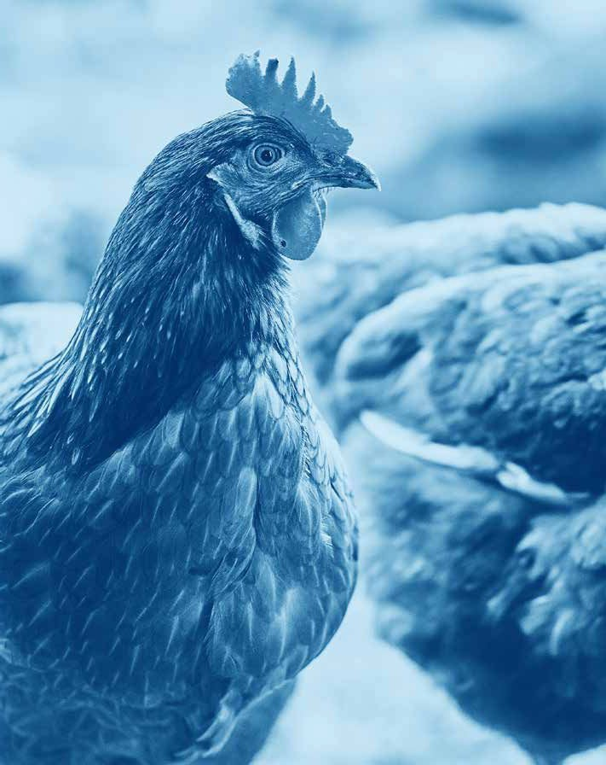


bbfaw.com

